Computer Science H446 Coursework Project:

Pac-man Game

Stefan Harris

Candidate Number: 1419

Centre Number: 19268

Contnts

Introduction 6

Analysis 6

Identifying the Problem (An Explanation of Pac-Man) 6

Solving the Problem using Computational Methods 6

Abstraction 7

Decomposition 7

Logic, Branching and Iteration 7

Pipelining and Concurrent Thinking 8

Performance Modelling 8

Thinking Ahead 8

Stakeholders 9

Researching Existing Solutions 9

Pac-Man (A Look into Ghost Movement and Behaviour) 10

Ms. Pac-Man 11

Pac-Man Championship Edition (CE) 12

Pac-Mania 13

What and What Not to Add 13

Features of the Solution 14

Limitations 19

Requirements for the Solution 19

System Requirements 19

Success Criteria 20

Design 25

Decomposition Diagram 25

Program Structure 27

Algorithm Design 28

Ghosts’ Direction Decision Algorithm 29

Ghost States 31

Game loop 33

Movement Interpolation 35

Responding to Movement Keys 36

Usability Features: User Interface Controls, and Sprites 37

User Interface 37

Controls 40

Sprites 40

Key Variables, Data, Structures and Classes 41

UML Diagram Example 41

Explanation and Justification of Class Attributes and Methods 43

Required Validation: Testing to Inform Development 49

Planning Post-Development Testing 51

Developing the Solution 51

Iteration 1 –Setting Up 51

Reflection 54

Iteration 2 – Creating and Populating the Maze 54

Reflection 58

Iteration 3 – Pac-man’s Movement, Collision, Wrapping and Score 58

Reflection 61

Iteration 4 – Programming Ghost Movement 61

Iteration 5 – Implementing the Other Ghosts 67

Pinky 68

Inky 69

Clyde 70

Reflection 72

Iteration 6 – Ghost States 72

Scatter and Chase 72

Frightened Mode 80

Eaten Mode 93

Reflection 96

Iteration 7 – Lousing, Winning and Scoring 97

High Score Encryption 97

Lives and Position Reset 98

Game Over Screen 102

Reflection 109

Iteration 8 – Pausing 109

Pre-Game Pause 110

Eaten Pause 111

Manual Pause 112

Capture Pause 113

Level Clear Pause 113

Reflection 114

Iteration 9 – Refactors, Fixes, Optimizations and Quality of Life Changes 114

Encapsulation, Getters and Setters 114

Improving Variable and Method Names 116

Fixing Bugs in the Ghosts’ Behaviours 118

Movement Utility Class 121

Smaller Hitboxes 124

Refactor of Direction Decision Algorithm 126

Minor Improvement to Pac-Man’s Movement 126

More Dynamic Score 127

Reflection 128

Iteration 10 – Graphics and Animation 129

Loading the Graphics 129

Pac-Man’s Frames 131

Ghost Frames 133

Win and Death Animations 135

Pellet Frames 138

Fixing an Eating Animation Bug 140

Maze Graphics 140

Reflection 149

Iteration 11 – Title Screen, Bonus Fruit, Refining Controls and Finishing Touches 150

Title Screen 150

Bonus Fruit 151

Major Refinement to Pac-Man’s Controls 154

Redesigning the Title Screen and Post-Game Screen 158

Final Touches 161

Minor Reformatting and Comment Editing 166

Reflection 166

Testing Compilation 166

Functionality Testing 166

Usability/Cosmetic Testing 171

Robustness Testing 172

Evaluation 173

Successes, Partial Successes and Failures 173

Usability Features 174

Screens 174

Controls 174

Sprites 174

Limitations and Potential Improvements 174

Maintenance 175

Corrective Maintenance 175

Adaptive Maintenance 175

Perfective Maintenance 175

References 175

# Introduction

This project aims to develop a program serving as a recreation of the 1980 coin-op arcade game Pac-Man, using both the household high-level programming language Python and a 3rd party library to enable game development, Pygame.

The project aims at creating a rather conservative recreation of the original. The core gameplay loop will be retained as much as possible by researching the original game’s mechanics, namely the mechanics of the ghosts: the algorithms that dictate where they will move, where they will move to and how to react to key game play moments. Any features outside gameplay will be mostly cosmetic and or serves as a quality-of-life improvement for the player.

# Analysis

## Identifying the Problem (An Explanation of Pac-Man)

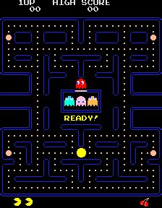Pac-Man is a 1980 arcade game developed and published by Bandai Namco in Japan. And published by Midway Games in North America. Despite initially receiving lukewarm reception in Japan, the game showed both critical and commercial success outside the nation and the franchise remains one of the highest-grossing video game series of all time.

Development of Pac-man begun in 1979, directed by Toru Iwatani with a nine-man team. Iwatani noticed that most arcade games of the time appealed more to a masculine audience, with conflict being quite unanimous. Discontent with this, he aimed to create a game that would appeal to woman as well as men. A colourful art style and game play loop that would appeal to all ages was the idea.

The core gameplay revolves around Pac-Man and his goal, to eat all the pellets/dots in the maze without being caught by the pursuing ghosts. Pac-man can turn the tables by tactically eating the large dots known as power pellets. This will frighten the ghosts, making them vulnerable to Pac-Man eating them for bonus points. Difficulty increases the more levels the player completes, with the ghosts becoming more aggressive among other subtle changes, like power pellets no longer fully functioning.

the beginning of a game of Pac-Man.

To add variance to the gameplay, each ghost has their own unique behaviour to catch Pac-Man, giving the illusion that they are working together and making them seem smarter than they are. They also alternate between behaviour states during a level, namely chase mode –when they are pursuing Pac-Man, and scatter mode – when they flee to the maze’s corners to give the player a breather.

## Solving the Problem using Computational Methods

One of the reasons I chose Pac-Man for my coursework is because I believe it serves as a good example on how computational methods can be applied to a large project to make it more approachable.

### Abstraction

Abstraction helps in reducing the amount of hardware resources taken up by the program, ensuring that performance is optimal on the range of target systems. An abstract model will serve as a representation of reality, only functioning in the ways it needs to.

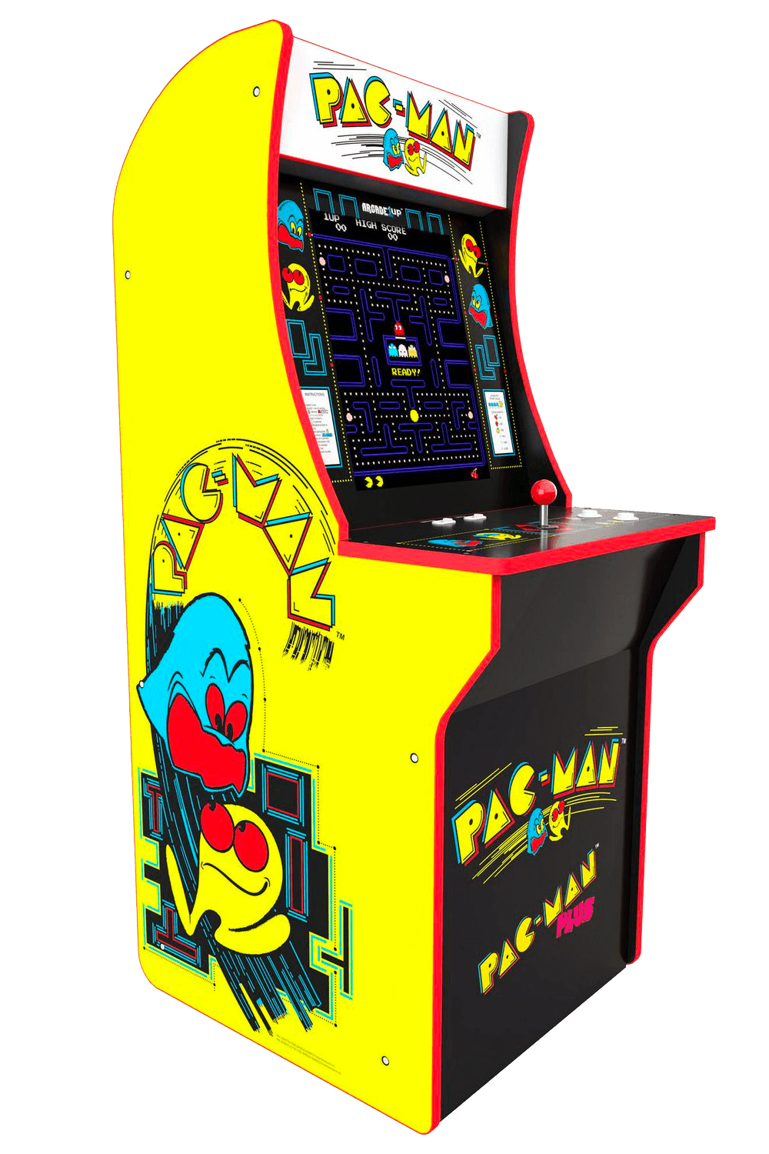Pac-Man is already an abstracted form of a chasing simulation. The game takes place on a 2D plane, yet still provides a good representation of a real-life chase scenario. The omission of a 3rd dimension results in far less lines of code, storage, and processing, a necessity when acknowledging the limited hardware of the time. All the entities are sprites consisting of only a couple colours and frames of animation, a drastic simplification of how the characters are depicted in the game’s promotional material and arcade cabinet. The maze does not represent any real-life location and is represented by simple outlines for walls. The entities can only move in cardinal directions.

With the source material already being abstracted, it is easy to find and implement the core mechanics into my project such as the player movement, ghost behaviour and ghost states while ignoring more superfluous aspects like cut-scenes between levels.

An original arcade cabinet. Note how the art on the side doesn't match the game's graphics, but more-so its bright colours.

### Decomposition

For complex problems like this, decomposition is invaluable for breaking it down into simpler, more manageable chunks that can be prioritised, developed, and tested individually. It makes life so much easier on the developer’s end.

This solution is no exception, it can be decomposed into its core components.

For example, the core gameplay loop of Pac-Man can be decomposed into a series of entities interacting with each other: Pac-Man, pellets, ghosts, bonus fruit etc. Each entity can then be further decomposed into their core behaviours. So, for Pac-man that will be his movement, his eating and dying. For ghosts, it is their movement algorithm and behaviour states. Once the game is fully decomposed, the components can then be prioritised, such as the maze being implemented before the gameplay since the maze will house all the gameplay.

### Logic, Branching and Iteration

These are pivotal for adding interactivity and dynamism to the solution. Without these the code is completely linear and with little to no meaningful interactivity, which is not optimal for a game, a program that is supposed to react to user input.

Iteration is essential because it allows the game to repeat operations indefinitely, significantly reducing the number of lines in the code base. It also allows the game to run indefinitely via a game loop.

Logic is an integral part of the gameplay; the ghosts will use logical comparisons to decide what will be the next best direction to get themselves closer to Pac-Man or to decide if a direction is eligible to move in or to decide if it is time to switch to a different behaviour state.

Branching in the form of if/else statements must be used for the game to respond to user input and produce an action. The game can check for user inputs each frame using a series of if statements. For example, when the player presses the left movement key, Pac-Man will move left, otherwise he will not.

Iteration in the form of for/while loops is integral for the game to run in real-time. A main game loop will be used to clear the screen, update the entities, and refresh the display for each frame. Iteration will also be used in entity behaviour; the ghosts will iterate through each cardinal direction to decide what direction to move in.

### Pipelining and Concurrent Thinking

Pipelining allows for one process to start while another is finishing. Concurrency is when multiple processes are split into time slices and ordered into a schedule to be worked on.

These methods allow for an increased program throughput, which is important for a game like this. The game should run at a consistent frame rate, preferably 60 frames per second; all computation between frames needs to be done within a ~16.67ms window. Major drops in framerate will mean choppy movement, stuttering and less responsive controls, the latter being the most unbearable since the game can demand quick reactions. The throughput pipelining and concurrency offers will ensure that all computation between frames will be done within the window, keeping performance at an optimum.

Concurrent processing via scheduling algorithms is present in almost every modern operating system. The same can be said for pipelining, which is a mainstay in most contemporary CPU architectures. These two methods will not need to be explicitly implemented in my code because these are implicit optimizations that are autonomous.

### Performance Modelling

Performance modelling means analysing the performance of algorithms to determine what processes are taking up the most time and addressing them accordingly. It is vital for the game to run smoothly so that there is minimal delay between the player’s input and what appears on screen. Excessive frame drops and delayed input can make the game cumbersome to play.

Knowledge of the scalability of algorithms will help in predicting any future performance issues and optimisations. Big $O$ notation is suitable for this task. For example, if I know that an algorithm has a time complexity of $O(n^{2})$, I can seek an algorithm that scales better, stopping the poor scalability form becoming an issue later in development.

Python’s built-in libraries such as ‘time’ will be used to measure the elapsed time between an algorithm starting and ending, with this information, it is possible to find the percentage of time an algorithm takes in a single frame or even the approximate number clock cycles it uses. Optimisations can then be achieved based on this data. However, knowing the Big $O$ is arguably more beneficial as the time for an algorithm to compute will very across hardware configurations.

### Thinking Ahead

This refers to the careful planning to make sure the project is completed to a good standard and within time. Thinking ahead is useful as it allows you to determine how much time should be spent on each key part of the solution.

I can achieve this by dictating a programming paradigm that the solution will revolve around, which will be Object Oriented Programming (OOP). By sticking to this, I can plan out how each entity of the game will translate to objects using Unified Modelling Language (UML) diagrams. OOP lends itself well to reusability and modularity through inheritance and polymorphism. Which is a big plus for saving time and for keeping the code base clean and simple.

Thinking ahead also refers to caching, the process where frequently accessed data can be temporarily stored somewhere for quick access when needed. In software this can be a web cache in local storage, in hardware this can be a small primary storage inside a processer. All modern consumer grade CPUs have a cache that is used implicitly, so I do not need to implement caching in my code.

## Stakeholders

This game can attract a variety of stakeholders, like how the original arcade release aimed to satisfy a wide demographic. These stakeholders include:

* **Children** – Aged 5 to 12, male and female. Children that have an interest in video games and or play video games as a pastime. These children may not be very versed in technology but will be able to pick the game up easily due to the simple controls and easy to grasp winning and losing conditions. They may also be attracted to the colourful appearance of Pac-Man and the ghosts. The game was designed for an arcade setting, allowing it to be played in short bursts. Suitable for children with short attention spans. The score can serve as a gateway to competition amongst a group of children. While the controls and graphics may be the most important to them, they may ask for a high score/leader board system to further facilitate competition. While possible, implementing this is not on top of my priority list. Implementing the gameplay first will not only satisfy all stakeholders, but also guarantees that the game will serve as a strong showcase of solving a problem using computational methods and algorithmic thinking within the time that I have. If I have enough time, I can add these extra features.
* **Adults** – Aged 20 to 50, male and female. Adults that remember playing the original arcade realise during its peak or remember playing later versions or realises. They may be a fan of Pac-Man, looking for a simple way of playing a recreation of Pac-Man without having to toy with emulation or other methods. Akin to the children, some adults may not be versed with technology, so they may seek a simple way of playing Pac-Man, which this solution will serve. The simple controls and arcade-centric design allows adults to use the game to get some entertainment during their free time. While the simplicity of the game can be appealing for young children, it can become boring for adults, they may ask for variety seen in other realises, like multiple maze layouts. Again, I want to focus on implementing the core gameplay, with extra features being added if I have enough time.
* **Programmers –** Likelyhobbyists that have an interest in how retro games work. These people are likely to have less of an interest in the game and more so on its code. They may find use in an implementation of Pac-Man’s underlying algorithms in a modern high-level language, they can fork the code for use in their own projects, without having to do research or use an emulator’s disassembler and debugger to try and make sense of the algorithms. These stakeholders may ask for the source code to be easy to read and understand. An aspect of my solution that will be a priority.

## Researching Existing Solutions

To replicate the game play of the original Pac-Man, I needed to do some research on existing solutions. This involved a dive into the original algorithm that dictates how the ghosts traverse the maze, their unique behaviour, and their various states. With this knowledge I will be able to confidently translate these algorithms into Python and Pygame.

The commercial success of the original of Pac-Man naturally led to many other realises over the years. Some offer simple quality-of-life improvements, to adding whole new mechanics. I will assess these features and decide whether to implement them or not.

### Pac-Man (A Look into Ghost Movement and Behaviour)

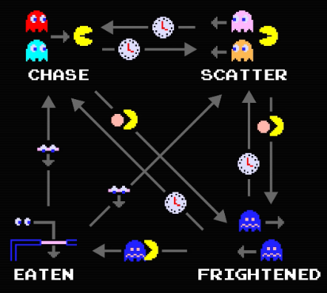One of the reasons I decided to do this project was because of this comprehensive video I watched a while ago from a YouTube channel called *Retro Game Mechanics Explained*. The video goes over every facet of the ghosts’ behaviours in detail.

Video graphic showing the four states and how they interact [22]

The video begins with an explanation of the four states and how each ghost moves between them. There are 4 states: chase, scatter, frightened and eaten. The ghosts will alternate between chase and scatter depending on a timer. When Pac-Man eats a power pellet, they will temporarily enter frightened mode and then enter eaten mode when Pac-Man touches them. Upon entering the ghost house, they will regenerate and either enter scatter or chase depending on the timer. This is something that I will defintely add.

The video then explains the timings for scatter and chase mode, with the quirk of Blinky constantly being in chase mode when there are only a few dots left in the maze, something that I will also add.

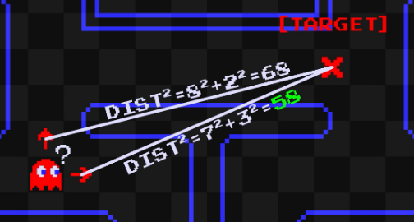An explanition of the movement algorithm is then given. The ghosts use a targeting system to determine the tile to move towards. Each cardinal direction is checked to see if it’s a valid direction to move in. A direction is concidered invalid if it leads into a wall or causes them move back the way they came. Out of the vaid directions, the distence between the tile the direction will lead to and the target is calculated. The direction that yields the smallest number will be the direction the ghost will move in. If all direcitons yield the same distance a pirority system is used to pick one. Up is given the highest piority, then left, down and right. All of this will be included.

Video graphic showing Blinky choosing a direction [22]

The various modes are then explained. During scatter mode, the ghosts’ target tile is set to a corner of the maze. When chasing, Blinky’s target tile is directly on Pac-Man, Pinky’s is four tiles ahead, Inky’s is dependant on Blinky’s and Pac-Mans postion, and Clyde is on Pac-Man, until he gets within eight tiles of him, in which case he will scatter away for several seconds. When fightened the ghosts will u-turn and begin to move in random, eligaiable directions according to a random number generator (RNG). All this will be added.

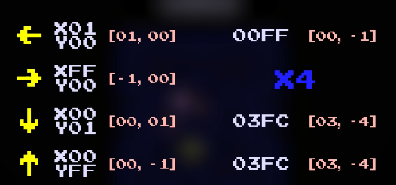The video addresses a bug that occurs when multipying the ‘up’ unit vector. The code that handles applying magnitute to unit vetors treats the x and y components as one 16-bit value rather than two 8-bit ones, leading to the multiplication of the y component overflowing into the x. For Pinky this means that her target tile is three tiles up and four left when Pac-man is facing upwards. This is obviously a bug, therefore I won’t replicate it in my solution.

Video Graphic showing the overflow error. Multiplying $FF by 4 makes $3FC. The left most nibble overflows into the x component. [22]

### Ms. Pac-Man

Released in 1982 by publisher Midway, Ms Pac-Man is the questionably licenced sequel to Namco’s original arcade release.

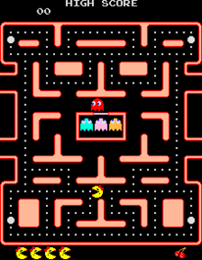The gameplay does not stray far away from the original, instead it adds new quality-of-life improvements and new content that still retains the timelessness of the original’s gameplay:

Start of a game of Ms. Pac-Man. Note how the walls are now solid pink and that they’re now two sets of warp tunnels.

* The maze walls are now filled with a solid colour that contrasts better with the black rather than being simple outlines that can blend into the background, especially so considering the blur CRT displays have, which were in ubiquitous during the era Pac-Man came out in. This offers a nice usability feature for the visually impaired, who may struggle to distinguish the walls from the background. This is something that I will certainly implement into my solution.
* One gameplay enhancement comes from the ghost behaviour. At the start of the level, Blinky and Pinky ghosts will move randomly for the first couple of seconds before falling into their typical behaviour. This not only adds a small ripple to the gameplay for experienced players but can also serve a good challenge to overcome and enhance the algorithmic complexity of in my solution. If I have enough time, I will add this.
* Ms. Pac-Man adds three new mazes that appear back-to-back for each level. These new mazes have two pairs of warp tunnels. This allows the player more options to evade the ghosts yet also gives the ghosts more options to intercept the player. While a nice addition, I will not prioritise it since I would like to get the core gameplay loop down pat before adventuring into other aspects of the solution.
* The bonus fruit is that appears in the original now moves through the maze. This makes the eating of it more frantic since you need to pay attention to the fruit is along with the ghosts. While a neat addition that can add extra challenge for experienced players, I am afraid that this may confuse novices into believing that it is just another threat. They may subconsciously associate anything that moves besides them to be one, so will put unneeded effort into avoiding it, making the game harder for themselves. While I will not consider adding this for the meantime. I may add it if I can use it to showcase a programming technique. Maybe the bonus fruit can inherit the movement of the ghosts using OOP?

### Pac-Man Championship Edition (CE)

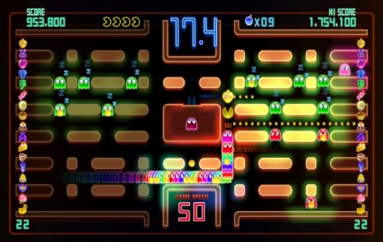Originally released in 2007, Pac-Man CE is of now the last game that series creator Toru Iwatani has worked on. This game can be considered Iwatani’s faster-paced reimagining of Pac-Man with modern game design sensibilities. When distilled, gameplay follows the same timeless loop as the original, but with some new major twists:

Pac-Man CE Midgame

* Pellets only appear in small clusters at defined points in the maze. Once all the pellets are eaten a bonus fruit appears that will reveal a new cluster. While I like this change, I believe that this was done to suit the faster-paced gameplay and would be too large of a change for my recreation of the original and may even alienate stakeholders.
* 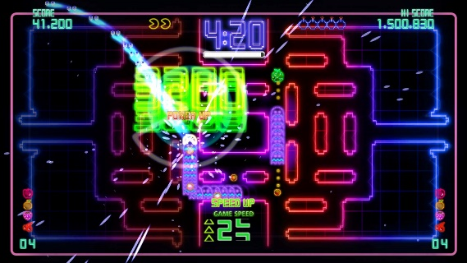Sleeping ghosts can found across the maze, who will wake up and pursue Pac-Man when he moves past them. This is to incentivise the player to get along trial of ghosts behind them, only to get a power pellet and eat them all in a row. This adds another loop to gameplay alongside eating pellets with is very satisfying to execute properly. But like the clusters, I believe that this is too much of a far cry from the original game I am trying to replicate. The long trail of ghosts can clog up the smaller maze of the original and while it should be trivial to instance all those ghosts using OOP, the sheer number can be too much for Python and Pygame. Performance issues can be encountered that I may not have enough time to solve.

The player eating a trail of ghosts behind them.

* Assistive effects are also added. Game speed slows down when Pac-Man is close to a pursuing ghost. Pac-Man can also use bombs to send all the ghosts back into their house at the cost of restarting the dot multiplier. I understand the need for slow motion since this game is significantly faster-paced, I felt like the tension of a ghost almost catching you from behind, only to narrowly escape them by turning a corner is reduced. I feel like this and the bombs do not gel well with the slower pace of the original. Though some of my stakeholders likely the children - may want these assistive effects, so I could add them as an option to enable if I have time.

### Pac-Mania

Released in 1987 for arcades, Pac-Mania is an isometric representation of the original, with some major additions:

* 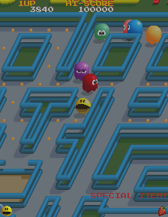Pac-Man can now jump over ghosts to serve as another option to evade them. This adds a tactical ripple to the gameplay. This makes more sense in an isometric perspective compared to a top-down one. While still possible top-down with some dynamic sprite scaling it seems like too much effort to implement into the solution for what it is worth.

Pac-Mania mid level.

* To balance out the jump, two new ghosts are added. Funky and Splunky. Both can jump and Pac-Man cannot jump over Splunky. Like the jumping mechanic, it seems like this would require a lot of attention to implement properly, which would detract from the quality of the core parts of the solution. The extra ghosts may also cramp up the small maze and confuse the player.
* Eating bonus fruit will speed up Pac-Man, serving as a power-up in distancing him from the ghosts, but also a power-down since it makes it harder to navigate the maze. This seems like a nice twist to gameplay, but I will need to see whether this will play nice in the smaller maze of the original.

### What and What Not to Add

Here is a table summarising the extra features that I would like and would not like to feature in my solution. I feel like my choices show that I only want to make conservative additions/changes.

|  |  |  |
| --- | --- | --- |
| **Will Add** | **Tentative (depends on time left and stakeholder feedback)** | **Will not Add** |
| Solid colour for maze walls. | Multiple maze layouts (two pairs of tunnels). | Clustered pellets. |
|  | Moving bonus fruit. | Sleeping ghosts. |
| Initially random ghost movement. | More than four ghosts. |
| Assistive effects like slow-motion and bombs. | Jumping for Pac-Man and ghosts. |

## Features of the Solution

|  |  |  |  |  |
| --- | --- | --- | --- | --- |
| Feature | Source of Feature | Essential? | Description | Explanation |
| The player must be able to control Pac-Man in four cardinal directions. | research | yes | Pac-Man will move accordingly to the player pressing the movement keys. | Moving Pac-Man will allow the player to achieve their goal of eating all the pellets. |
| Maze must be loaded and rendered correctly. | research | yes | The maze must load in within a reasonable amount of time and render correctly. | Gives the player a sense of their surroundings and allows them to correctly navigate the maze. |
| Pellets and power pellets must be rendered within the maze. | research | yes | Pellets and power pellets must be loaded and rendered alongside the maze. | Provides the player with the goal of eating all the pellets. |
| Ghosts must use an algorithm to navigate the maze. | research | yes | The ghosts will use the same algorithm as the original release. Each cardinal direction is evaluated and omitted if it leads into a wall or back to where the ghost came. If the direction passes, the distance between the next tile and target tile is calculated. The direction with the shortest distance will be picked. | Gives the player the challenge of avoiding the ghosts. |
| Each ghost must replicate their unique behaviour from the original. | research | yes | Each ghost will target a different tile to navigate to. During chases mode, Blinky and Clyde’s tile will be on Pac-Man, Pinky two tiles ahead of Pac-Man and Inky a tile calculated using Pinky’s tile and Blinky’s position. | More challenge for the player since they must memorise the behaviour of each ghost. |
| Ghosts must switch between scatter and chase modes according to a timer. | research | yes | Each ghost will monitor a timer and switching between chasing Pac-Man and fleeing to the corners of the maze. | Scatter mode will allow the player to take a short break from the pursuit. |
| Ghosts must become temporarily frightened when Pac-Man eats a power pellet. | research | yes | The ghosts will turn blue, turn around and move in random directions for several seconds. | A pivotal part of the gameplay loop; it allows the player to eat them. |
| Pac-Man must be able to eat frightened ghosts. | research | yes | Once eaten, a ghost will become a pair of eyes and flee back to the ghost house to regenerate. The player is rewarded with bonus points. | Completes the gameplay loop of Pac-Man being hunted by the ghosts and turning the tables to hunt them instead. |
| The level must be considered complete when Pac-Man eats all the pellets. | research | yes | After eating all the pellets, the ghosts will disappear, and Pac-Man will remain still for several seconds while the maze flashes white. The game will then proceed to the next level. | Tells the player that that they passed the level. |
| The bonus fruit must appear to be eaten. | research | yes | A fruit will appear in a fixed location in the maze after some time has elapsed in the maze. Pac-Man can eat this to get bonus points. | Gives the player a small extra challenge that shouldn’t take long to program in. |
| Pac-Man must die when he gets caught by an un-frightened ghost. | research | yes | When caught, Pac-Man will remain frozen in place and playout his death animation and loses a life. If he still has lived the player would resume the level, else they’ll see a game over screen. | Adds stakes to the game. The player will be incentivised to not make too many mistakes. |
| The time spent between scatter and chase modes decreases over time. | research | yes | After being in scatter mode for three times, the next scatter will only last 5 seconds instead of 7. | Adds a difficulty curve to the game. |
| Blinky will always be in chase mode when there is only a few pellets left in the maze. | research | yes | Blinky will always target Pac-Man when there is 20 or less pellets left. | Adds a difficulty curve to the game. |
| Ghost behaviour will become more aggressive the more levels the player completes. | research | yes | The initial durations between scatter and case mode will become smaller the more levels are competed. | Adds a difficulty curve to the game. |
| Replicate ‘up’ unit vector overflow error. | research | no | In the original realease. The code that handles adding magnitige to unit vectors. treats the x and y components as one 16-bit value rather than two 8-bit ones, leading to the multiplication in the y component overflowing into the x. | I decided to reject this since it’s obviously a bug, likely unintended by the developers. |
| Blinky and Pinky’s random movement. | research | yes | Blinky and Pinky will behave like they’re in frighted mode for the first couple of seconds of a level. | Adds a ripple to gameplay that can catch out experienced players. It will also add to the algorithmic complexity of the ghosts. |
| Title Screen | Own idea | yes | Displays the title of the game along with a prompt asking the user to press a key to begin the game. | Allows the player time to prepare before playing. |
| Pause Screen | Own idea, stakeholders | yes | Pause and resume execution of the game on demand using a key stroke. | Allows the player to readjust their posture and or have a break. |
| pause screen menu | Own idea | no | A menu appears upon pausing the game, asking the player if they want to resume or quit. | While a nice feature in terms of player accessibility. This functionality can be replicated using key strokes, therefore it’s not essential. |
| Solidly coloured maze walls. | Research, stakeholders | yes | Maze walls will consist of a solid colour instead of outlines. | Makes it easier for the player to see the maze, especially if the player is visually impaired and or is playing on a small display. |
| high score and leader board system | Stakeholders | no | High scores will be saved and added to a leader board to compare. | Enables a sense of competition among players.  I decided to omit this feature in the interest of time. |
| multiple mazes | Research, stakeholders | no | Each level will have one of four mazes, each with a unique layout. | Provides come variety to the game.  Will be omitted or added later in the interest of time. |
| Bouncing bonus fruit. | research | no | The bonus fruit that appears will move around the maze like a ghost. | Adds a ripple to by making the player pay attention to both the fruit and ghosts.  Decided to omit this feature due to the aforementioned confusion it can cause in novice players. |

### Limitations

This project will not end up being a feature rich or ‘complete’ remake of Pac-Man. I want to make an expressed focus on implementing the core mechanics of the original game and extra features afterwards. These extra features will be simple to implement, like solidly coloured walls, as to not distract from the progress of implementing the core features.

Pac-Man’s movement, the ghosts’ movement, win and lose conditions and behaviour states are deemed the most essential and will receive the most attention. Features like bouncing bonus fruit, multiple mazes and a high score system will be either omitted outright or have a chance of being implemented later.

My omission of curtain features is done so that I know I have enough time to finish implanting the core features before the deadline. One example is a pause menu. Instead of the player clinking on a button to resume the game, they can instead press a key like escape to achieve the same thing. This saves me from having to program a pause menu and figure out its design, allowing me to focus on the core features.

## Requirements for the Solution

The project will be developed on a Microsoft Windows machine, but will have multi-platform compatibility in mind. While Python and Pygame are multi-platform, I still need to look out for subtle differences. One example is using backward slashes for directories in my code despite forward slashes being used in *nix systems. Pythons built in module ‘os’ will solve this discrepancy.

For this project to succeed, I would need to:

* Have access to a computer running an operating system compatible with Python and Pygame.
* Use the programming language Python with modules from its standard library and any external libraries when necessary.
* Use the game library Pygame and all its relevant functions and methods.
* Use an image manipulation program to edit sprites and make concepts.

### System Requirements

* OpenGL API for graphics rendering.
* OpenAL API for audio.
* MinGW 4.8.1 or Microsoft Visual C++ Express 2010 (MSVC).
* OpenAL Windows driver.
* Operating Systems: Linux, Windows, MacOS, Free BSD, Open BSD.

[1] [2]

Failure to meet these requirements will lead to the development of the game being delayed or in the worst case, unable to continue. In terms of the end user, their hardware and or software may not be powerful enough to run the game or is missing essential requirements for Pygame to operate correctly, such as OpenGL. But most devices today should meet these relatively low system requirements.

### Success Criteria

|  |  |  |  |
| --- | --- | --- | --- |
| **Criteria** | **Category** | **Measured by** | **Justification** |
| Make the game boot up and display a window. | Functionality | Development Testing | This is the only means for the player to access and interact with the game. |
| Have the game be able to display Pac-man and be capable of switching between animation frames. | Functionality | Development Testing | Pac-man will be the object that the player controls, it be the most focused on aspect in the game. It is important that Pac-man looks good. |
| The player can press another movement key while holding another and Pac-Man will update his movement to the newly pressed key. | Usability  Robustness | Development Testing | Pac-man’s movement must not only feel responsive, but also initiative for new and experienced players. A new player may need time to get a grasp of the controls, which means their fingers may get muddled. Pac-Man responding to the last key pressed ensures that he promptly responds to player intentions. |
| Have Pac-Man be able to move in all four directions while keeping aligned to the grid of tiles. | Functionality Robustness | Development Testing | Allows the player to make Pac-man fully traverse the maze and avoid the ghosts, keeping Pac-man fixed to the tiles will prevent Pac-man from clipping out of the maze. |
| Allow Pac-Man to move smoothly between the tiles. | Usability  Cosmetic | Development Testing | The smooth movement will give the player the enough reaction time to decide whether they should turn a corner or continue to move forward. It also ensures that Pac-man looks good and feels good to move. |
| Allow the turning of corners not be pixel perfect. | Usability | Development Testing,  Interview | Prevents the player having to fight the controls by ensuring that Pac-Man’s collision is perfectly aligned to turn corners. This will make the game feel more intuitive.  Stakeholders can be asked about how the game feels to control to inform development. |
| Have Pac-man freeze in place when the maze is complete. | Functionality  Usability | Development Testing | Signals to the player that the maze is clear. |
| Make Pac-Man collide with the walls of the maze along with the entities inside it. | Functionality  Robustness | Development Testing | The collision will be the bases of the game’s mechanics. |
| Make the player’s score increase when Pac-man eats pellets. | Functionality Robustness | Development Testing | Provides an incentive to eat as many pellets as possible and in turn get the highest score. |
| Kill Pac-Man upon colliding with an un-frightened ghost and deduct a life. | Functionality  Robustness | Development Testing | Invading the ghosts is the main challenge of the game, the player must be punished if the ghosts catch them. |
| Make the game render the maze. | Functionality  Usability | Development Testing | Seeing the maze allows the player to know its boundaries and how to navigate it. |
| Have each tile of the maze have a flag stating whether it is solid or not. | Functionality | Development Testing | Plays into the collision detection and to make the player know the maze’s bounds. |
| Efficiently load in the pellets of the maze with the power pellets and fruit being in the right place. | Functionally  Robustness  Performance | Development Testing | There should be as little downtime between the player starting the game and the game starting (outside of telegraphing that the game is starting). |
| Have the warp zones at the sides of the maze correctly teleport Pac-Man and the ghosts. | Functionality  Robustness  Usability | Development Testing | The warp zones will allow the player to escape situations they otherwise would not, while the ghost also being able to use them provides challenge. |
| Have the maze flash white upon Pac-Man eating all the pellets. | Cosmetic | Development Testing | Signals to the player that the maze is clear. |
| Ensure that the number of pellets does not reset after Pac-Man dies and respawns. | Functionality  Usability | Development Testing | Alleviates some of the difficultly of clearing a maze. |
| Have all the ghosts stay in the house for a set amount of time upon the beginning of the level. | Functionality  Usability | Development Testing | Gives the player a head start and prepares them for the pursuit. |
| Implement each ghosts’ behaviour to intercept Pac-man. | Functionality  Robustness | Development Testing | Gives challenge and unpredictably to the game. |
| Reset the ghosts’ position to the house after Pac-Man dies and respawns. | Functionality  Usability | Development Testing | Gives the player a level playing field after dying. |
| Implement the 4 states that the ghosts will go into at designated times. (Chase, scatter, frightened and eaten). | Functionality  Usability | Development Testing | Not only will this introduce some dynamism to the gameplay, but the scatter eaten, and frightened states give the player a break from the constant pursuit. |
| Ensure that the ghosts will go into a frightened state upon Pac-Man eating the power pellet. | Functionality  Reliability  Usability | Development Testing | Provides an incentive to eat the pellets but also allows the player to strategically eat them to maximise score or to make a retreat. |
| The player can eat a power pellet and reset the fright timer. | Functionality  Robustness | Development Testing | Provides a way for the player to easily get a get a steak of ghost eating, boosting their score a lot. |
| When Pac-Man eats a frightened ghost, add the bonus points to the score and show their eyes moving back to the ghost house. | Functionality  Robustness  Usability | Development Testing | Provides an incentive to eat the ghosts, the eyes indicate that they are eaten and them moving back to the house potentially puts them back into an advantageous position for the player. |
| Ensure that an eaten ghost does not become frightened. | Functionality  Robustness | Development Testing | An eaten ghost must fully successfully retreat to the house. If they become frightened again, the player can exploit the eaten ghost by using first eating them, eating a power pellet right after and eating them again. Effectively doubling their points. |
| Alter the behaviour of the ghosts depending on the number of pellets left. (e.g. Blinky moving faster when there is 30 left.) | Functionality | Development Testing, Interview | Adds challenge and a feeling of haste to the final moments of a level.  Stakeholders can be interviewed to find their opinion of this to inform development, perhaps it could be too stressful for some. |
| Hide the ghosts when Pac-Man collects all the pellets or is dying. | Functionality  Usability | Development Testing | Indicates that the threat of the maze is gone. |
| Decrease the amount of time the ghosts are in the scatter state when the more levels are completed. | Functionality | Development Testing, Interview | Increases the challenge by decreasing the amount of time Pac-man is not being perused.  Stakeholders can be interviewed to find their opinion of this to inform development, perhaps it could be too stressful for some. |
| Display the score and high score above the maze. | Functionality  Usability | Development Testing | Gives the player a goal to reach. |
| Store the high score inside a text file and load it at run-time. | Functionality  Usability | Development Testing | Makes sure that the high score is retained for when the player plays the game again. |
| Encrypt the high score in the text file | Functionality | Development Testing | Ensures that the high score can’t be tampered with. |
| Display the lives and fruit below the maze. | Functionality  Usability | Development Testing | Informs the player of how many lives/mistakes they have. |
| Change the amount of fruit displayed depending on the current level. | Functionality  Usability | Development Testing | Informs the player of how far they came. |
| Display the title screen and ask for a key prompt to start the game. | Functionality  Usability | Development Testing | Welcomes the player and gives them a change to get prepared before starting. |
| Display a game over screen upon lousing all lives and going back to the title screen after some time. | Functionality  Usability | Development Testing | Indicates to the player that they have lost, and the game has stopped. |
| Add a manual pause that can be called on command. | Usability | Development Testing | Allow the player to take a breather at any time to plan their next move or to do something else. |
| Be able to spam the pause button without one game mechanics breaking. | Robustness | Development Testing | Since there is no limit to how many times you can pause, it’s important for pausing to not break anything. |
| Pause the game for a short time before starting the game. | Cosmetic  Usability | Development Testing | Allows the player to prepare for gameplay. |
| Do a short pause when eating a ghost, clearing a level and getting caught. | Cosmetic  Usability | Development Testing | Adds emphasis to key gameplay events. Pausing after getting caught allows the player to recognise their mistake. |
| Pac-Man’s movement should work the same when the player is tapping or holding down the movement keys. | Usability  Robustness | Development Testing | Allows for multiple modes of play. The player will be able to control Pac-Man to their personal preference. |

# Design

## Decomposition Diagram

Here is a full decomposition of the project. Decomposition diagrams are useful as they allow me to have a holistic view of the project and how to prioritise features. For example, when I begin work on the ghosts, I would know that I would need to implement the chase state before each ghost behaviour.

|  |  |  |  |
| --- | --- | --- | --- |
| **Program Component** | **Description** | **Explanation** | **Justification** |
| Screens | The various screens that the player will encounter and interact with. The core user experience. | Screens include title screen, leader board, pause screen, options, game over/victory screen, etc.  Each screen will have its own content, such as the options screen having sliders for volume and game speed. Each screen can be navigated through each other. So, the title screen can bring you to options and options can bring you back to title. | The screens are the backbone of the players experience of the game. Having a range of screens to navigate will make them feel accustomed to the overall game. Screens also serve as good first impressions. Having a title screen before throwing the player into gameplay will make the solution feel more like a game rather than a prototype. |
| Logic and Systems | The logic and systems that the player will experience throughout the game. | This includes all the logic behind each entity of the game, such as Pac-Man’s movement and collision detection. The ghosts’ direction decision algorithm, determining ghost states etc.  All of these are considered to have logic because of their heavy use of branching and iteration. For example, each carinal direction needs to be iterated through for the ghosts to find a suitable direction. | This is the backbone of all the gameplay, without any of these logic and systems, there will not be a functional game and most entries in my success criteria will not be met. |
| HUD | The information displayed for the player during gameplay. | This includes a level count (represented by fruit) lives, current and high scores this information will be displayed around the maze, easily read by a quick glance. | This information provides the player with vital information that supplements the diegetic info during gameplay, such as the number of pellets left. The displaying of a score and high score gives the player an extrinsic goal of beating that high score. Showing the lives left tells the player how many more mistakes they can conduct.  It is possible for me to show even more information, like whether a ghost is in scatter or chase mode, but I feel like removing that uncertainty will sap the suspense of gameplay and reveal the smoke and mirrors of the ghost AI. I feel like it’s more rewarding if the player would discover the states on their own rather than the game telling them. |
| Sound | Sound made by the various entities, such as Pac-Man’s eating and the ghosts’ movement. | Sound will be loaded into the game to load time in a lossless format like WAV. These sound bites are then played when appropriate so for example a munching sound for when Pac-Man collides with a pellet. | While implementing sound in Pygame does not demand much algorithmic complexity, it does serve to give more diegetic information to the player to supplement the information from the visuals.  For example, a player does not need to shift focus to check if an eaten ghost is retreating if they can just listen to the sound cue.  This lends itself well to a more immersive game experience. |
| Animation | The frame sequences that Pac-Man, power pellets and the ghosts play out during gameplay. | Each frame of animation will be sliced from a sprite sheet and appended into linked lists. These lists are then passed into each entity. These entities will then use pointers to switch frames when needed. So, Pac-Man will cycle through his eating animation while on the move for example. | Animation both serves as a visual flourish and a bolstering of the algorithmic complexity of the solution. Getting animation right requires using timers to ensure that each frame is only shown for a curtain amount off frames. It also requires specific pointer manipulation to make sure that the correct frames are being shown. |

## Program Structure

My project will use an object-oriented design.

Each suitable entity in the game will be an object. This approach enables me to use the advantages of inheritance and polymorphism. For example, I can define a class called ‘Ghost’ which houses the underlying algorithms for movement and state behaviours. I can then create other classes for the other ghosts that *inherit* from this ‘Ghost’ class and *overwrites* existing methods and attributes in the ‘Ghost’ class to implement their unique behaviour. The ‘Ghost’ class can have a method to set their target on Pac-Man, a child class called ‘Pinky’ will overwrite this method to set her target 4 tiles ahead of Pac-Man instead. Encapsulation will also be used to further compartmentalise and protect class attributes, but the latter his handled differently compared to other languages.

This paradigm allows the code base to remain relatively small and readable. The encapsulation makes it easy to test and debug. It also prevents me from having to copy the same code for each ghost, I only change what needs to be changed. Both advantages will save me time that I can use to focus on developing a working solution. OOP generally lends itself well to games compared to other paradigms such as procedural programming due to its (mostly) direct correlation with game entities, like sprites meshes and so on. This, along with the above mentioned are the reasons why I chose this paradigm.

## Algorithm Design

When designing algorithms pseudocode and flowcharts are common ways to plan them. Flowcharts allow for an abstract representation that is useful for understanding program flow, while pseudocode is great for understanding how an algorithm can be implemented in many programs thanks to its agnostic nature. These reasons are why I opted to use both.

### Ghosts’ Direction Decision Algorithm

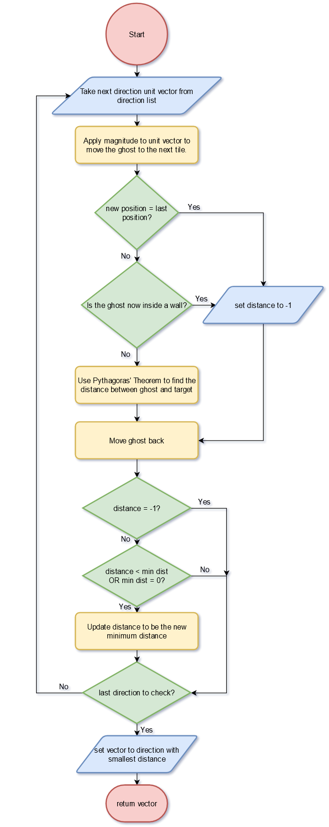

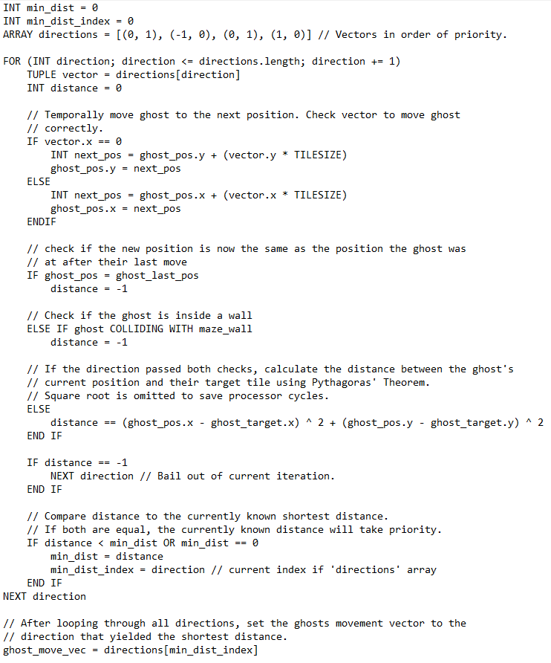

Above is a flow chart and pseudocode of the algorithm that will allow the ghosts to pick a direction that will result in the shortest path to their target. It is designed to be like how the original game decided the next direction each ghost moves in.

The original game had a system in which each direction had priority over each other if the distance calculated from the current direction was equal to the currently known minimum distance. This can easily be implemented by putting the unit vectors inside the direction list in the order of their priority and ensuring that the distance calculated from the current direction needs to be more than - but not equal to - the minimum distance. For example, ‘UP’ is the first direction in the list, so it is the first to be evaluated, its distance will be stored as the currently known minimum distance. ‘LEFT’ is the next direction to be evaluated and yields the same distance as ‘UP’. The comparison between ‘LEFT’s’ distance and ‘UP’s is ‘current distance < minimum distance’, so it will evaluate to false and up remains the shortest distance.

When calculating the distance using Pythagoras’ Theorem, square rooting the distance can be omitted. This is because the ranking of the distances in terms of length will be the same no matter if the distances are squared rooted or not. Some CPU cycles can be saved by skipping square rooting.

### Ghost States

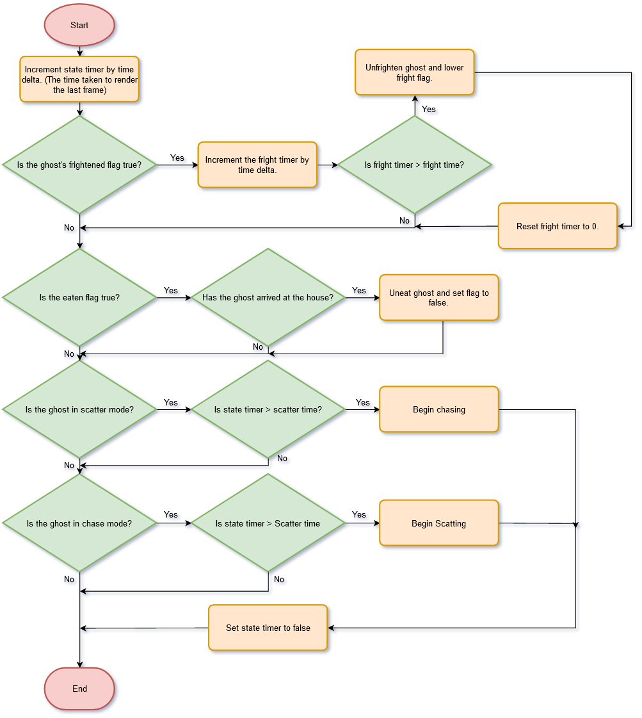

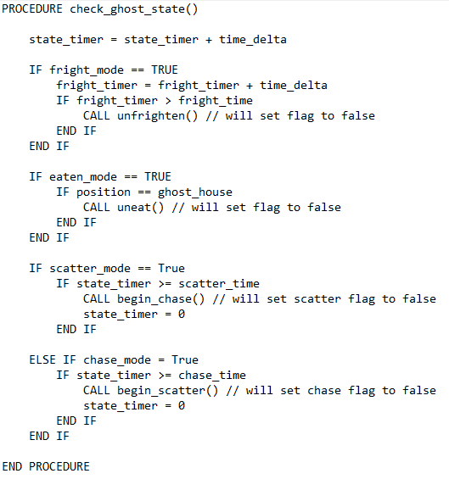Here is the design for determining ghost states, called by each ghost each frame. The method used is a simple timer that increments based on the time taken from the previous frame. This is to ensure that the rate of incrimination does not fluctuate if the frame rate drops or increases. The branching will check how many seconds have elapsed and change state accordingly. I still do not fully know how each ghost will switch states in terms of modifying speed, appearance, etc. That is why they are obfuscated as function calls.

### Game loop

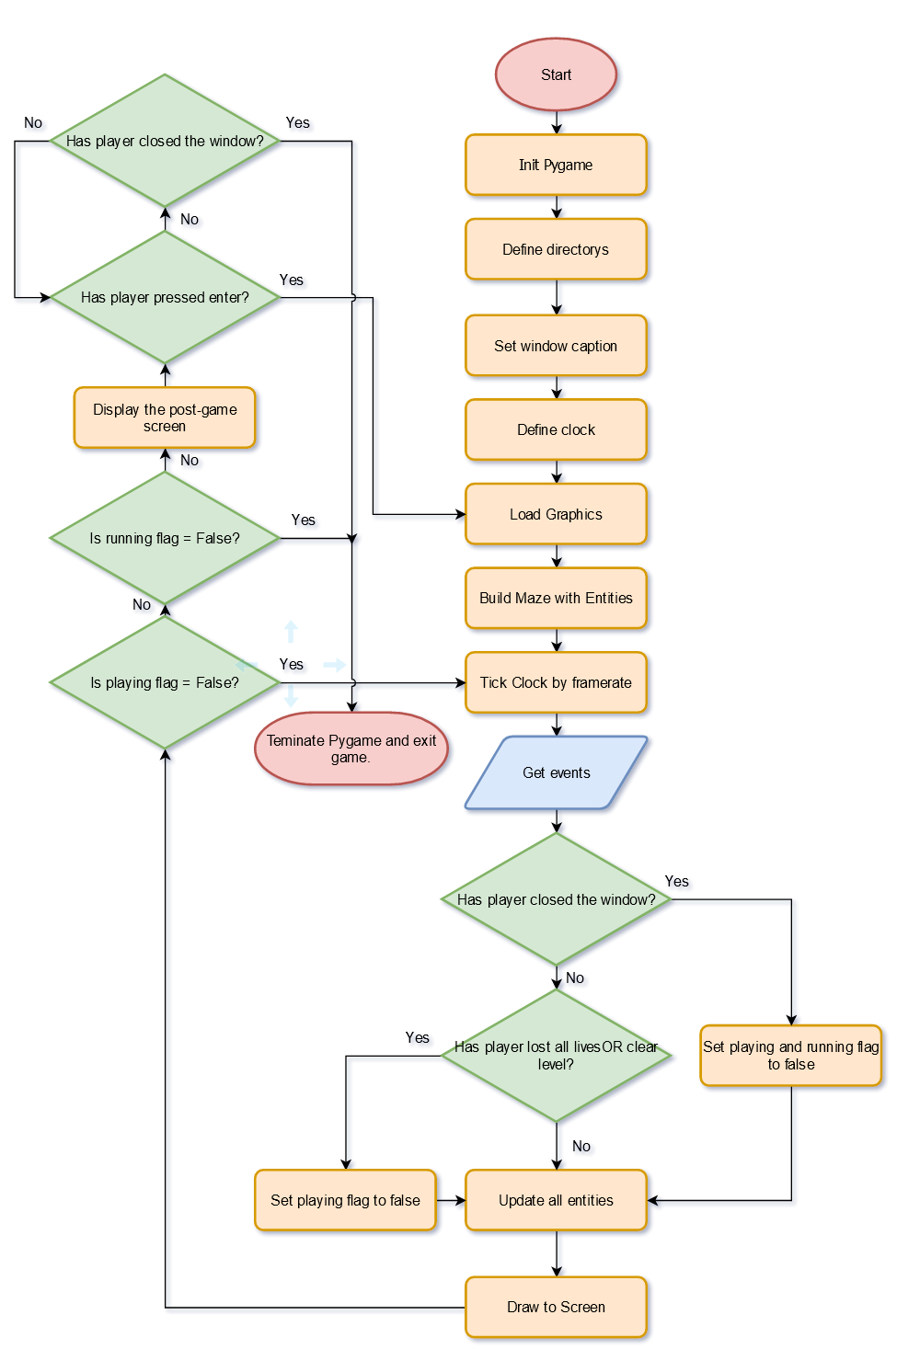

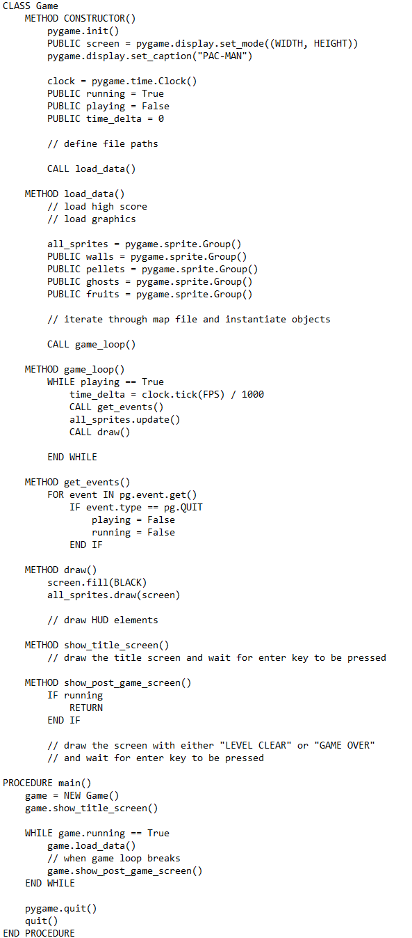

Here is the design of the game class, inspired by Chris Bradfield of KidsCanCode’s Pygame tutorials [3]. This will be the first class to be instantiated.

There are who loops. An outer loop that checks if the game is running or not, and an inner loop that handles the updating and drawing of the game objects. When the inner loop breaks due to the player quitting the game. The outer loop will also break, quitting the game. If the inner loop breaks due to the player passing or getting a game over then the outer loop will not, and the post-game screen will be displayed instead, yet will still break if the player decides to quit at this point. This clever design ensures that the source code is kept nice and small and makes it easy to debug.

### Movement Interpolation

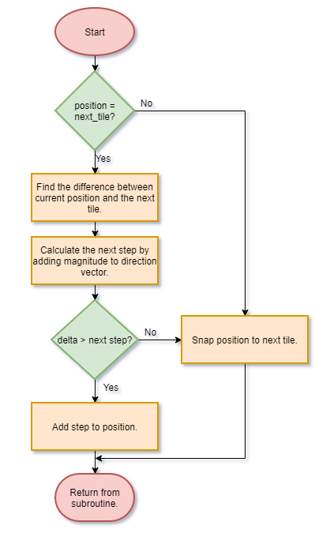

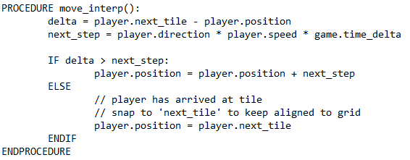

For Pac-man and ghost movement, I wanted to implement interpolated movement. Instead of instantly teleporting to the next tile, they would instead smoothly move over the course of many frames. The movement must allow the player to reverse Pac-man’s direction while transitioning between tiles yet not cause him to become off grid, because then it would become impossible to turn corners into pixel perfect passages.

After searching for some solutions, I found this StackOverflow thread of someone asking how to implement smooth movement in a tile-based game [4]. A user by the name of Rabbid76 responded with a detailed solution that happened to be exactly what I was looking for.

Every frame a method will be called. This method will find the difference between the objects current position and the ‘next_tile’, found every frame. The object’s unit vector is then multiplied by its magnitude and the time delta to get the number of pixels the object should move by in this frame. A check is done to see if the object has over shoot ‘next_tile’. If not then move the object, if so, then move the object, else snap the object’s position to ‘next_tile’.

### Responding to Movement Keys

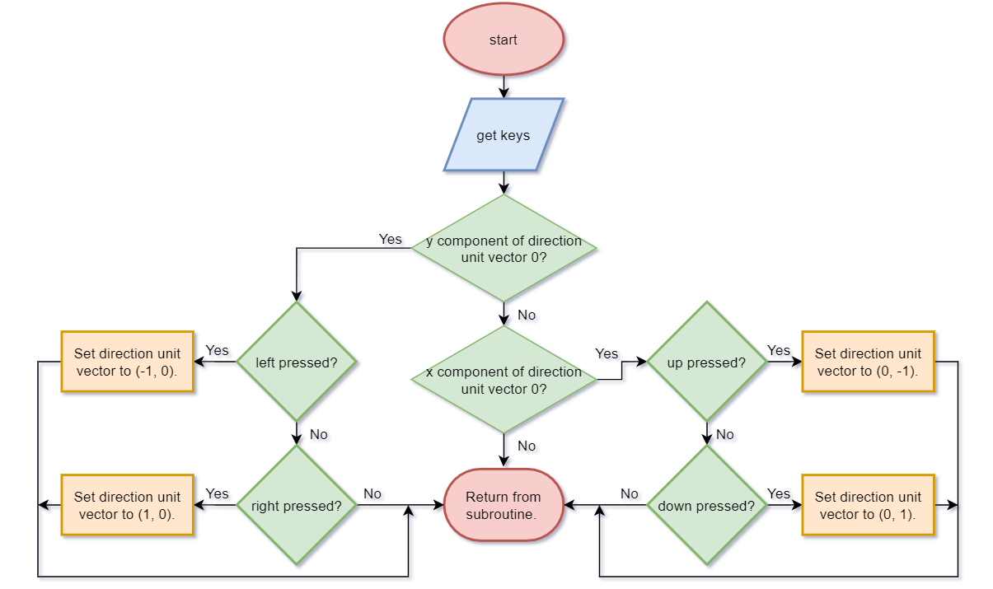

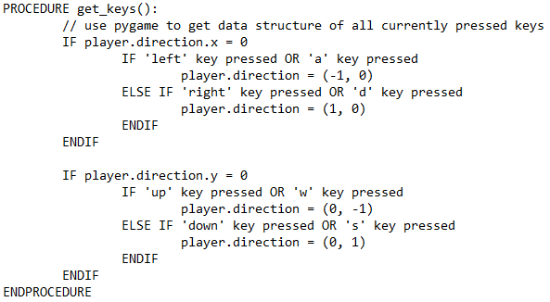

Rabbid 76’s solution also included this method called ‘get_keys’ which is called every frame [4].

This checks the state of every key to see if one of the four movement keys (WASD or up, down, left, right) is pressed, a Boolean OR is used to also check WASD. When a key is pressed, the appropriate unit vector is stored into ‘direction’. The method also checks to see if Pac-Man is not moving horizontally or vertically prior to checking the keys. This makes the method more efficient since it can skip checking half the keys and mitigates any complications with the movement.

## Usability Features: User Interface Controls, and Sprites

One main aspect of my solution is ease of use. This especially pertains to the potential stakeholders of my solution, who would want a quick and easy way to play some version of Pac-Man. There are many ways to approach ease of use for my solution, such as simple controls, a clean user interface that does not serve to confuse and bright, high contrast graphics that stand out from the background.

### User Interface

The various screens are going to have the same over all theme, a black background with white text in an easy-to-read font. This ensures that the information on screen is easy to digest. But I am not just limited to a black background. I can also add in image as a background to make it a little more interesting and compensate for the reduced readability of the text by adding a translucent background behind it, so the image can still be seen without sacrificing the reliability of the text. Due to how Pac-Man is a simplistic game graphically, I believe that going for the first approach will fit the simple theming of the game more closely while also being quick to develop and iterate upon.

During a 2018 GDC talk, game developer Zach Gage explained his approach to visual hierarchy in user interface design, called ‘the three reads’ [5]. This idea is that each visual element of your game should be separated into a primary, secondary, and tertiary read. Each element of the game should be placed into this hierarchy based on its immediate importance to the player with each read separated using size, colour position and so on [5]. So, for example, the gameplay can be split into three reads. The primary read will be maze and the gameplay elements that are housed in it. All of this will be right in the middle of the maze and constantly in the player’s face. Secondary reads will include the score and live gages. These will be more to the side yet still readily available for the player at a quick glance. Tertiary reads include the high score gage and the eaten ghosts. Unless close to the high score, a player is not going to play much attention to that gage and eaten ghosts are no threat to the player so I can get away with them just being a pair of eyes. I will try and incorporate this UX design approach as much as possible in my project. While I can just ignore this, it does serve to moderate the elements that are shown at any one time. Adhering to the simplistic theme of Pac-Man, thus catering to potential stakeholders. If I did not consider this then the game may appear too complex and drive them away.

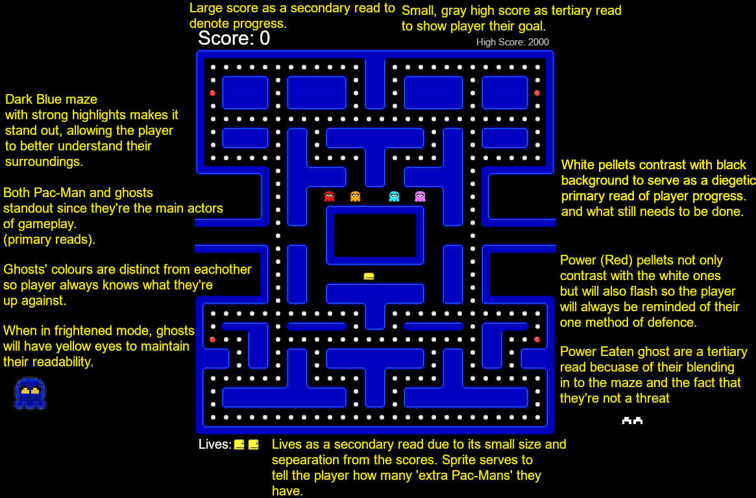

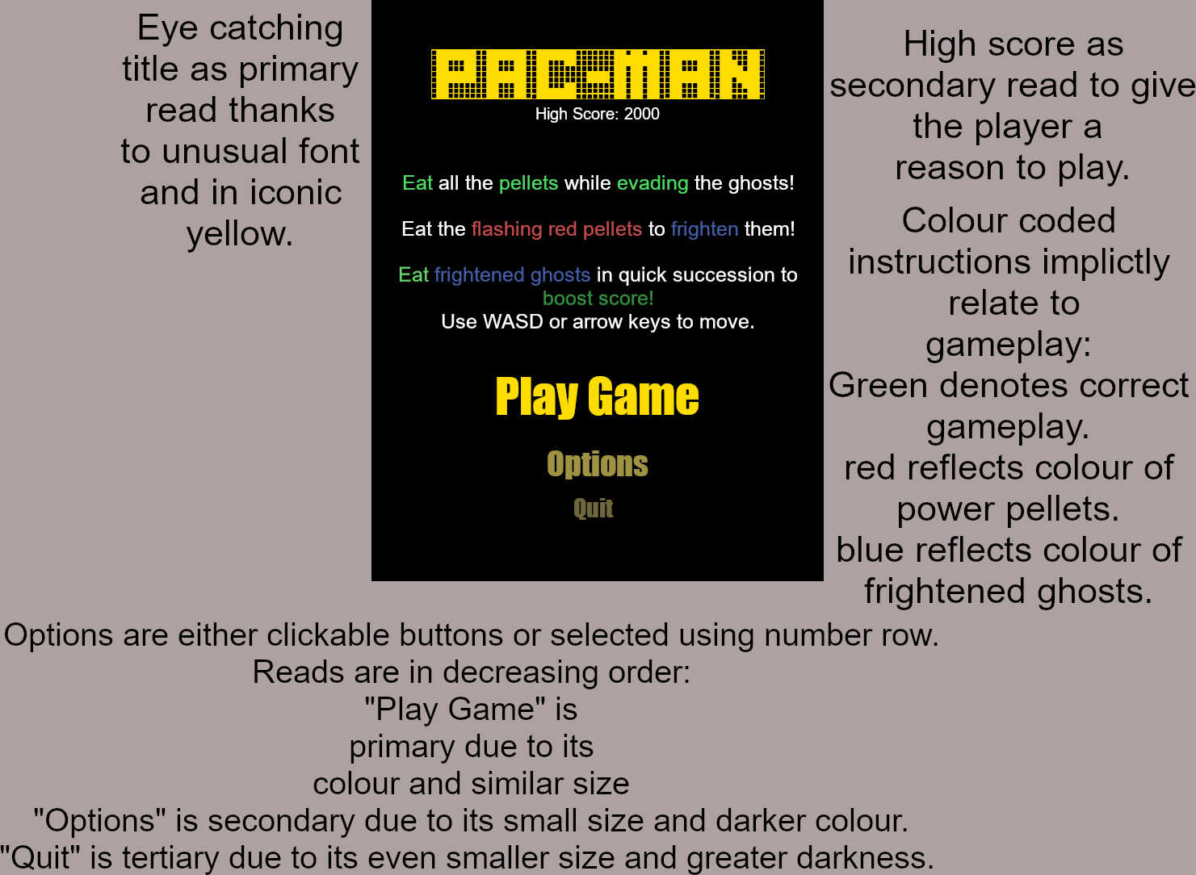

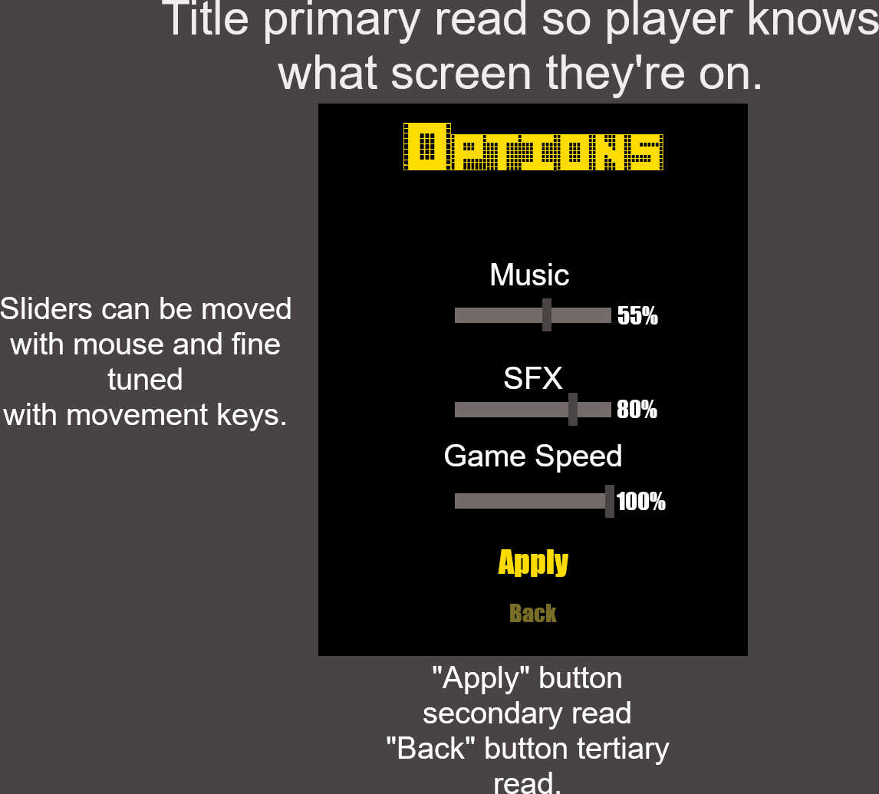

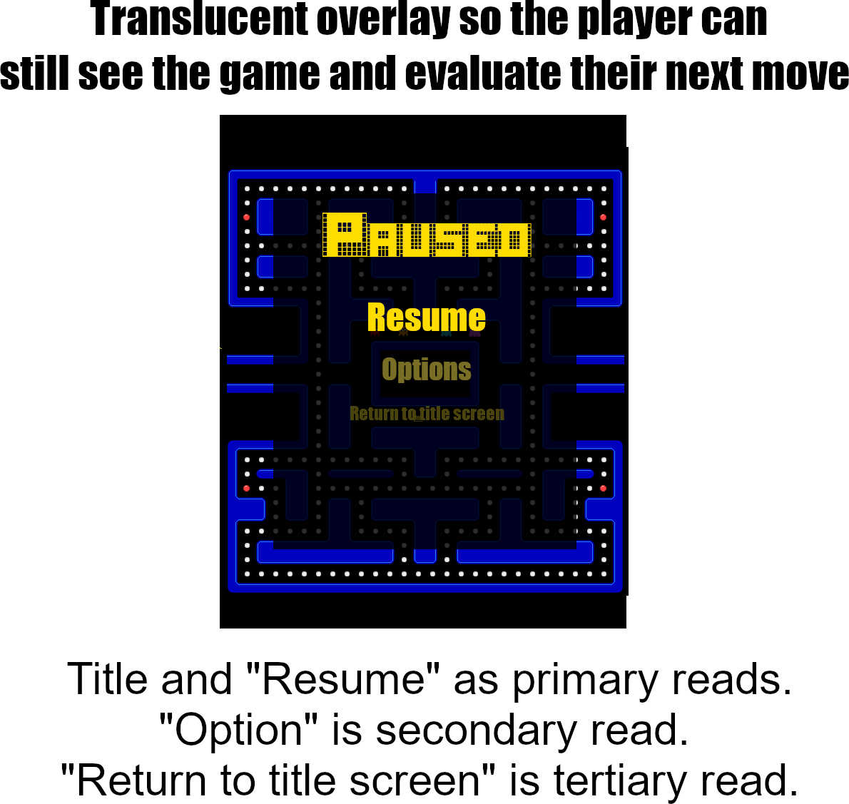

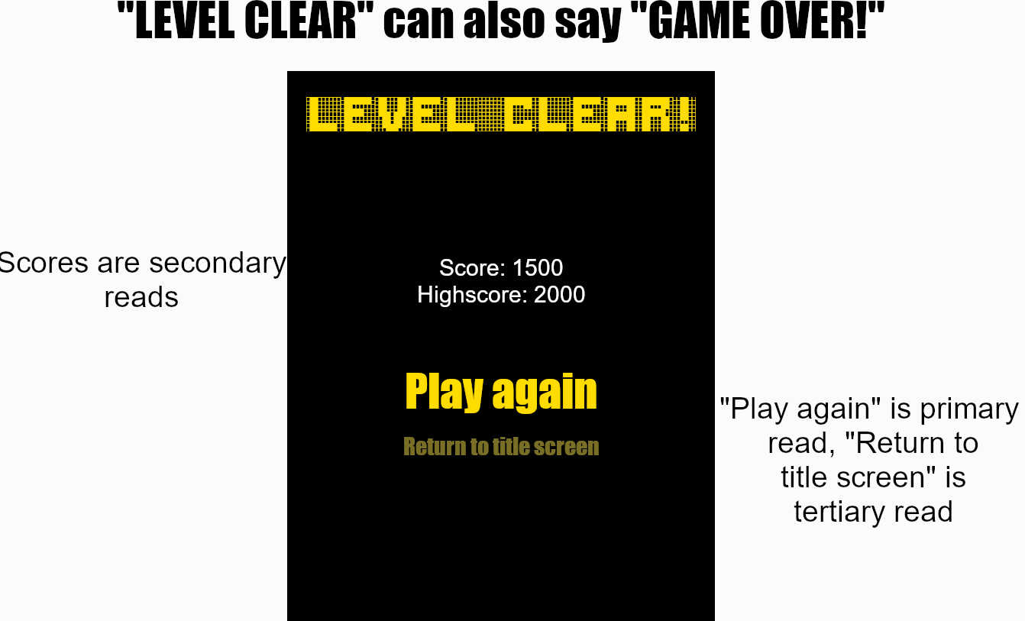

### Controls

Pac-Man’s controls should be simple enough to move Pac-Man with ease. The controls will make the player hold down a movement key to make Pac-Man move in the corresponding direction. While this may be a suitable method of movement, I am informed that other versions of Pac-Man do it in a different way. Pacman Doodle has the ability for Pac-Man to move in a direction at the press of a key, no holding required. Subsequent movement key presses will be memorised, and Pac-Man will move in that corresponding direction when possible [6]. While this does seem like a great accessibility feature, I am afraid that it may lead me to dwell too much on movement; leaving not much time to incorporate other, equally important features of the ghosts. For now, I will pursue implementing the holding approach. If any stakeholders and or play testers complain about the controls, then I would consider adding Pacman Doodle’s method more.

### Sprites

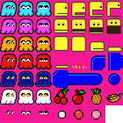

This is the sprite sheet for the game. A sprite sheet has several advantages over having separate image files. A sheet can be algorithmically ‘sliced’ into separate sprites and loaded at run time. This makes the sheet quite extensible since I can just add more sprites without having to worry about adding a dedicated line to load it in. Having a single image for all the sprites cleans up the file structure of the project and reduces the amount of reads from secondary storage since all sprites will already be in memory, improving overall performance.

The sprites are adapted from an entry on OpenGameArt by the author drakzlin [7]. I took the sprites that were the most relevant to the game and pellet swapped them using GIMP’s colour exchange feature. I lightened up the blue on one of the ghosts so it resembled the appearance of Inky more and to better contrast with the background. I added new sprites that all the ghosts will temporarily change to when frightened, they will flash between dark blue and white right before the state wears off to prepare the player for the resuming chase. Another set was added for when a ghost is eaten. This is to indicate that a ghost is harmless and is retreating to the house.

I also palette swapped the Pac-Man sprites from the original sheet from blue to yellow. Not only does it now resemble the Pac-man original game more, it also makes him more visible on the black background. I made a death animation from the existing sprite work to indicate that the player has been caught.

I added an extra animation frame to the power pellet, so it flashes and draws the player’s attention. This is also the reason why the power pellet is slightly bigger than the normal ones.

## Key Variables, Data, Structures and Classes

### UML Diagram Example

To further demonstrate why I am using OOP, below is a Unified Modelling Language (UML) diagram demonstrating the contents and inheritance of the classes. UML diagrams are a good show case of how classes inherit from each other. Which is a key component of my solution’s structure.

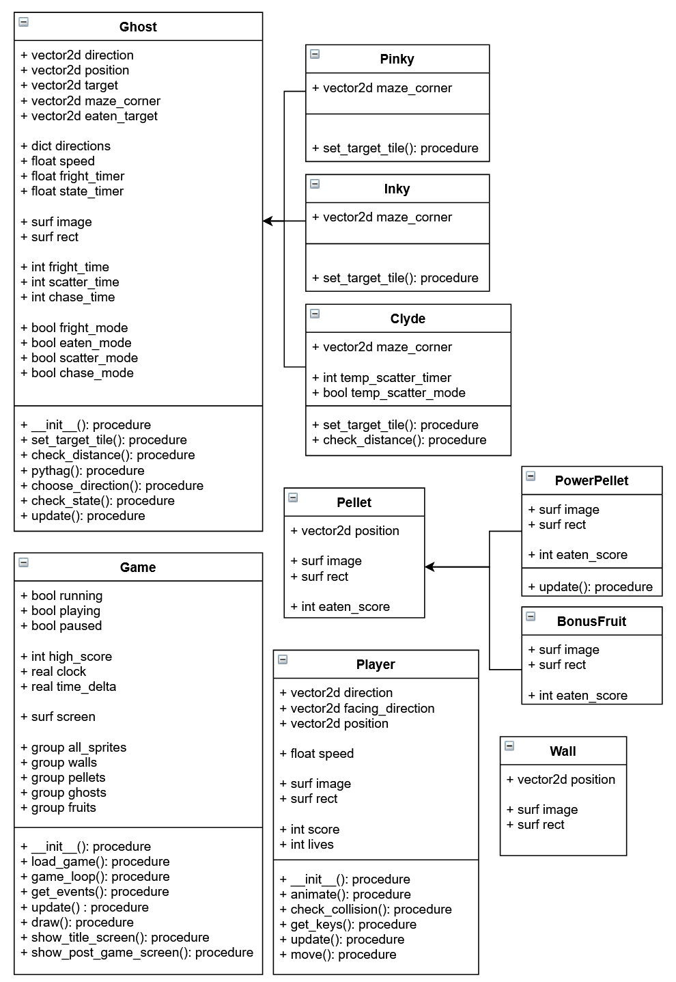

There is a parent class called ‘Ghost’. It will hold all the attributes and methods required for a ghost to function. This includes movement, states pathfinding, etc. The other ghosts will inherit all the code from this ‘Ghost’ class and override the necessary components for their unique behaviour. For example. The method ‘set_target_tile’ in the ‘Ghost’ class would set the attribute ‘target’ to Pac-Man’s position, but this method will be overridden by Pinky and instead target four tiles ahead of him, and Inky will override the method with his own unique behaviour. Each child ghost will also override the ‘maze_corner’ attribute so they all scatter to their own corner.

Clyde is a bit of a special case. Due to how he needs to check how close Pac-Man is, he has more functionally than the others. To account for this, the method ‘check_distance’ in the parent class is a dummy method, it has nothing inside it, yet is still called. Clyde can override this method to implement the distance check and thus add the functionally for himself, but not for the parent class.

### Explanation and Justification of Class Attributes and Methods

#### ‘Game’ Class

|  |  |  |  |
| --- | --- | --- | --- |
| **Key Attributes/Methods** | **Data type/Structure** | **Description** | **Justification** |
| playing | Boolean | A flag to check whether the player is in gameplay or not. When this flag is lowered, the game loop will break. | Works in tandem with the ‘running’ flag. If the player dies or wins, the ‘playing’ flag will lower, but ‘running’ will not. This means that the game will not bail from the method to display the post-game screen. |
| running | Boolean | A flag to check whether the player has quit the game, either via the close window button or an in-game quit button. | Works in tandem with the ‘playing’ flag. When the player quits, both flags will be lowered. Skipping the method, it display the post-game screen and straight to the method to quit Pygame. |
| clock | float/real | Increments or “ticks” by the framerate after each frame. | Ensures that the game to able to update correctly after the end of each iteration of the game loop. |
| time_delta | float/real | Counts the number of milliseconds it took to render the last frame by dividing the clock’s “tick” by 1000. | Helps to ensure that timers and movement are dependent on time rather than framerate.  For example, let’s say that the framerate drops from 60 to 30FPS. When calculating Pac-Man’s next position for the upcoming frame, the delta can be used to rebase that calculation (next_step = unit_vector * magnitude * time_delta). Pac-Man will still move at a consistent speed.  This can be extended to timers as well (e.g. state_timer += time_delta). Ensuring that timers increment at a constant framerate no matter the framerate.  Doing this guarantees that the gameplay will remain consistent no matter the specs of the hardware it’s running on. |
| load_game() | method/procedure | Loads external data such as the sprite sheet, maze sound files etc. This is also where graphics will be sliced, and entities instantiated. | While it is possible to implement data steaming, so assets are retrieved from secondary storage, loading everything into primary storage is simpler to program and circumvents complex memory management, which could incur memory leaks. I/O bottlenecks can also be a problem that can negatively impact performance.  Plus, the memory requirements for my game are low enough to justify it all being in primary storage. |
| game_loop() | method/procedure | Contains a conditional loop that ticks the clock, calls each sprites ‘update()’ method and draws everything to the screen. | This is the backbone of the entire game. Without this iteration, it would be impossible to make the game run for an arbitrary number of frames. It is also the backbone for gameplay and graphics. |
| update() | method/procedure | Iterates through each entity in the ‘all_sprites’ group to call their update() method. Which includes movement and checking states. | While I could add a line to call each entity’s update method. This is a neater way as it allows an arbitrary number of entities in the ‘all_sprites’ group. |

#### Player Class

|  |  |  |  |
| --- | --- | --- | --- |
| **Key Attributes/Methods** | **Data type/Structure** | **Description** | **Justification** |
| direction | 2dVector | A unit vector that corresponds to the movement key that is being pressed. For example, if the player is pressing ‘left’ then the vector will be (-1, 0).  The ‘speed’ attribute will apply magnitude to this vector. | One advantage of unit vectors is that they store velocity. By applying magnitude this vector, both the speed and direction of the player is known.  Unit vectors means that I can have a separate attribute for direction and speed. I can modify the speed without modifying the vectors themselves.  I can also apply a different magnitude to it. If an explicitly stated the speed in the vector, then I will not be able to apply magnetite to find Pinky’s target tile for example. |
| facing_direction | 2DVector | A unit vector that stores the direction Pac-Man is facing. It is derived from ‘direction’. Pinky applies a magnitude of two tiles to this vector to find her target tile. | One advantage of unit vectors is that they can store velocity. By applying magnitude this vector, Pinky can find her target tile. |
| position | 2dVector | Stores the pixel position of Pac-Man. The origin point ((0, 0)) is at the top-left of the screen. | Using Pygame’s vector data structure rather than storing the x and y components in separate attributes or a tuple. comes with some nice advantages. I can ensure that both components of the vector are manipulated when performing arithmetic on it. Yet I can still manipulate a single component using dot notation (e.g., position.x += 10) |
| speed | float/int | The magnitude that applied to the unit vector to get the numbers of pixels he should move per second. | Applying magnitude to a unit vector rather than specifying the speed in the vector allows me to modify the speed without directly manipulating the vector. |
| score | int | Stores the player’s current score. | While a could have added this attribute to the ‘Game’ class to avoid using getters when it comes to comparing to the high score, a score is something personal to be player. It makes more sense in an object-oriented point of view. |
| lives | int | Stores the number of lives the player has. | Like ‘score’ it makes more sense to make this an attribute of the player. |
| animate() | method/procedure | Advances to the next frame of the eating animation. Uses a delay so that the animation frame does not advance every game frame. | Doing this in a separate method makes the code more modular and allows it to be called for other animations, like the death animation. |
| check_collision() | method/procedure | Checks whether Pac-Man has collided with pellets or ghosts. | A separate method keeps to code modular, maintainable and the ‘update()’ method clean and legible. |
| get_keys() | method/procedure | Checks whether any of the direction keys have been pressed and updates ‘direction’ and ‘facing_direction’ accordingly. | A separate method keeps to code modular, maintainable and the ‘update()’ method clean and legible. |
| move() | method/procedure | Moves Pac-Man a step towards the next tile each frame. The time delta is used so that his movement speed is time based. | A separate method keeps to code modular, maintainable and the ‘update()’ method clean and legible. |

#### ‘Ghost’ Class

|  |  |  |  |
| --- | --- | --- | --- |
| **Key Attributes/Methods** | **Data type/Structure** | **Description** | **Justification** |
| target | 2dVector | Stores the position of the target tile the ghost will traverse towards. | Without this attribute, the ghosts would not be able to intelligently traverse the maze. Random movement may be used instead, which is far less interesting and cuts a lot of the algorithmic complexity of the solution. |
| maze_corner | 2dVector | Stores the position of the maze corner each ghost will travers towards while in scatter mode. | Without this attribute, the ghosts would not be able to correctly behave while in scatter mode. |
| eaten_target | 2dVector | Stores the position of the tile each ghost will traverse to while in eaten mode. Once they arrive, they will become uneaten. | Without this attribute, the ghosts would not be able to become uneaten again, removing all the challenge from the game. |
| directions | dict/list/array | Stores the four cardinal directions each ghost can move in. These vectors will be iterated through during the direction decision algorithm to check their eligibility to move in. | Storing these vectors in a data structure makes it easy to iterate through using a count-controlled loop. This iteration is essential for the algorithm to work and must be clean and efficient. ‘directions’ helps achieve that. |
| fright_timer  state_timer | float/real | Timers that increment each frame. ‘fright_timer’ is incremented only while in frightened mode, ‘state_timer’ will be paused as well.  When each timer reaches a threshold, they are reset to zero and the appropriate action is performed. For the ‘fright_timer’ that is unfrightening each ghost and for the ‘state_timer’ that is toggling between scatter and chase mode. | These timers are pivotal for the state switching. Without them the ghosts will always be in scatter or chase mode or always in frightened mode. These timers are important for the game’s dynamism. |
| fright_time  chase_time  scatter_time | int | Stores the duration of each state. When the timers reach these thresholds, they reset to zero. | While these integers could be hard coded (magic numbers) storing them in attributes is much more malleable and sustainable. These attributes can be modified depending on the level for example. The higher the level the less time the ghosts spend scattering. |
| fright_mode  eaten_mode  scatter_mode  chase_mode | Boolean | Flags to check what state a ghost is in. | Allows for the timers to increment correctly, for example, if a ghost has entered frightened mode. ‘fright_flag’ is raised. The game then checks if fright flag is raised, if so, skip the incrementation since the ghost is not in a normal state. |
| set_target_tile() | method/procedure | Finds the target tile for the ghost to traverse to while in chase mode. For the ‘Ghost’ class it is Pac-Man’s position. | Separating this into a method allows it to be overridden by the child ghosts. |
| check_distance() | method/procedure | A dummy method that is overridden by Clyde. Clyde will use this to check how close Pac-Man is to him. If he is within an eight-tile radius, then he will scatter. | Clyde has added functionality compared to the other ghosts. Using a dummy method that is called every frame ensures that Clyde can add this functionality. |
| pythag(x1, y1, x2, y2, sqroot) | method/function | Calculates the distance between two positions using Pythagoras’ Theorem. | Making this a method allows it to be called anywhere. |
| choose_direction() | method/function | The direction decision algorithm. Evaluates each direction and returns the unit vector that corresponds with the shortest distance between the ghost and target tile. | Without this algorithm, the ghosts will never be able to traverse the maze like they did in the original game. While I could just make the ghosts more randomly, doing so would greatly reduce the algorithmic complexity of the solution and results in much less interesting gameplay. |
| check_state() | method/procedure | Consists of a series of branches that checks the current state of the ghost and reacts accordingly. It also increments and checks the timers. | Without this, the ghosts will never switch states, resulting in far less interesting gameplay. |

#### ‘Pellet’ Class

|  |  |  |  |
| --- | --- | --- | --- |
| **Key Attributes/Methods** | **Data type/Structure** | **Description** | **Justification** |
| eaten_score | int | Stores the amount of points the player should gain upon eating a pellet.  Will be overridden by both the ‘PowerPellet’ and ‘BonusFruit’ classes to have their own score. | This score is something personal to all edible items in the game, therefore it should be stored inside them as an attribute. |

## Required Validation: Testing to Inform Development

To ensure that development goes smoothly, validation checks are necessary. For an action game like this, the only input validation would be player input. Gameplay validation includes squashing bugs like going through walls, ensuring that animations play correctly, collision works correctly and so on.

|  |  |  |  |  |  |  |  |
| --- | --- | --- | --- | --- | --- | --- | --- |
| **Module/ routine** | | **Input/File input** | **Validation rule(s) used** | **Explanation of validation rule(s)** | **Justification of validation rule** | **Test data** | **Justification of chosen test data** |
| Maze loading | | Text file | Format and presence check. | Checks to see if the ‘maze file’ is of the correct format and reads each character accordingly. | This will guarantee that the maze will render correctly. | A text file containing characters representing each entity and maze walls along with characters that do not represent anything. | To check how the maze building algorithm handles characters that do not represent any game entity. |
| Player Input | | Player pressing the movement. | Closed input | The player presses the movement keys and see Pac-Man move accordingly. | To see if pressing the movement keys does make Pac-Man move. | The player pressing two movement keys at the same frame. | To see how Pac-Man reacts to two keys being pressed at the same frame, namely what direction he should move in. |
| Collision checks against pellets, ghosts, and walls. | | The position of both Pac-Man and entities. | Presence check | Pac-Man checks to see if he has collided with a ghost, pellet or wall each frame, | To see if Pac-Man can correctly collide with the relevant entities. | Pac-Man meeting one or more of these entities. | To see how Pac-Man will react to colliding with objects. |
| Ghost direction validation. | | The position of the ghost and walls. | Presence check | The ghosts should invalidate directions that lead to a wall or cause a U-turn | To see if the ghosts can rule out the correct directions, only calculating the distances of valid directions. | The ghost at a corner, where two directions lead to a wall and another causes a U-turn. | Tests both direction validation checks. |
| Scores and lives | | The type of entity that Pac-Man collided with. | Presence check | Pac-Man should louse a life when touching ghosts and gain points when touching pellets and fruits. | To see if Pac-Man can correctly gain points and lose lives. | Pac-Man colliding with a pellet and ghost and the same time. | To see whether losing a life has precedence over gaining points. |
| Ghost states | | The state of the timers and flags. | Length check | The ghosts should change states depending on the state of flags and timers. | To check if the ghosts will correctly change states. | Checking if they move to the maze corner, flash during frightened mode and reacting to being eaten or seeing a power pellet being eaten. | This encapsulates all the opportunities for a ghost to change states. |
| Resetting positions. | Pac-Man dying. | Presence check | Both Pac-Man and the ghosts should reset positions upon Pac-Man dying. | To see if they will reset their positions. | Pac-Man getting caught by a ghost. | This is the only moment in which positions should be reset. |

## Planning Post-Development Testing

Since I am making a game, post-development test data is more limited than say if I was making a database. With a database test data to easy to come by, it can be the various user inputs into it. With a game the only data going in is user input and arguably the high score.

To compensate, my post-development testing will consist of a large compilation of testing the solution against the success criteria, with a video showing proof of the game either achieving, partly achieving, or failing each criteria entry.

# Developing the Solution

## Iteration 1 –Setting Up

The first stage of development is to make the ‘skeleton’ of the game’s code. This stage can be generalised to any Pygame project.

I have created a script called ‘main.py’. This is where the game’s initialisation, updating, drawing and game loop will reside. Other scripts will import in this file to make use of its variables, functions, objects, etc. Next was to create two other scripts: ‘settings.py’ and ‘sprites.py’. Settings houses all the constants used in the game; these will be used all throughout the other scripts. ‘sprites.py’ contains all the game’s entities as classes which are instantiated by the main script. Decomposing the code base across multiple files makes the code easier to navigate through and understand, thus speeding up development time.

At the start very start of the project Pygame is imported with the alias ‘pg’, to make it easier to type. The ‘path‘ function is imported from the ‘os’ module to ensure that any use of file paths in the code remains platform agnostic. ‘sys’ is used to safely exit the program. And finally, the other scripts are imported with a wildcard, so that the folders so the scripts’ variables and methods do not need to be prefixed with the name of their respective script.

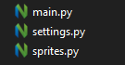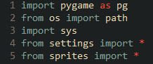

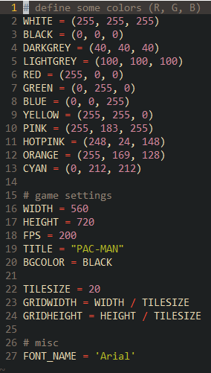Next is to populate the settings script with constants. Having all the constants in one file makes it easy to change values and ensures that the change will be reflected throughout the game.

Now its to create a class called ‘Game’ inside main, this will be responciable for initallising Pygame, the window, loading data, managing the game loop and checking the game’s state. These jobs will be encapsulated into separate methods. To help with further mainitance of the game, I opted to use python’s docstrings. There are multi-line comments placed just below a subrotine’s definition, great for describing what the routine does and the purpose of each paramiter.

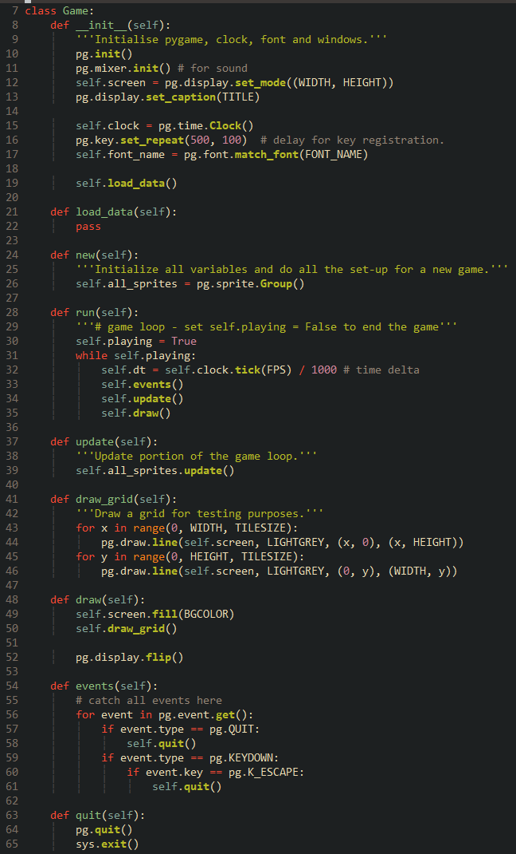

To instantiate the game I call a subrotine called ‘main’ at the start of execution. This will instatiate the game and falls into an infinite loop that calls the run method, which will in turn call the ‘run’ method and and game loop. The reason why these methods are under a infinite loop is to make the future implemtation of multiple screens easier. When the player gets a game over. The loop will terminate and the ‘run’ method will return back to ‘main’ another method is then called to show the game over screen. If the user wants to play again, the method will return and both ‘new’ and ‘main’ will be called again to start a new game.

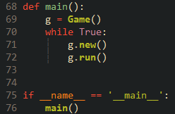

Upon running the main script. Pygame will initallise and display a window of 560x720 pixels, with a black background, gray grid and apporiate title. Clicking on the close window button will close the window and exit the game as expected The next step is to populate this window with the maze.

### Reflection

While it may seem like not much happened, this is arguably one of the most important iterations in all of development. Without the window and screen, the player would have no way of interacting with the game. The ‘skeleton’ of game is also important as it will provide an extensible foundation in which the rest of the game will be added to. The smooth development of all subsequent iterations relies on the quality of this initial code.

Next is to render the maze and populate it with the maze and pellets.

|  |  |
| --- | --- |
| **Done** | **To do next** |
| Make the game boot up and display a window. Allows the player to interact with the game. | Render the maze to house gameplay. |
| Create the ‘skeleton’ of the game. Provides an extensible base to implement mechanics. | Efficiently load in and render pellets to eat. |

## Iteration 2 – Creating and Populating the Maze

After a bit of searching, I found a neat method to generate the maze, it involves using a text file that is used as a ‘map’ of sorts, each character represents an object at that position. The program then parses the file to create the right objects in the right places [8].

First, I created a file called ‘map.txt’. I then used an image of the original maze to place all the walls and pellets in the correct places, this was the result.

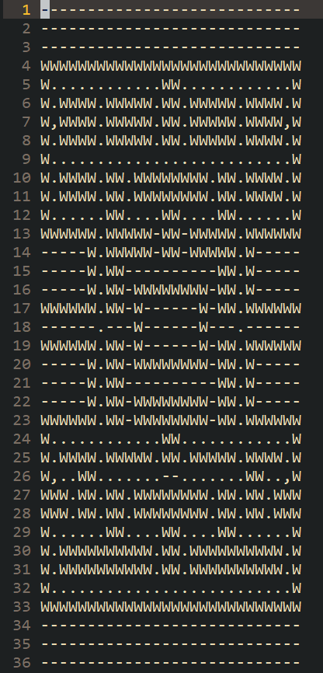

Hyphens mean an empty tile, W means a wall, full stops mean a pellet and commas mean a power pellet.

Over in the main script, I added to the ‘load_data’ method to open the map file and append each character into a list.

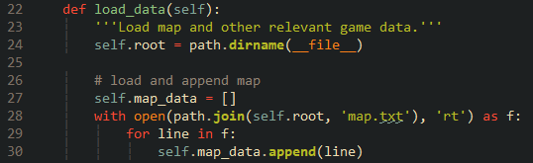

Before parsing the list, I needed to create the classes for the entities in the file inside the sprites script, the first one was the walls.

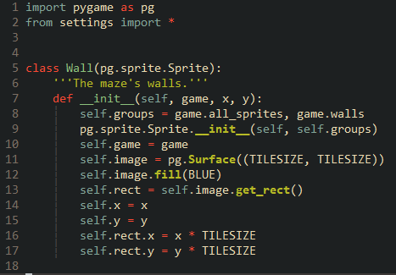

This is a simple class definition, upon instantiation the sprite will add itself to the defined groups initialised by the game, all the attributes and variables inside the game object is passed into the wall sprite. This allows for attributes to be easily accessed without breaking the rules of encapsulation.

Back in main I declare a walls sprite group and use nested iteration to parse each character.

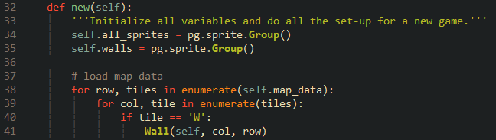

The code will read the data in a row-by-row fashion, ‘row’ and ‘col’ holds the current index, or it other words, the current x and y coordinates of a tile.

Upon running the game, no walls appeared, that is because I forgot to add a line in the draw method that draws all sprites onto the screen.



After adding that line, the walls render correctly.

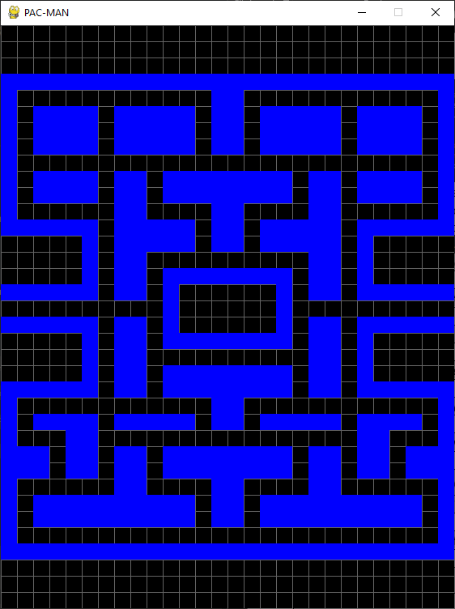

While this method does successfully render the walls, the nested iteration does mean this algorithm does have a polynomial time complexity of ${O(n}^{2})$. When I begin to add more entities to the maze, the time taken for this algorithm to complete will increase. After I get the ghosts fully implemented, I will focus in making this algorithm more efficient. I am thinking of storing all the entities inside of a dictionary instead of using an else if chain to find the correct entity. While I do not think I can get away with not using nested iteration, the process of finding an entity will be at least a constant time complexity of $O(1)$.

Adding the pellets was a similar process, but instead of solid blue block (‘rect’ in Pygame), they will be images. This is because I struggled to get the pellets in the middle of a tile when they were just rectangles, they were going to be replaced with images eventually anyway. Later, I will implement a system to get the images from a sprite sheet, but for now the images can reside as separate files inside a directory called ‘img’.



The pellet class is like that of the wall, but this calls a method to load in an image. It uses the parameter ‘typ’ to determine the correct image to load. The ‘os’ module’s ‘path’ function is now included in the sprite script to help load the image. ‘vec’ is a variable name given to pygame’s 2d vector feature, vectors will become very useful once I begin work on the ghost’s movement.

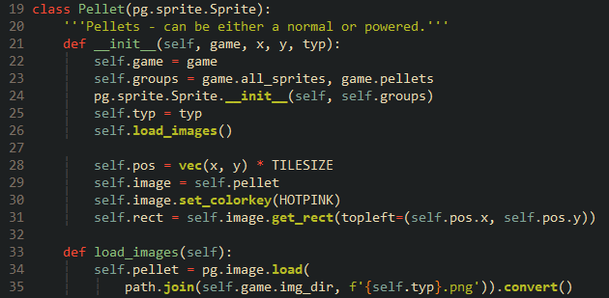

The new directory is defined inside load_data at main…

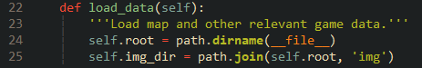

and a new sprite group is added along with two else if statements for the maze generation.



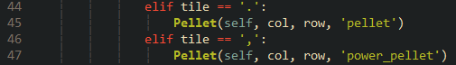

The pellets are now rendered. Now it is time to create Pac-man and program his movement.

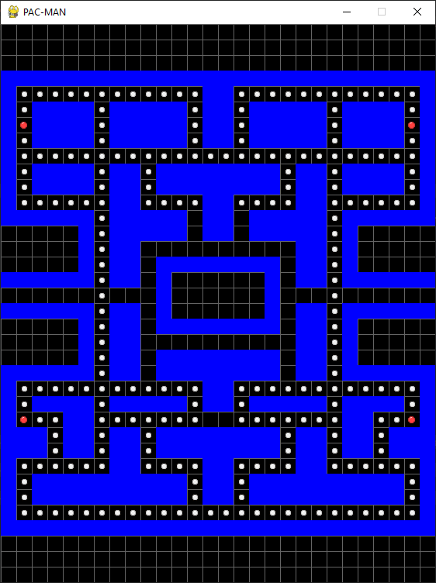

### Reflection

The maze is now implemented, providing the ample space to house all the gameplay. I may in the future redesign it to match the concept more closely. But that is quite low on my list of priorities now.

Naturally, the gameplay should start being developed. The best place to start is with Pac-Man, the main star of the game.

|  |  |
| --- | --- |
| **Done** | **To do next** |
| Render the maze with all the walls in the correct places. | Load in Pac-Man |
| Efficiently load in and render the pellets, including power pellets. | Make Pac-Man controllable by the player. |
|  | Make Pac-Man smoothly move between tiles while keeping aligned to the grid. |
| Make Pac-Man collide with the maze’s walls in a pixel perfect manner. |

## Iteration 3 – Pac-man’s Movement, Collision, Wrapping and Score

I began with creating Pac-man’s class (called ‘Player’). The __init__ method is about the same as the other sprites just with the inclusion of several extra attributes to make the solution work.

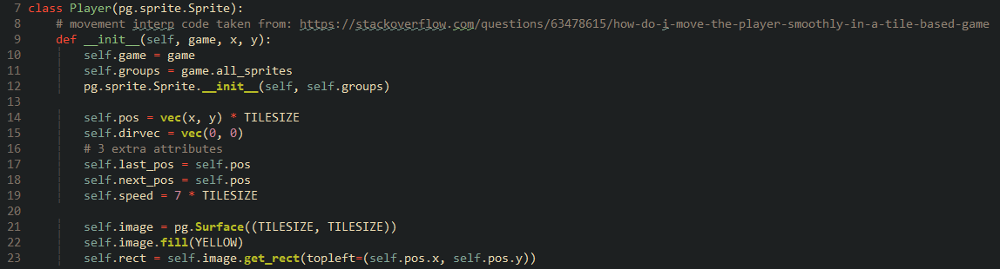

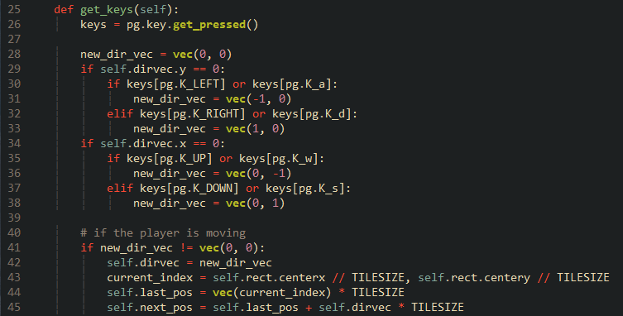

The ‘update’ method is where the actual interpolation is done.

If Pac-Man’s position is not equal to next tile, a delta between his current and next position is calculated along with the number of pixels Pac-man could move this frame (next_move). The time delta (dt) is included in the latter to ensure that the number of pixels Pac-man moves is not dependant on the framerate, but rather on the time it took (in milliseconds) to render the last frame. If the framerate ever drops, Pac-Man will not slow down.

A check is then done to see if Pac-Man is not going to overshoot the next tile. If he will not, then he can move the calculated number of pixels, else snap him to the new tile and halt his movement.

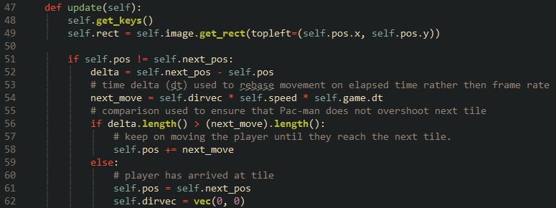

After doing the now typical process of adding Pac-Man to the maze, he moves as expected, but phases through walls.

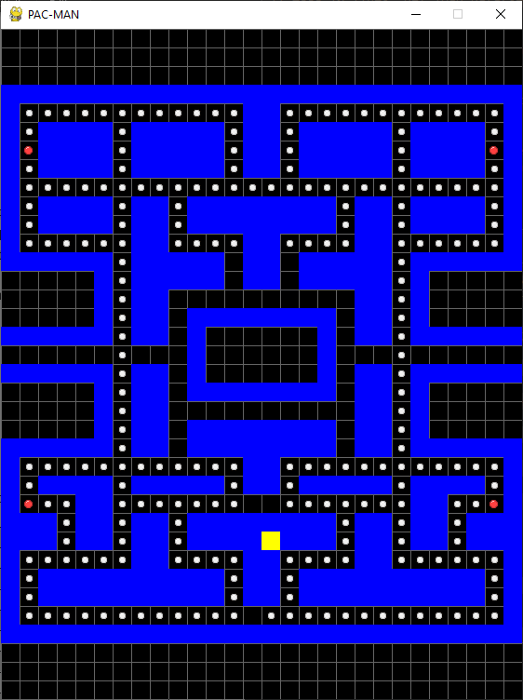

Adding a simple collision check in the ‘update’ method will allow him to collide with the walls. A collision check against the pellets can also implemented, with a new attribute called ‘score’, incrementing every time Pac-Man collides with one.

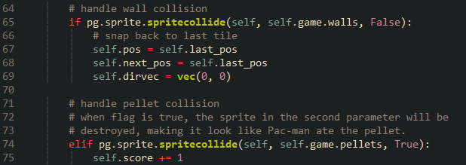

Maze wrapping also be implemented inside this method, these are position checks. Note that the position of every sprite is defined at the top left.

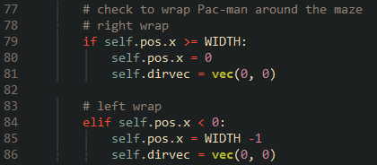

To display the current score to the player, a ‘draw_text’ method is defined in the ‘game’ class. This method it then called inside the ‘draw’ method will all the appropriate parameters.

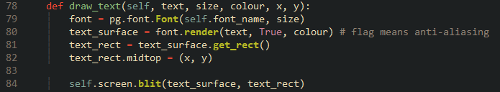

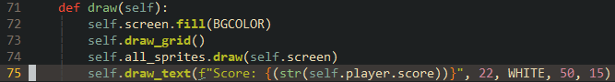

Now Pac-man able to collide with the walls while eating pellets to increase the score.

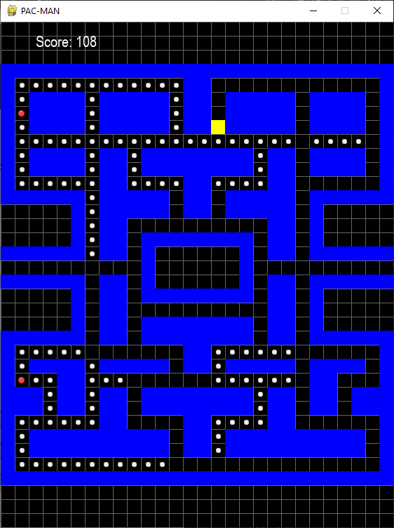

### Reflection

Pac-Man’s movement is working, but that does not mean it is perfect. Over development I will regularly review the movement and respond to feedback from my stakeholders in ways to improve it, as it is the core of the user experience.

Implementing the ghosts are next, in terms of movement it is an extension of Pac-Man’s. It is the direction decision algorithm that is the most interesting aspect.

|  |  |
| --- | --- |
| **Done** | **To do next** |
| Load Pac-Man into the maze. | Create the ‘Ghost’ Class to implement Blinky. |
| Make Pac-Man controllable by the player. | Program the direction decision algorithm to allow ghosts to move towards a target tile. |
| Make Pac-Man smoothly move between tiles while keeping aligned to the grid. | Make the ghost smoothly move towards the target tile. |
| Make Pac-Man collide with the maze’s walls in a pixel perfect manner. |  |

## Iteration 4 – Programming Ghost Movement

The original arcade release of Pac-man uses a simple yet elegant algorithm to navigate the maze to reach a destination using shortest path, while not as sophisticated and robust as Dijkstra or A*, it still uses algorithmic practices such as iteration.

The first ghost to be added will be Blinky. Blinky has the simplest behaviour out of the four, all he does is make a beeline straight towards Pac-Man. Once his movement and targeting is incorporated, implementing the other ghosts should be relatively easy.

First things first is to create a class for Blinky called ‘ghost’. Its attributes are mostly the same as Pac-Man’s, except for three new attributes: a vector called ‘target’, a dictionary called ‘directions’ (since python does not support defining a list with tuples inside, I had to use a dictionary) and a flag called ‘between_tiles’.

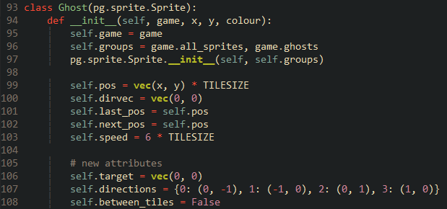

A new method called ‘check_dist’ is created, this will iterate through all four cardinal directions and pass them into a nested method called ‘eval_dist’, which will check if the direction causes the ghost to move into a wall or make it U-turn. The index of the appropriate axis to add magnitude to is passed into the nested method.

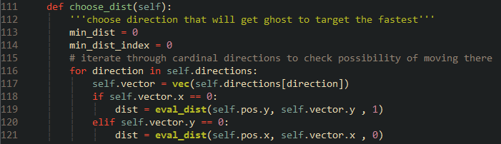

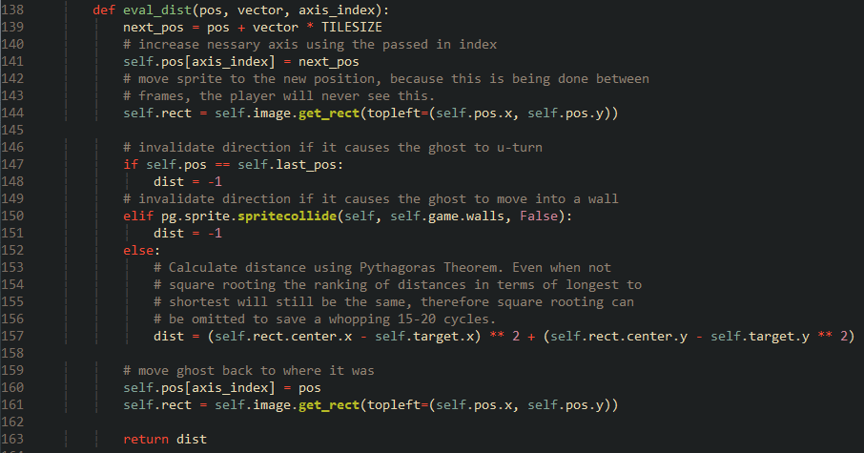

After the direction has either retuned -1 or the distance, the parent method will compare the retuned distance with the currently known shortest direction and will update it accordingly.

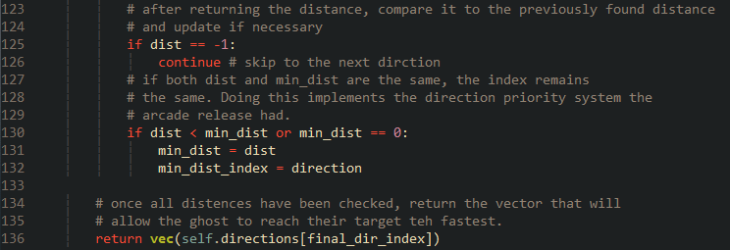

Now with the algorithm in place, it is time to implement the movement, the movement code will for the most part be copied from the ‘player class’ to ensure that the ghosts will get movement interpolation as well, with the addition of a ‘between_tiles flag to ensure that the ghosts only seek a new direction when they are *not* between tiles, its needless and a waste of performance to find a new direction every frame. Screen wrapping will be implemented as well.

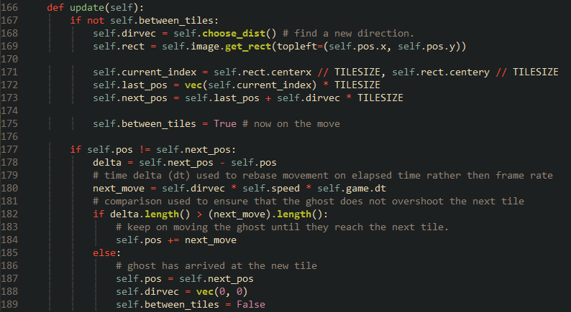

Another method is created called ‘set_target’ that’s called in ‘update’, it simply sets the target to Pac-Man’s position, the reason why I created a separate method is because I want the other ghosts to inherit and override it to allow them to find their own unique target.

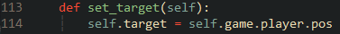

For testing purposes, I will also add to the game’s ‘draw’ method to draw a small red square to represent Blinky’s target position. I will do the same for the other ghosts when they are added.



After adding Blinky to the maze, he is able to navigate it and hunt down Pac-Man, but there’s a bug that occurs right at run-time. Blinky can move into the wall above him before moving down and back into the maze.

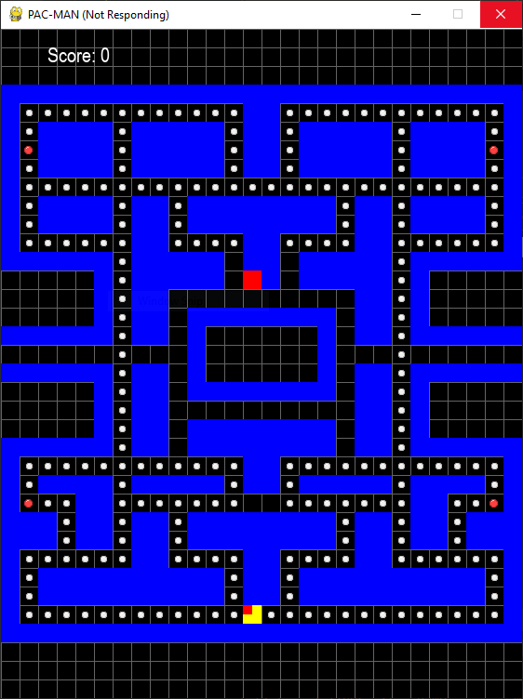

Despite using Neovim to edit code due to its model, keyboard centric focus, I do find the Python IDE Thonny useful for its debugging features. I can set a breakpoint on the line where ‘choose_dist’ is called and step through the algorithm to find out what is wrong.



I found that the first time the algorithm evaluates a direction (up), ‘last_pos’ is the same as ‘new_pos’, therefore the direction gets omitted when it should not.

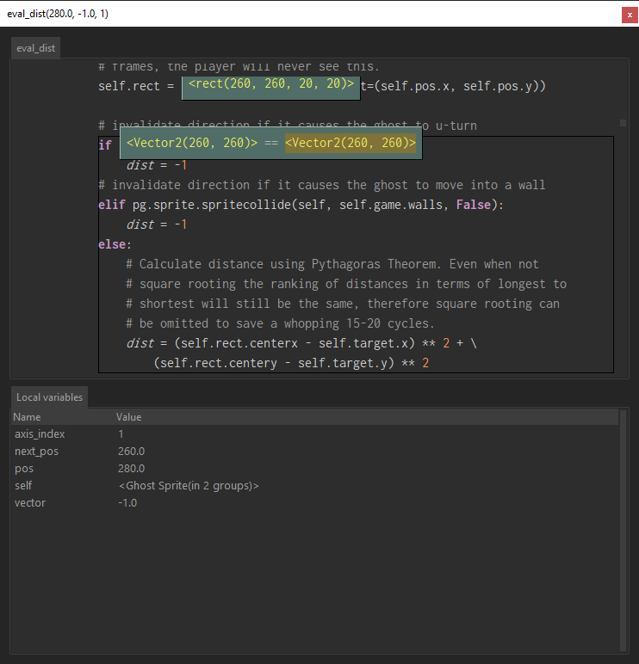

This omission happens to each direction, so ‘min_dist_index’ remains at zero, therefore ‘up’ is chosen by default.

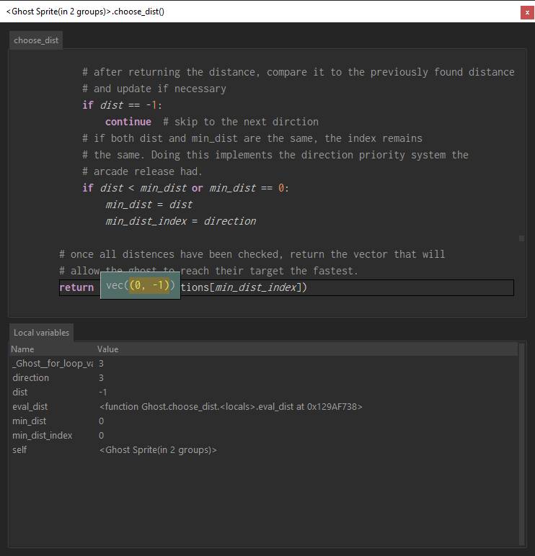

By the second run through, ‘last_pos’ is no longer the same as ‘pos’. The algorithm corrects itself by this point.

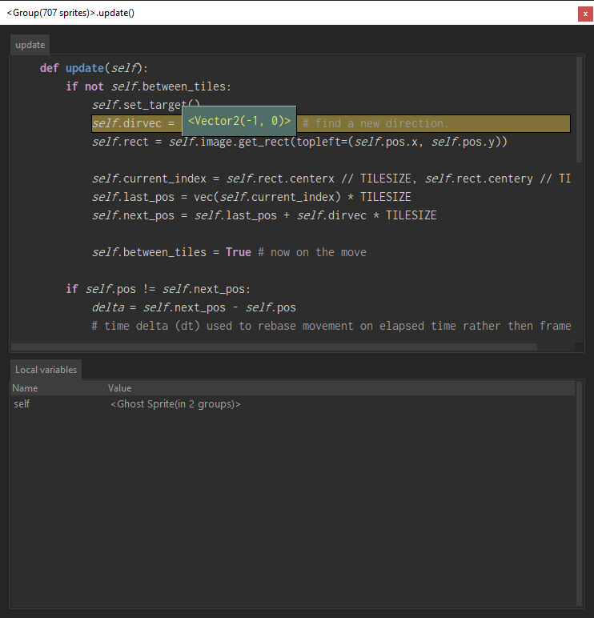

To fix this, I added a Boolean flag to the class’s attributes called ‘first_move’ I then added an additional check during direction evaluation to see if this flag is false. This flag is forced to be false at the end of the algorithm.

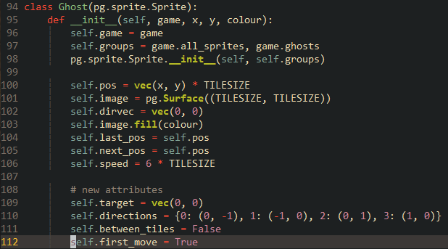

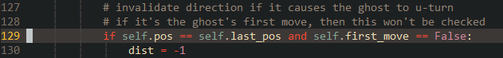

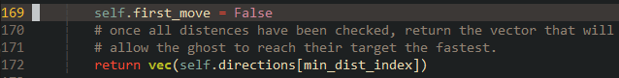

Doing this prevents this check from happening during the first run through the algorithm but allows it to be checked on all subsequent runs.

The ghost movement is now complete. Blinky can reach Pac-man from any part of the maze with no issues. Blinky also moves smoothly and is able to use the warps on either end.

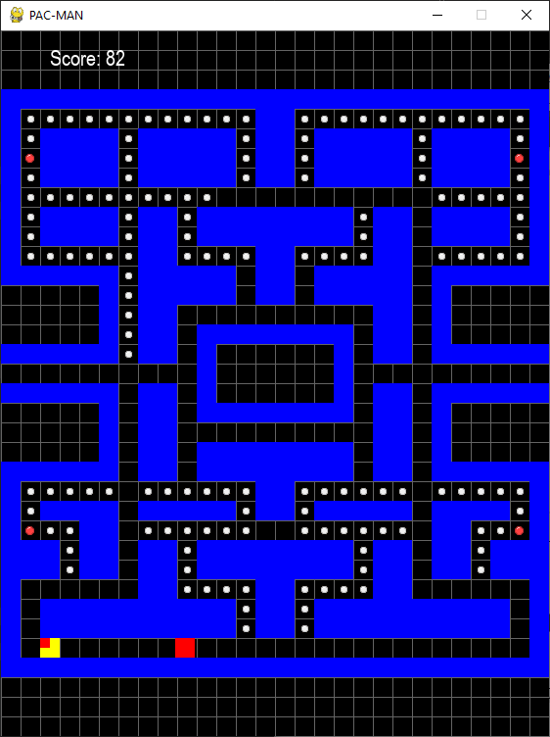

With this done, implementing the other ghosts and their respective behaviour should be trivial thanks to polymorphism.

|  |  |
| --- | --- |
| **Done** | **To do next** |
| Implemented Blinky. | Implement the other ghosts using inheritance and polymorphism. |
| Implemented the direction decision algorithm; allowing Blinky to move towards his target tile. | Implement Clyde’s distance check using a dummy method. |
| Make Blinky smoothly move towards the target tile. |  |

## Iteration 5 – Implementing the Other Ghosts

One of the reasons why I chose to make Pac-man for my coursework is because I knew it would serve as a good showcase for the techniques Object Oriented Programming (OOP) provides, namely inheritance and polymorphism. With inheritance, I can make a ghost inherit all the attributes and methods from the ‘Ghost’ class, making a carbon copy without having to copy and paste. I can then use polymorphism to *overwrite* the inherited methods from the parent class to implement that ghost’s unique behaviour. Using these two techniques keeps the code base small and easy to follow.

### Pinky

Implementing Pinky required modifying a bit of Pac-man’s movement code. Since Pinky’s target is always two tiles ahead of Pac-man, so I need to define the direction he is facing.

I achieved this by adding a new attribute to the ‘Player’ class called ‘facing_dir’, set to a vector of (1, 0). Then inside ‘get_keys’ I set this attribute to the corresponding unit vector when a key gets pressed.

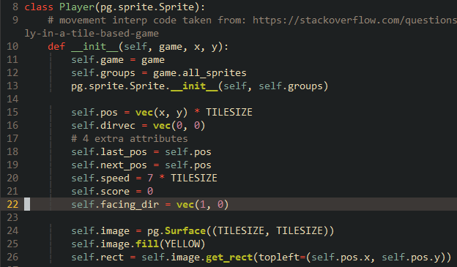

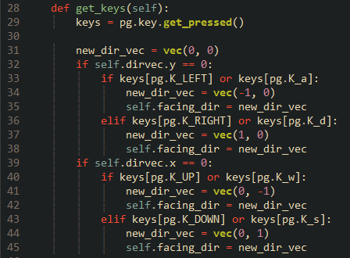

The reason why I could not just use Pac-Mans current movement direction is that it is reset to (0, 0) upon releasing a key and arriving at a tile. ‘facing_dir’ will retain its vector even after the key is released, it will only update upon the next key stoke.

Now a new class called ‘Pinky’ can be created and inherit from the ‘Ghost’ class.

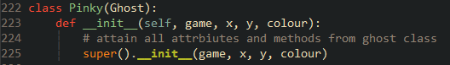

This class can then overwrite the parent class’s ‘set_target’ method, so that Pinky will target the position two tiles ahead of Pac-man.

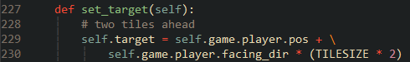

After updating the draw method to show Pinky’s target and adding her to the maze. She sports the same movement as Blinky, but instead has her target two tiles ahead of Pac-Man’s facing direction.

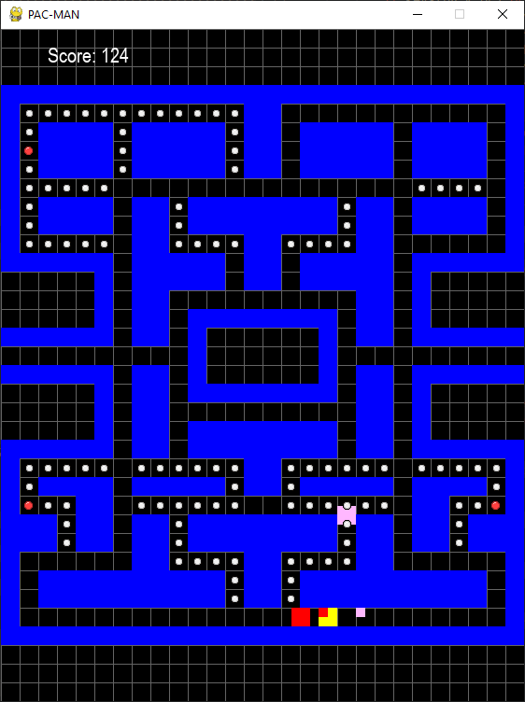

### Inky

Inky has the most unusual and complex targeting behaviour, but the process of inheritance and polymorphism can be done for Inky.

I need the absolute distance between Pinky’s target tile and Blinky, so I took the distance calculation from the direction decision algorithm and moved it into its own method called ‘pythag’, I also gave it a flag to tell it whether to square root the distance or not, which Inky will do. The algorithm now calls this new method.

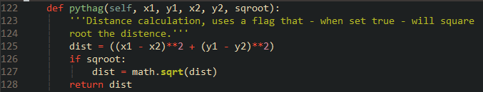

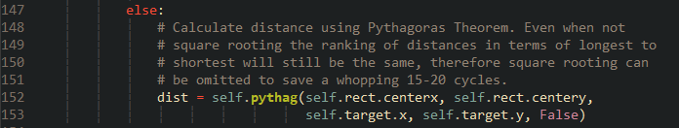

Once Inky has the distance, it is then inversed and added to ‘inter_pos’. The target is set as this sum.

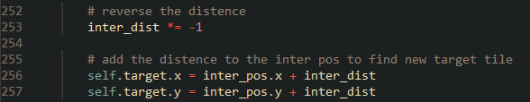

Inky is implemented.

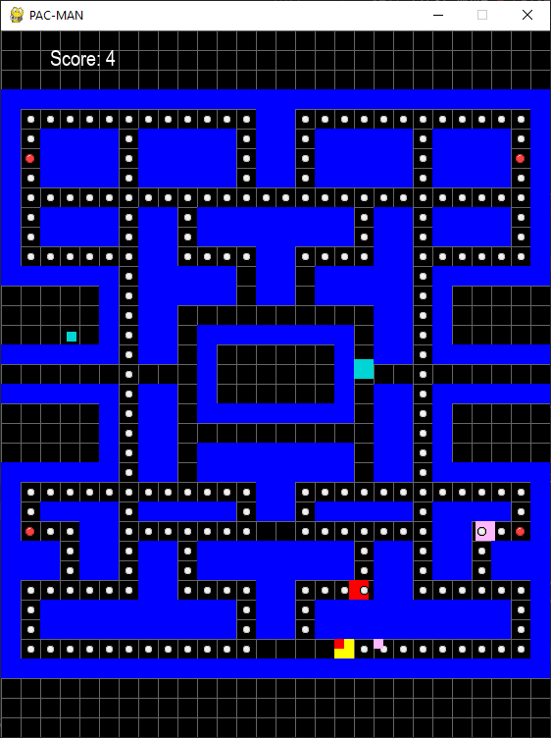

### Clyde

Clyde is the odd one out of the bunch, he has the same behaviour of Blinky until he gets within 8 tiles of Pac-Man, he would then flee to his corner of the maze for 2 seconds before resuming his chase.

A new method is defined inside the ‘Ghost’ class called ‘check_dist’, called every frame. This is a dummy method, it does nothing. This method will be overridden by Clyde.



Alongside inheriting all the methods from ‘Ghost’, Clyde has several extra attributes.

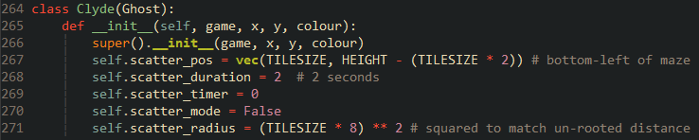

The dummy method ‘check_dist’ is overridden…

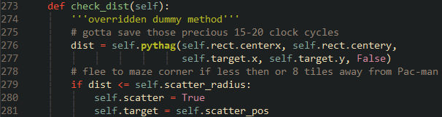

along with ‘set_target’.

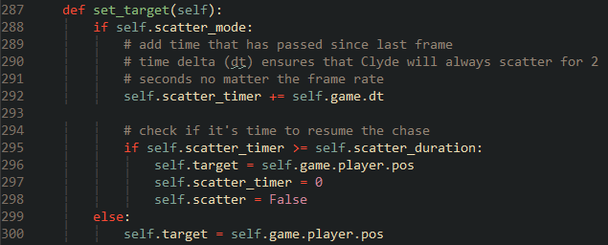

I decided to draw an orange circle around Clyde to visualise his range, along with the target.

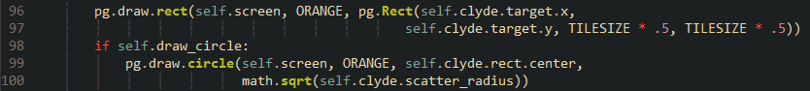

Due to the visual obstruction the circle causes, I allowed it to be toggled using the ‘1’ key.

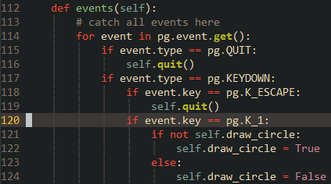

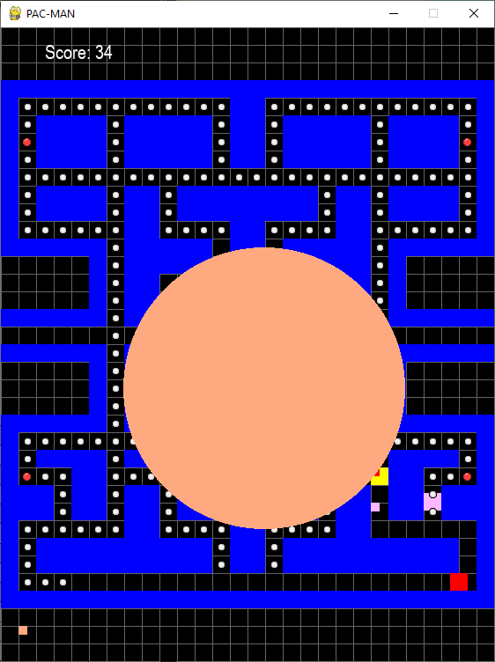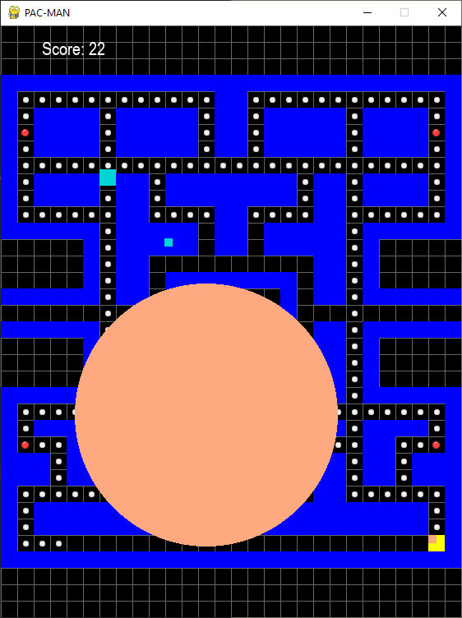Clyde’s is now implemented.

### Reflection

The unique behaviour for each ghost is now done. The gameplay is starting to become fleshed out. I may return to these behaviours and tweak or fix any bugs.

Now it’s time to add the ghost states, which will further flesh out the gameplay.

|  |  |
| --- | --- |
| **Done** | **To do next** |
| Implemented the other ghosts using Polymorphism, extending the gameplay while keeping the code base relatively small. | Implement scatter and chase mode. |
| Implemented Clyde’s distance check using a dummy method and Polymorphism. | Implement eaten and frightened mode. |
|  | Implement Pac-Man’s pellet and ghost collision to facilitate eaten and frightened mode. |

## Iteration 6 – Ghost States

### Scatter and Chase

Now that each ghost’s unique behaviour is implemented, it’s time to program their states.

During the first level of the game, the ghosts begin in scatter mode, meaning that they will target their respective corners of the maze. After 7 seconds, they switch into chase mode for 20 seconds, before scattering for another 7 seconds and so on. After being in scatter mode 2 times, the next scatter will only last 5 seconds. After five scatters, the next chase will last indefinitely.

Firstly, I set up the appropriate attributes in the ‘Ghost’ class.

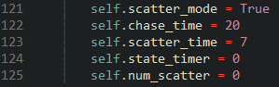

Then I define the maze corner positions for each ghost in each of their ‘__init__’ methods. Alongside overriding methods, polymorphism can also be used to override attributes.









A new method is defined in the ‘Ghost’ class called ‘check_state’, called each frame. This alternates between chase and scatter states depending on the allotted time for each state and what the scatter flag is currently set as.

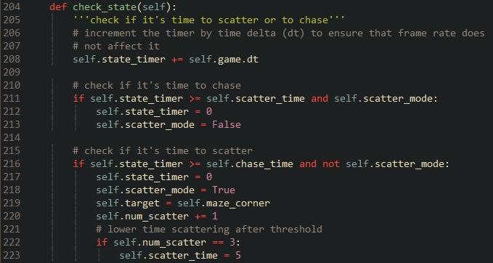

The beginning of ‘update’ has been modified to facilitate this new method. After five scatters all ghosts will be forced into chase mode. Clyde’s distance check and general target updating are both ignored while in scatter mode, since all the ghosts should be doing is moving to their corners.

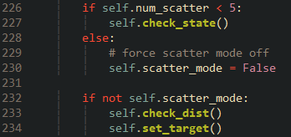

I also set up some debugging text to be drawn on screen. The state timer is truncated to whole seconds before being drawn because the decimal places are irrelevant and it gives more space for other information to be drawn, debug or not.

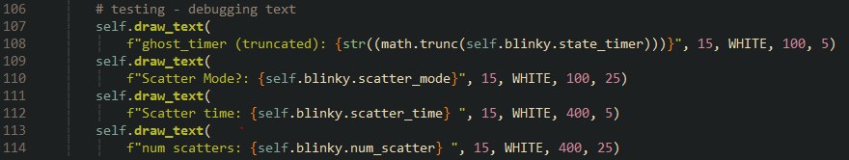

Upon running the game, the ghosts were able to switch between states and correctly react to each one. However, I encountered two bugs.

The first was the fact that all the ghosts were only targeting one corner of the maze upon the initial scatter and only on that initial scatter.

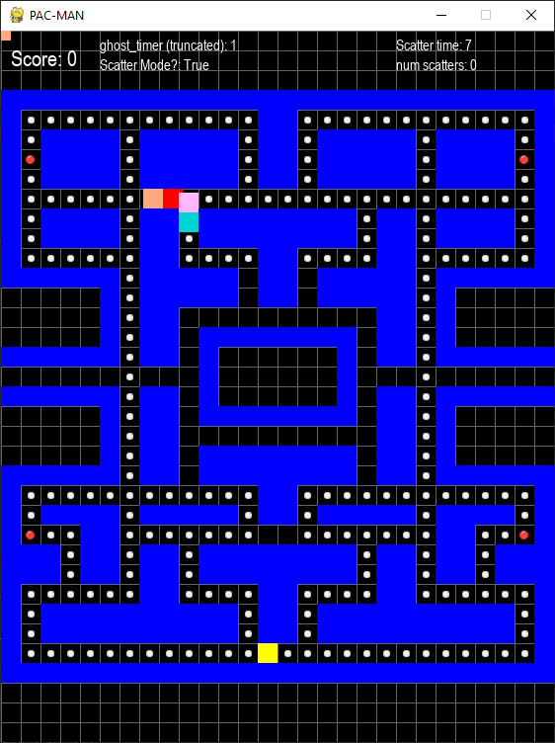

I fixed this by making use of the ‘first_move’ flag that I used to fix the movement algorithm. I added a check to the ‘check_state’ method to force each ghost into their corners during their first move.

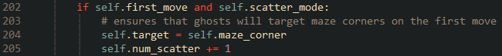

Clyde ignores the change in states, this was because flag to scatter had the same name as the flag of the parent class, overriding the parent flag and thus incorrectly setting the flag to a different value compared to the other ghosts. I fixed this by simply changing the name of Clyde’s flag to something more apt.



Another bug involved Inky’s targeting. When switching to scatter mode, he fails to update his target to his corner, it remains where it was.

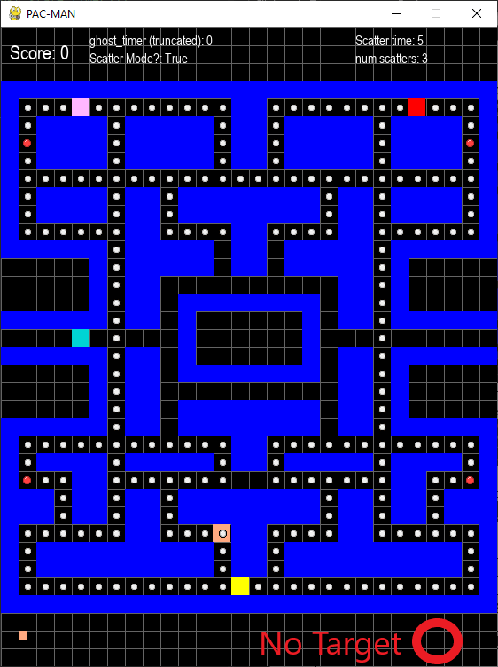

Using Thonny’s debugger again, I set a breakpoint at the line where the ghosts’ targets are set to their maze corners. I resumed execution until I was able to step through the assignment of Inky’s target.



Unlike the others, it appeared that Inky’s target was being set to an arbitrary position.

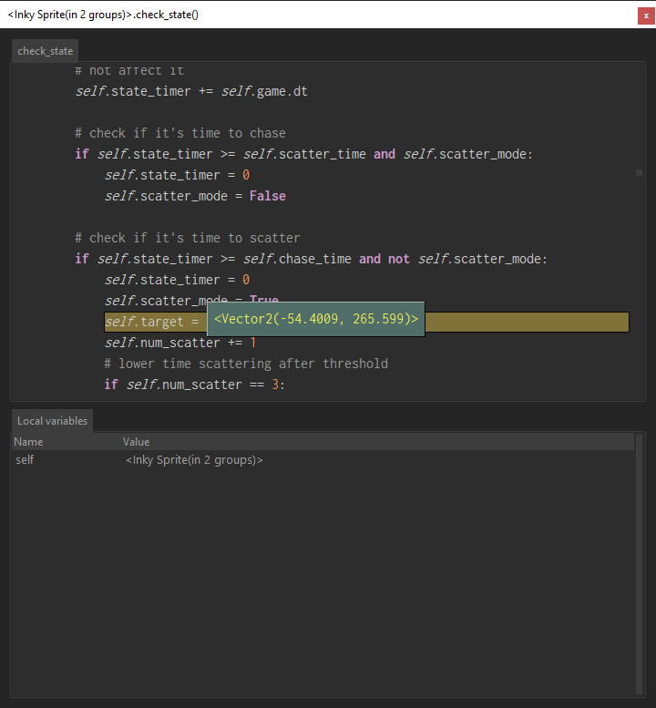

I suspected this to be the target that was just calculated before the change in states. Therefore, I set a breakpoint where Inky’s target is set and discovered this to be the case. This explains why his target remains in place.

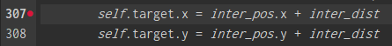

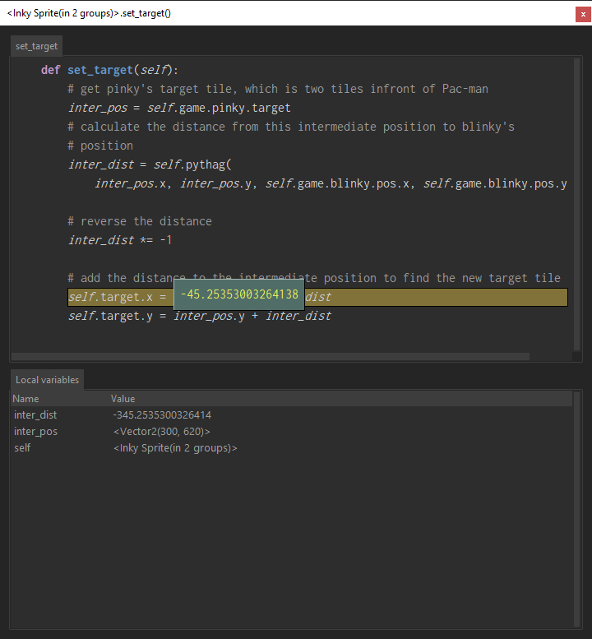

While the solution was not obvious, I noticed that Inky was the only ghost to have his target set by modifying the two vector components individually rather than assigning a completely new vector. Therefore, I modified the target assignment to be more like the others.



Going back to the maze corner assignment shows that Inky’s target is now being correctly set.

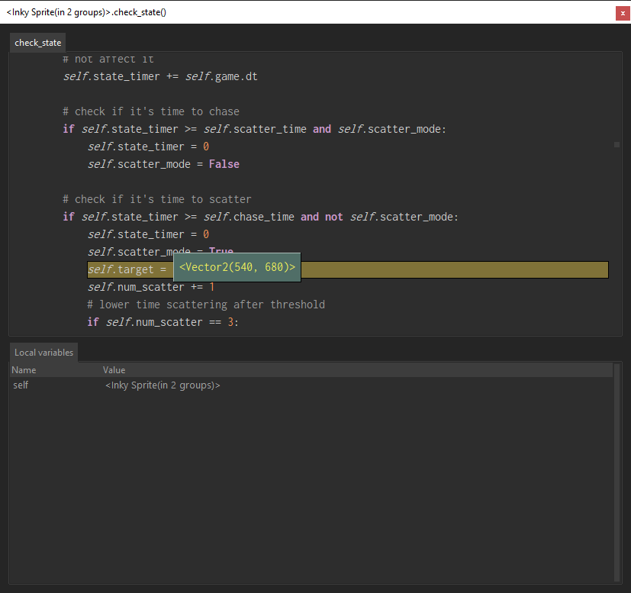

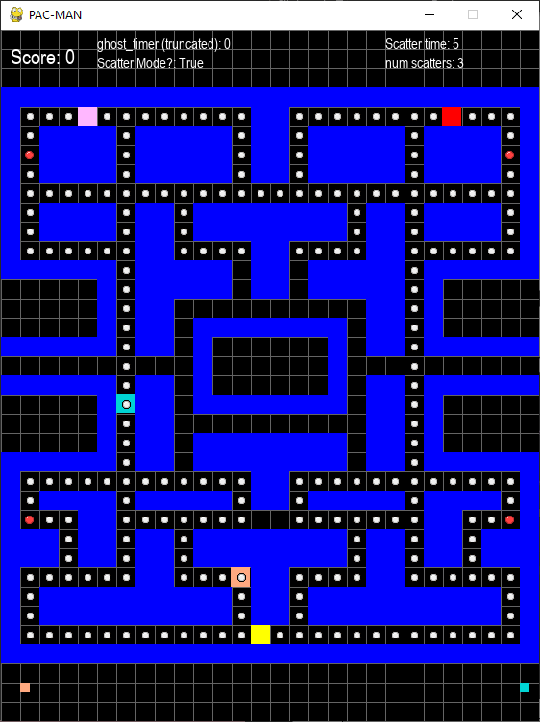

I am not entirely sure why the individual vector component assignment caused this bug. I may need to look more into Pygame vectors. Now that I know that individual vector assignment can cause bugs, I will consider it going forward.

#### Blinky’s Exception

One rule with Blinky is that he will be forced into chase mode when there is only 20 pellets left in the maze. This threshold becomes larger the more levels the player completes.

To implement this, I stated with adding a new attribute to the ‘Game’ class called dots_remain. This keeps track of the pellets remaining.



This attribute is then decremented by one each time Pac-Man eats a pellet.



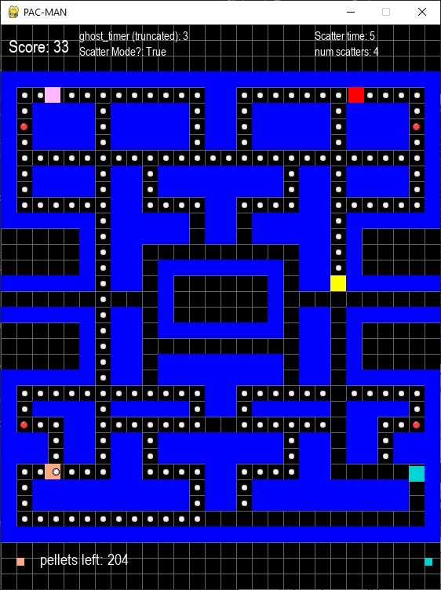

A new flag is then added to the ‘Ghost’ class…



Along with two checks. One is in the ‘Game’ class’ ‘update’ method…

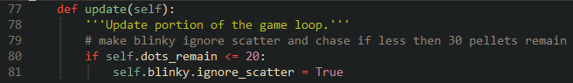

And another in the ‘ghost’ classes ‘update’.

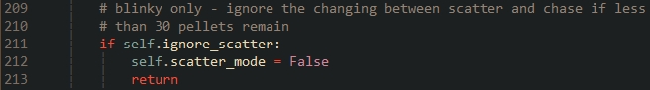

Since the flag is only set true for Blinky, he should be the only one to prematurely jump out of the method.

To test this, I changed ‘scatter_time’ to a large number. Blinky will ignore scatter mode upon there only being 20 pellets remaining.

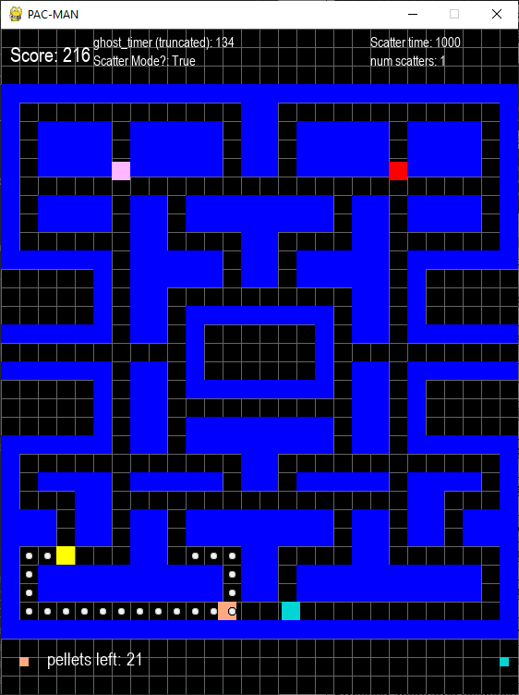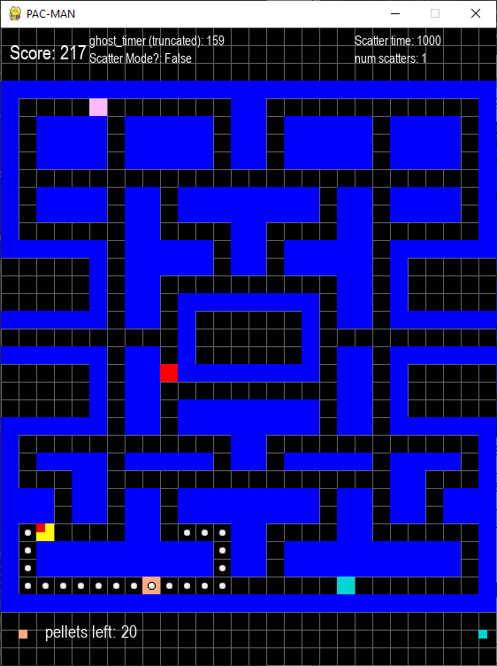

Blinky is now able to ignore the change in states.

### Frightened Mode

When Pac-man eats a power pellet all ghosts will enter frightened mode They will all simultaneously turn dark blue and flip their direction 180 degrees. Their movement algorithm gets modified as well. They will simply pick a random eligible direction instead of picking one that will get them closer to a target.

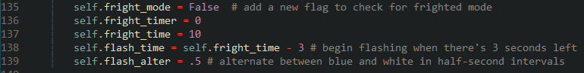Just like the other modes, I added new attributes to govern this mode. A Boolean value to check for frightened mode and timers, including timers for when the ghosts flash before exiting frighted mode to give the player a head’s up.

#### Fright Switch

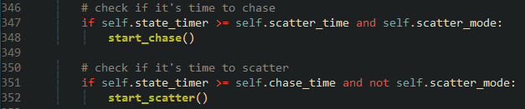I knew that implementing this mode would require a lot of modification to existing methods in the ‘ghost’ class. So, to prepare I refactored the code inside the ‘check_state’ method by encapsulating each mode switch into its own nested method. When it is time for a ghost to switch to scatter mode for example, it will now call the ‘start_scatter’ method which will activate scatter mode like before. Doing this makes easier to differentiate each mode and makes debugging easier.

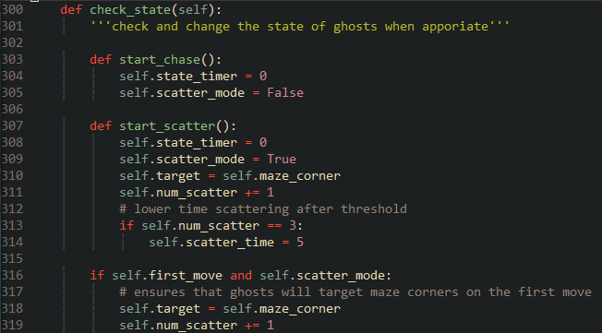

After creating an empty nested method called ‘fright_switch’ in ‘check_state’. I needed to add a collision check between Pac-Man and a power pellet. To do this I differentiated the two pellets by creating a ‘powerPellet’ class that simply inherits from the ‘Pellet’ class. I then updated the maze generation algorithm to instantiate from this new class upon parsing a colon.

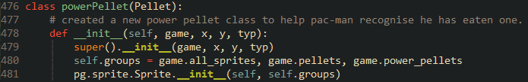



Now I can add a collision check to the ghosts’ ‘check_state’ method. That will call ‘fright_switch’ upon being true.



Inside this method I needed to change all the ghosts’ colour to a dark blue and slow them down. After some attempts, I settled on using a for loop to iterate though each ghost in the ‘ghosts’ sprite group, changing each ghost each iteration.

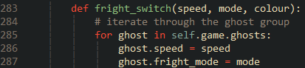

Appropriate parameters are then passed in.



Upon running the game and eating the power pellet a placed next to Pac-Man for testing purposes, the ghosts slow down, and turn blue.

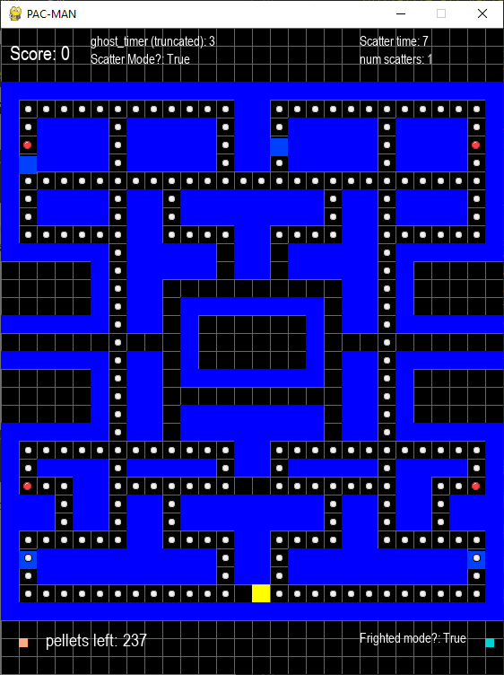

To get them back from frightened mode, I opted to use ‘fright_switch’ again (hence the name). I appended an if else statement. When entering frighted mode ‘fright_mode’ for each ghost will be set true, thus turning blue. However, if a ghost is exiting the mode, they will turn into their normal colour based on the current index of a passed in list of colours.

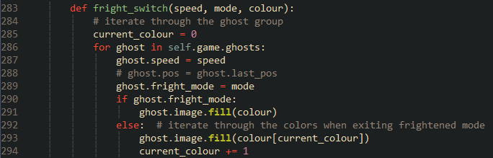

I then added another branch to pause the state timer while in frightened mode, and instead increment the fright timer.

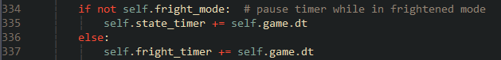

Once it’s time to exit frightened mode, ‘fright_switch’ is called again. Restoring the ghosts’ former speed and passing in a list of colours corresponding to each ghost’ position in the sprite group.



While the ghosts are now able to enter and leave frightened mode. It dawned on me that the order in which the ghosts are added to the sprite group depends on the order in which they were instantiated. In my map file, Clyde if the first of the four to be added, then Blinky, Pinky and Inky. If I were to change the position of the ghosts, this will assign the wrong colours to each ghost upon exiting frightened mode.

To see this, I set the scatter time to a large duration and placed each ghost in positions in which the order of ghosts in the sprite group is different. I then frightened the ghosts upon starting. When returning from the mode each ghost received the wrong colour. Inky got Pinky’s colour, making it seem like Pinky is circling Inky’s corner.

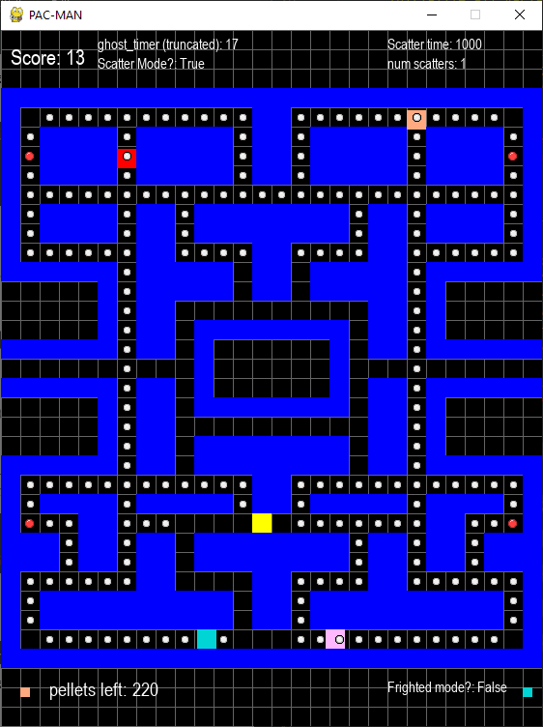

This bug is obviously detrimental to gameplay, but fortunately had a quick and easy fix that ended up simplifying the method.

I accompanied the ‘speed’ and ‘colour’ attributes with new constants. ‘ORIG_SPEED’ and ‘ORIG_COLOUR’ these will retain the original speed and colour of the ghost.

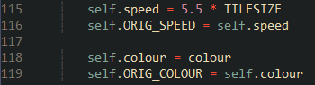

‘fright_mode’ is then modified. Instead of taking in a list, the method will now check if the ghost is frightened. If so, its speed and colour will be set to its constants, else enter the mode by setting speed and colour to the passed in parameters. Because the ‘speed’ and ‘colour’ parameters are not needed when calling this method to exit the mode, I made them optional by setting their default value to ‘None’ (known as ‘null’ in other languages).

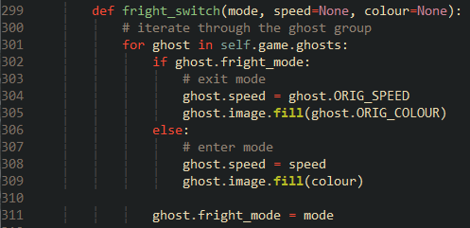

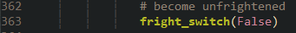

Now each ghost can change back into their correct colour upon leaving frightened mode, regardless of their position in the sprite group.

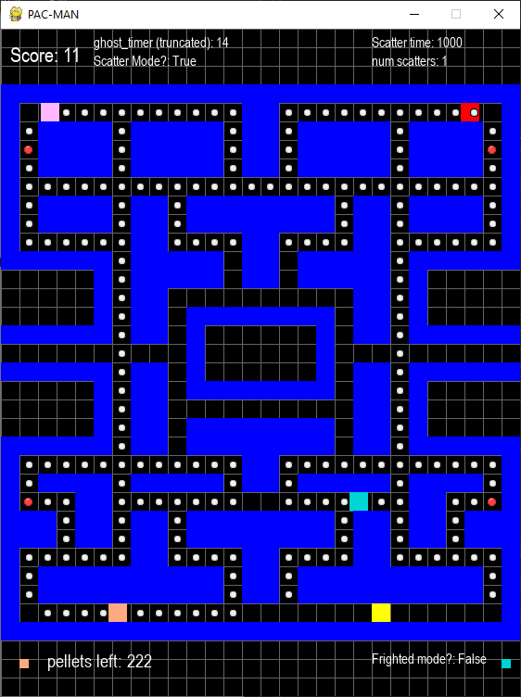

#### Random Movement

With switching out of the way, it is time to modify the ghost direction decision algorithm to account for this new mode. Due to the pseudo-random nature of the movement, I imported the ‘random’ module into ‘sprites.py’, which can generate numbers and manipulate data structures in a pseudo-random manner.



While in frightened mode, each ghost will store each direction into a list. Once all directions are checked, a random eligible direction will be chosen from the list, this gives each direction an equal chance of being chosen.

Inside ‘choose_dist’ a defined an empty list called ‘fright_list’

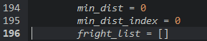

An extra check is added inside ‘eval_dist’. After the two evaluation checks are done. the distance calculation will only run if not under frightened mode.

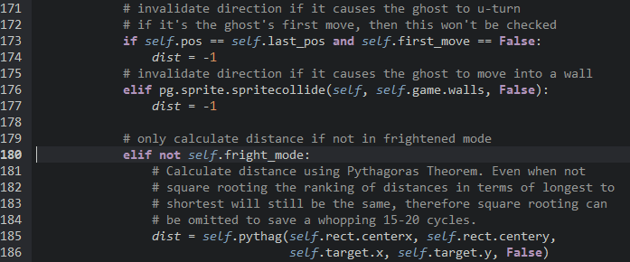

Upon returning from eval_dist either -1 or 1 is appended to ‘fright_list’. Distance comparison is skipped while frightened.

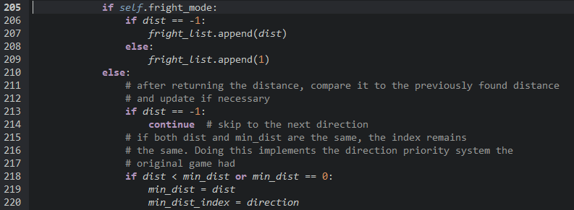

Once all distances are added to the list, the algorithm falls into a forever while loop. A random index with its corresponding value is taken from the list. If the value is not -1 (invalid direction), the direction with the corresponding key is retuned.

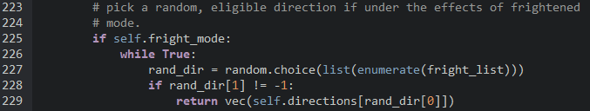

While this solution does work, I did realise some big inefficiencies with it. Picking a direction in such a manner opens up the chance of the algorithm picking an invalid direction multiple times. This means that there is now the highly unlikely chance of a ghost taking more than the allotted frame time (in this case 16.6ms for 60FPS) to decide on a random direction. If this happens the ghost will not move on the next frame, resulting in a visual stutter. The algorithm is also horribly inefficient if the ghost can only move in one direction, like down a corridor. It will still pick a random direction even when only one of them is guaranteed to be valid.

Instead of using ‘fright_list’ to store valid and invalid directions and using their index to pick a unit vector, the list can instead store the current index the iteration is on. So, if the algorithm is on its first iteration and the direction is valid, index 0 will be appended to the list. Once all directions are checked ‘fright_list’ will only contain the key values for valid directions. The forever loop used to find a valid direction can now be omitted since the first direction picked is guaranteed to be valid.

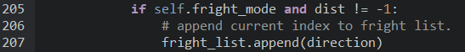

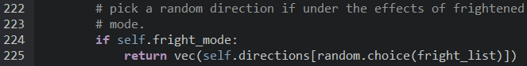

The ghosts can now efficiently find a random direction when frightened.

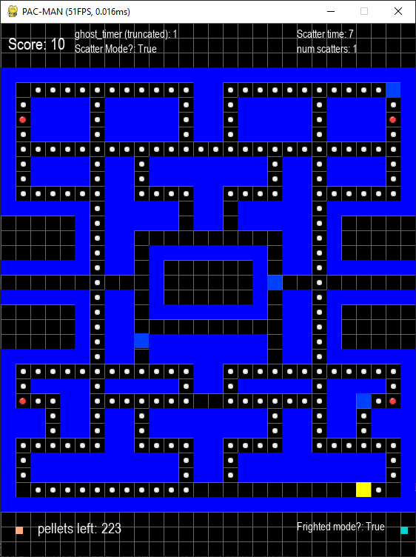

#### Flashing

The flashing is an important aspect of this mode; it telegraphs to the player that the effects of frightened mode will be soon going away, asking the player to prepare for the resuming pursuit.

I added an extra attribute to aid in switching the ghosts between two colours. ‘flash_colour_duration’ is a timer that only increments during the final 3 seconds of frightened mode. When it is more than or equal to ‘flash_alter’, the ghosts will change colour. The reason why ‘flash_colour_duration’ has the same value as ‘flash_alter’ is so that the ghosts will immediately switch colour as soon as the threshold is met.



Under the line of code that increments the ‘fright_timer’ in the ‘check_state’ method, I added a check to see if the incrementing timer has surpassed the flashing threshold, if so then a nested method called ‘check_flash_alter’ is called.

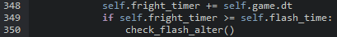

‘check_flash_alter’ increments ‘flash_colour_duration’. If the duration exceeds a ‘flash_alter’ then reset the duration and switch the colour to either white or frightened purple depending on the current colour.

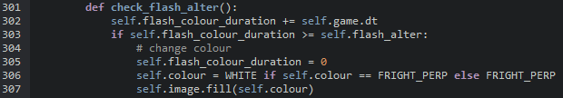

Now the ghosts will flash several times before returning to their normal states.

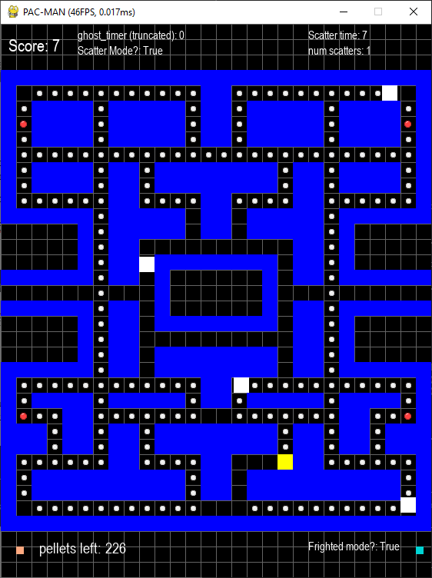

#### Fixing Screen Wrapping

When testing this mode, I encountered a bug involving screen wrapping. When a frightened ghost used the right maze warp, they can escape the maze. I hypothesized this was due to how the checks to see if the ghosts can warp uses their ‘pos’ which is at the top left of their rectangle collision (rect). The wrap will only commence when ‘pos == WIDTH’, when their topleft corner is at the edge of the screen. The direction decision algorithm executes before the wrap check, so the ghost would end up escaping the maze before being warped.

To test this, I modified the map file to place Pac-Man inside the corridor leading to the left warp and Inky (ghost does not matter) at the right corridor. A power-pellet is placed to the left of Pac-Man so he can eat it as soon as the game starts. To ease debugging, I removed all the other ghosts.

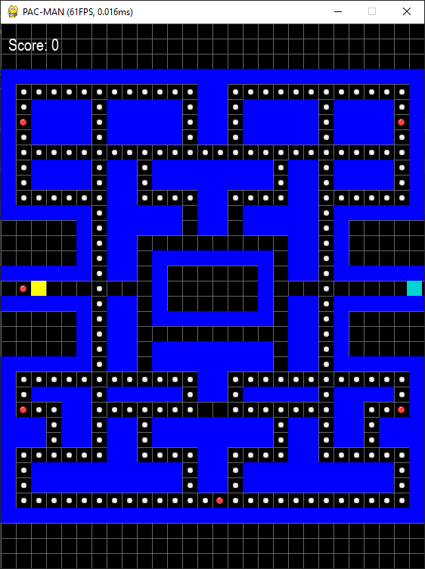

The idea is to eat the power pellet before Inky can use the warp, so he will be in a frightened state.

I then once again use Thonny’s debugger by placing a breakpoint at the check for wrapping at the right.

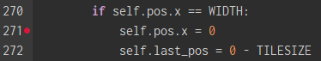

Upon stepping into the code you can see that ‘last_pos’ is being redefined to -20, the x coordinate of the tile left of Inky after wrapping. ‘last_pos’ was originally a vector that is now an intiger. This is the root cause of this bug.

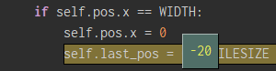

I continued to step froward until I reached the direction decision algorithm, specifically the part that checks if the new position that the current direction leads to is the same as the last position. When looking at how the ‘left’ direction gets checked its position is compared to ‘last_pos’. Because ‘last_pos’ is now an integer, the check will always evaluate to false. 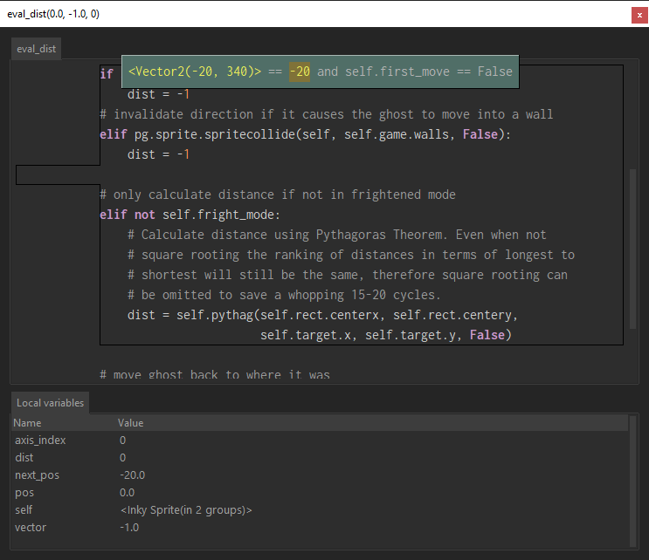

This incorrectly validates the direction and allows it to be randomly chosen against ‘right’. If ‘left’ is chosen, then the ghost will U-turn and escape the maze.

The fix was quite simple, avoid overwriting ‘last_pos’ as a vector by assigning to its x component.





Now the ghosts no longer escape the maze while frightened, no matter what side of the screen they wrap from.

Another bug was that after becoming frighted once, the ghosts would not become frightened on subsequent power pellets being eaten.

I used this bug as a chance to refactor Pac-Man’s collision detection. If he has not collided with a wall, then check whether he has collided with a pellet. If so, check if it is a power pellet and call each ghosts’ ’fright_switch’ method with the appropriate parameters. I then moved this block of code into a new method called ‘check_collision’, called after the movement algorithm, now housed in its own method called ‘move()’.

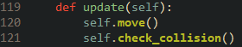

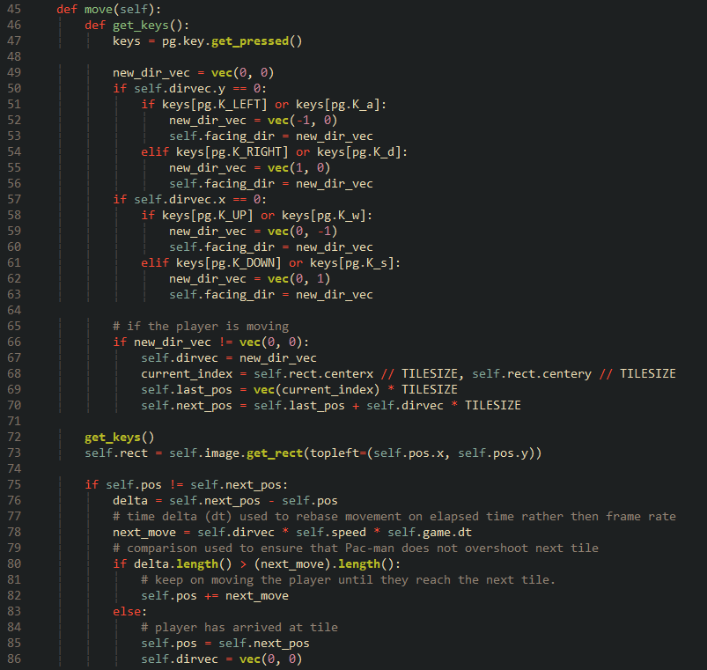

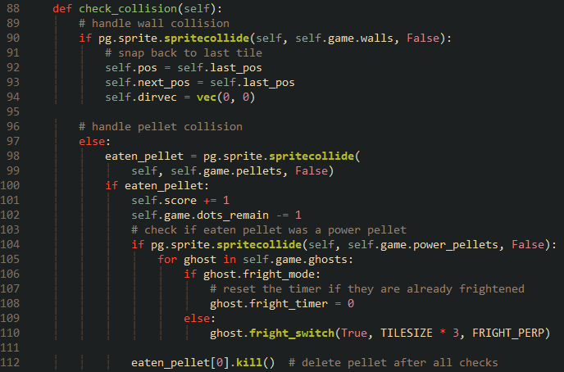

This refactor makes it easier to test and debug each aspect of Pac-Man as he is now compartmentalised into subroutines. The refactor of the collision detention improves its efficiency due to how the power pellet check will only commence when Pac-Man collides with any pellet in general.

If Pac-Man collides with a power pellet, the ghost group will be iterated upon and have their method called. While testing this I noticed that the duration the ghosts remain in frightened mode does not reset when Pac-Man eats a power pellet while the ghosts are frightened. So, I added a simple check to reset their counter if frightened. This mimics how the original game handled this scenario.

The final piece for this mode is for the ghosts to U-turn upon entering frightened mode. This was the first feature of this mode that I tried to implement, but after failing to get it working, I decided to leave it for last and get the more vital features implemented. That seemed to have been a good call since implementing it was surprisingly simple this time round.

Inside the ‘fright_switch’ method I added a line inside the condition to enter the mode. It multiplies each component of the ‘dirvec’ vector by -1, effectively reversing the ghosts’ directions.



While this did reverse their directions, they continued to glide in that direction, phasing through walls.

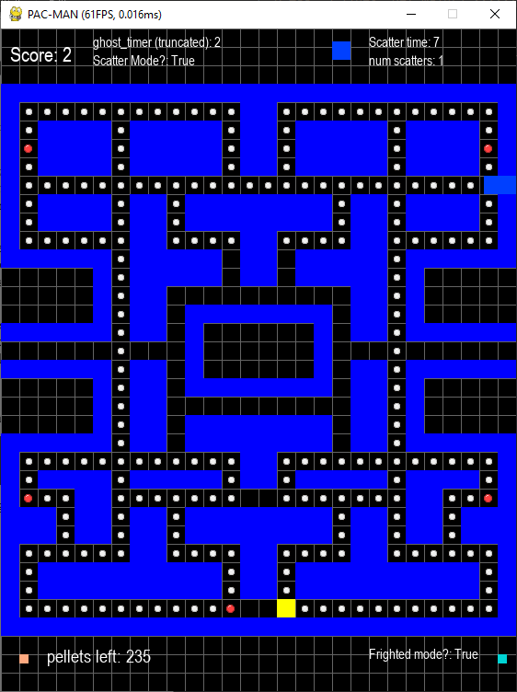

This was because the ghosts were now moving away from their ‘next_pos’, thus never arriving there and never calling the direction decision algorithm, which houses their only collision check against walls. To fix this I swapped the vectors of ‘last_pos’ and ‘next_pos’. Here is the pythonic way of doing this:



It looks like I was naive. While at first the code appeared to be working properly. I discovered that the swapping of the vector’s causes an annoying edge case which crashes the game. When a ghost is not between tiles and becomes frightened, all directions will evaluate to false due to the ghosts’ new positions in the direction decision algorithm always being the same as ‘last_­­pos’, so no directions are added to the ‘fright_list’, resulting the ‘random’ module crashing since it can’t pick a random value from an empty list.

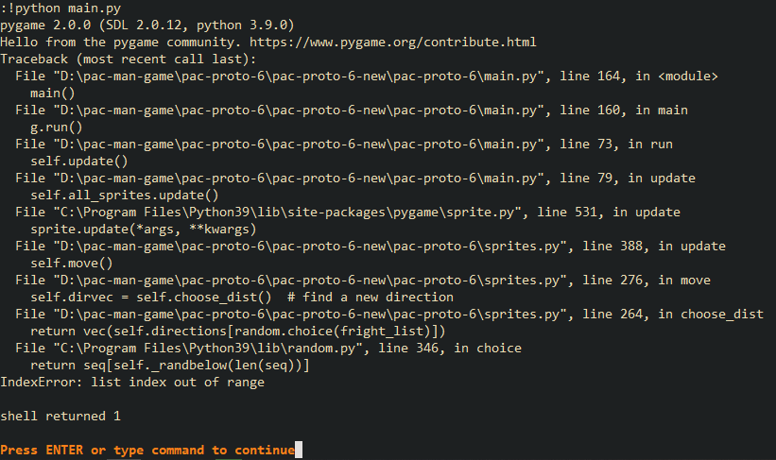

To test this, I changed the framerate cap of the game to 1. By modifying the constant ‘FPS’ in settings.py. This ensures that the there is no movement interpolation; Pac-Man and the ghosts will always be in between tiles.

I found out that swapping the individual components of the vectors stops the crash from happening but results in the ghosts jumping two tiles over in their new direction. After extensive debugging I still cannot figure out why this is happening. After some trial and error, I managed to fix this by setting the ghosts rect to its position after swapping ‘last_pos’ and ‘next_pos’.

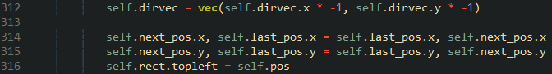

Now the ghosts can enter frightened mode, reverse their direction, move randomly, flash during the final three seconds and return to normal. This mode is now fully implemented.

### Eaten Mode

The final mode to implement is eaten mode. When Pac-Man collides with a frightened ghost, they will become eaten and quickly flee to the ghost house. On arrival they will exit eaten mode and resume whatever mode they were in before becoming frightened. The player gains 200 points for eating ghosts.

Two new attributes are added to the ‘Ghost’ class’ constructor. I use green as a place holder to indicate that a ghost will be eaten. When I add graphics, the eaten ghosts will be depicted as a pair of eyes instead.

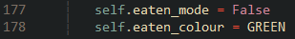

I expand Pac-Man’s ‘check_collision’ method to account for touching frightened ghosts. A list of collided ghosts are stored in a local varaible called ‘collided_ghosts’. This list is iterated through and if the ghost is frightened then they will change to green to indicate their eaten state. The appropriate flags are changed.

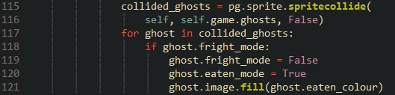

Upon starting the game and colliding with a frightened ghost, they will turn green.

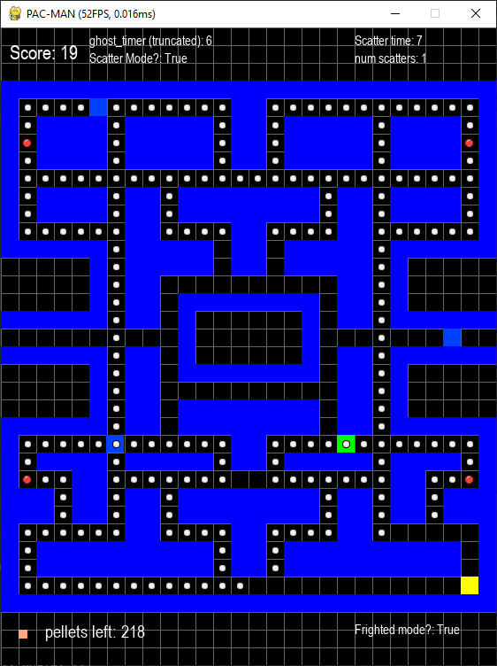

With the collision down pat, it is time to fully program the mode.

I add new attributes. For all my speeds up to this point I added a decimal place to avoid a strange bug in which the ghosts become stuck. After testing this bug, it seems like having a speed that’s a multiple of ten causes it.

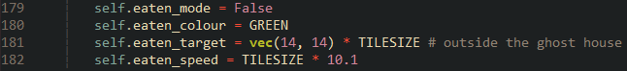

Akin to frightened mode. I made a new method in the ‘Ghost’ class called ‘eaten_switch’. Like ‘fright_switch’, it serves to both allow a ghost to enter and exit eaten mode. This method is called when Pac-Man collides with a frightened ghost and when the eaten ghost arrives at their target (outside the ghost house).

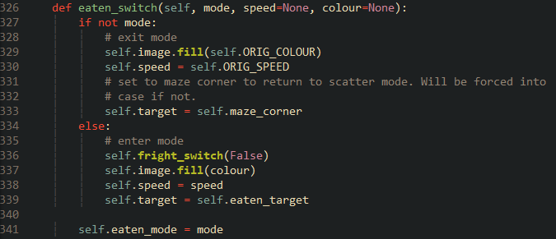



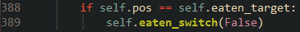

Upon entering eaten mode their speed will dramatically increase as they rush over to their target.

I also modified ‘check_state’ so that the ‘state_timer’ is paused while in eaten mode.

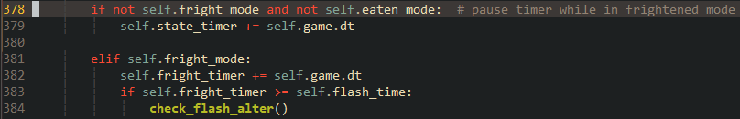

When testing I noticed that the eaten ghost was failing to retain their target at ‘eaten_target’ and instead were keeping their eyes on Pac-Man. This was because the method ‘set_target’ was still being called. So, I added a check at the start of the method ‘move’. While there I also done some optimizations. I enclosed the entirety of the movement algorithm in a check, so it only executes when a ghost is not between tiles. Executing this code every frame is pointless since the ghosts cannot move in a new direction until they are aligned with a tile. Recalculating targets while in frightened mode is also pointless since the ghosts will be moving randomly, so I added a check for that as well.

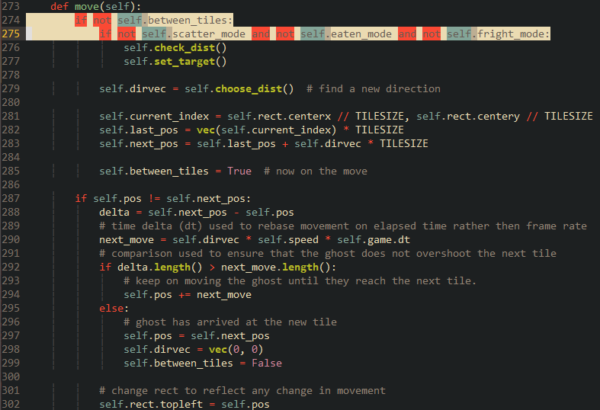

This did interfere with Clyde. Because ‘set_target’ was now being called less frequently, the duration in which he scatters after coming too close to Pac-Man is now longer. This was rectified by dividing his ‘scatter_duration’ by ten.



One other oddity I noticed is that Pac-Man seems to be eating ghosts from some distance away, around 1 to 2 tiles away. This was due to the ghosts’ collision rectangle lagging behind the sprite as they were only being updated when the ghosts are not between tiles. Moving the line responsible for updating the rectangle out of the code block in ‘move’ solved this.

Finally, I added a line to increment Pac-Man’s score by 200 when eating a ghost.



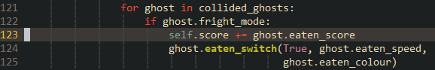

Now Pac-Man can eat the ghosts to gain bonus points and make them return to the house. The pausing of the state timer along with the fact that the ghosts can no longer all be in the same mode gives the gameplay dynamism and chaos that adds to the challenge.

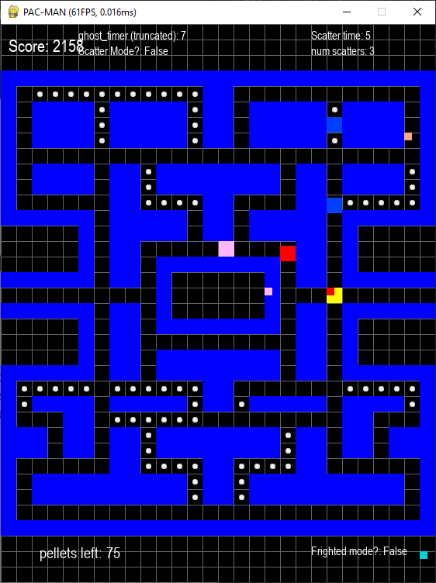

### Reflection

The ghosts are complete. I may in later iterations return to their code to do some reactors to make the code cleaner or to facilitate a new mechanic or to fix any bugs or mistakes I may find.

Next is to implement the winning and losing conditions, which will complete the gameplay and put it in a state for future polish.

|  |  |
| --- | --- |
| **Done** | **To do next** |
| Implement scatter and chase mode. Adding more dynamism to gameplay. | Implement the win and louse conditions, which should naturally extend from Pac-Man’s collision checking. |
| Implement eaten and frightened mode. Which adds the core gameplay loop of frightening and eating ghosts. | Implement a scoring system, which should also naturally extend from the collision detection. |
| Implemented pellet and ghost collision, giving the player a goal (eating all pellets) and an obstacle (the ghosts). | Implement a high score system. Ensuring that the text file which stores the score is encrypted to prevent tampering. |

## Iteration 7 – Lousing, Winning and Scoring

When Pac-Man collides with unfrightened ghost, he should die and lose a life. If he loses all his lives, then a game over screen should play, showing the player’s score, the high score and asking them whether they would like to play again or quit. When lousing a life, the number of pellets on screen should not change.

If Pac-Man manages to eat all the pellets on screen, then the player will instead be greeted with a screen congratulating them. Showing their score and high score and notifying them as to whether the score is a new record. They all then be prompted to play the game again or not.

### High Score Encryption

First, I create a new text file called highscore.txt. That holds the high score. I’ll set it to an arbitrary value that is feasible for a player to obtain, I chose 2000.

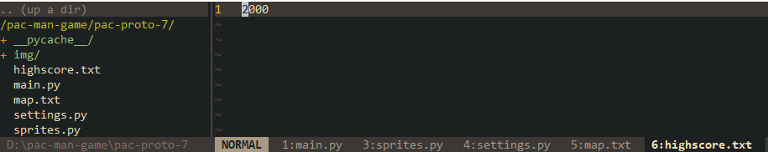

This value would be very easy to modify, so I decided to add some form of encryption. I found a tutorial that teaches how to encrypt and decrypt files using symmetric key encryption. [9].

Using this tutorial, I installed the module and created a new script called ‘key_gen.py’ which generates a key and stores it in a file called ‘highscore_key’.

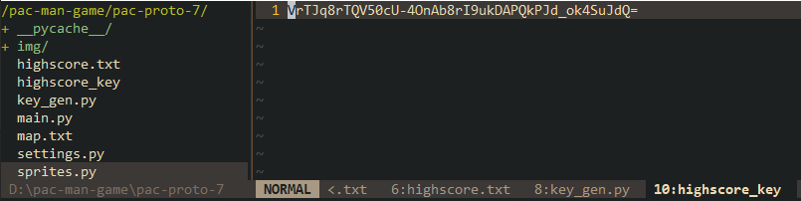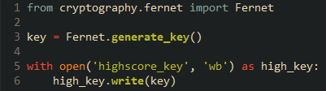

I then extended the script to make use to load on the high score, encrypt it using the key and storing the now encrypted score back into ‘highscore.txt’.

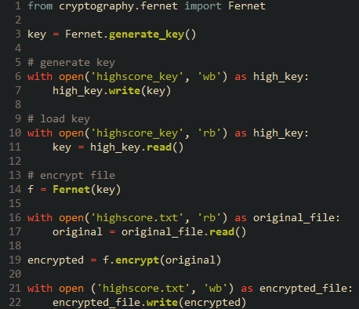

The score is now encrypted.



### Lives and Position Reset

I add a new attribute to the ‘Player’ class called lives, set to 2.



Over at ‘check_collision’ I add a check to see if the ghost is not frightened and not eaten, in other words, is either it scatter or chase mode. If so, then deduct a life from Pac-Man.

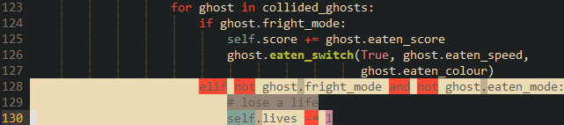

When losing a life, the positions of Pac-Man and the ghosts must be reset., so I added constants to both classes that retain the original position of these entities.

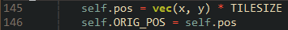

I then create a new method in ‘Game’ called ‘reset_pos’. This resets the position and states of both Pac-Man and the ghosts. The ghosts will be forced into scatter mode upon resetting. The players ‘last_pos’ and ‘next_pos’ appeared to be preventing the Pac-Man from returning to his original position, so they are set to the original position like in the constructor.

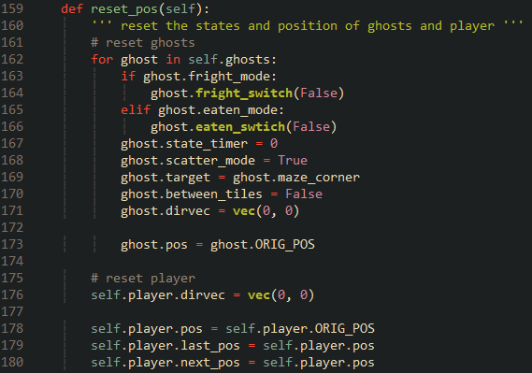

This method is called after deducting a life. The loop to check the ghosts that Pac-Man has collided with is then bailed from since its guaranteed that Pac-Man is no longer touching a ghost.

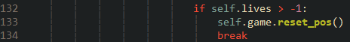

There were several bugs with this:

If a direction key is depressed when ‘reset_pos; is called, Pac-Man’s, position would reset to his origin for a single frame before returning to where the collision occurred. I took a note for how I fixed the direction decision algorithm using a flag and declared a new attribute called ‘first_frame’, Set to true. In ‘update’ this flag is checked and if it is true, then ’move’, which houses direction input and movement will be skipped. The flag is then set false.

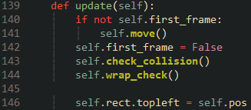

Inside ‘reset_pos’ This flag is set to true so that ‘move’ will be skipped for the next frame.

One major flaw I found with Pac-Man’s movement was that he was able to phase through ghosts when Pac-Man is moving into a to wall. I fixed this by changing the order in which the methods are called in ‘update’ to be like the screenshot above. It also appears to have stopped the ‘jitter’ Pac-Man has when moving into a wall, making his overall movement appear smoother.

Another major flaw is that both Pac-Man and the ghosts do not reset their positions to their origin perfectly, they seem to reset one or tiles away from their origin for Pac-Man it seems that this error worsens for further he is away from his origin.

I first broke out Thonny’s debugger and set a break point where Pac-Man’s position his set to his origin to see what value ‘ORIG_POS’ is at this point.



I also set a break point when his position defined in the constructor to see the original value of ‘ORIG_POS’.



Upon running the program reached the second breakpoint I added. It showed Pac-Man’s position being the vector I expected.

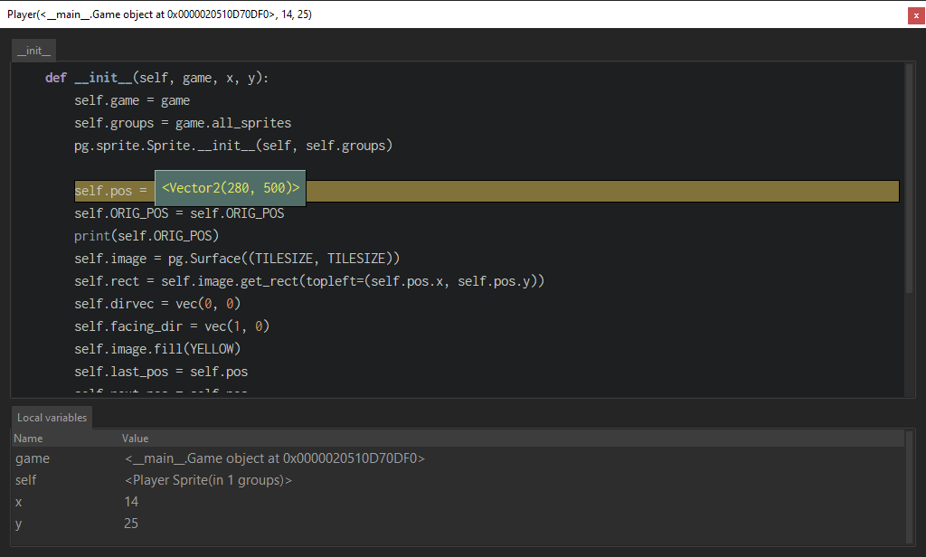

I then resumed the game and moved Pac-Man a bit before making him get caught. When captured the other breakpoint was reached and I saw that the x component of ‘ORIG_POS’ strangely had decimal places with a number that was not a multiple of 10. This value explains why Pac-Man and the ghosts are slightly off grid after resetting and why Pac-Man can be way off his original position.

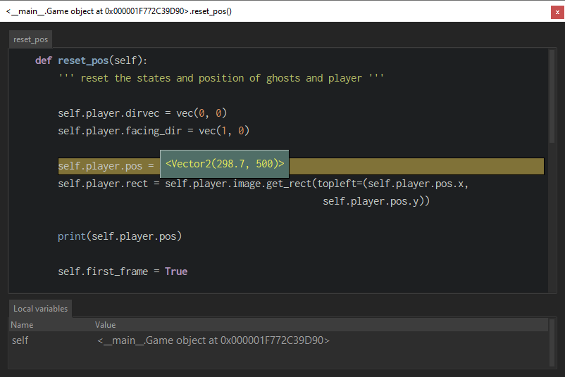

The decimal complaint told me that this could be something to do the ‘move’ method, added a line in ‘move’ to print the value of ‘ORIG_POS’ after Pac-Man has moved a single step. It will also print the value of ‘pos’ next to it to see if that’s influencing the vector of the former.

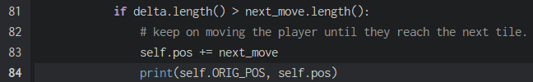

I then ran the game without debugging and moving Pac-Man around a bit, looking at the console output and saw that both vectors are the same, confirming that ‘pos’ is in some way affecting ‘ORIG_POS’.

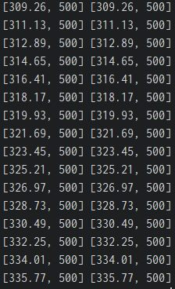

To fix this I changed the line that initialises ‘ORIG_POS’ to be the vector of ‘pos’ to instead be just like how ‘pos’ is defined. I also done the same in the ‘Ghost’ class.



The bug was still occurring after the positions were reset, so I changed the lines where the positions are set to ‘ORIG_POS’ to instead assign the individual components of it.





The position reset now works perfectly.

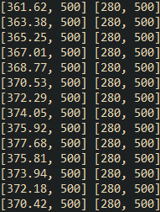

### Game Over Screen

The code behind the screen switching is based on Chris Bradfield of KidsCanCode’s tutorial series on making a vertical platformer, namely the part where he implements the splash and game over screens [10] [11].

In the ‘Game’ class’ constructor I add an attribute called ‘running’. This flag will dictate whether to quit the game or not.



The events method is modified to account for this new attribute, quitting or pressing escape will call the nested method ‘quit’ which sets both ‘playing’ and ‘running’ False.

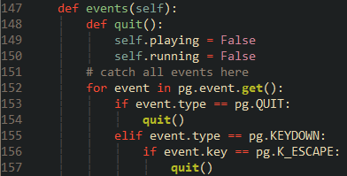

When ‘playing’ is set to false, the game loop inside the method ‘run’ will break and return to the ‘new’ method, which will then return to ‘main’.

A new method called ‘show_post_game_screen’ is then called. Which will display either a game over or congratulations depending on game state. If ‘running’ is false, then the game will bail from the method to avoid displaying it for a split second before terminating. Due to the while loop the call for ‘new’ was residing it no longer being true. ‘pg.exit()’ and ‘sys.exit()’ are called; terminating pyagme and the program respectively.

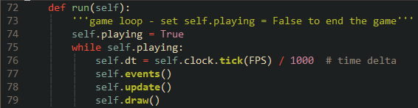

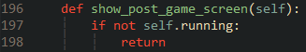

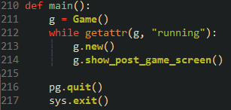

Inside Player I add twot lines that set running to false and a message to display on the post-game screen when the amount of lives reaches less than 0.

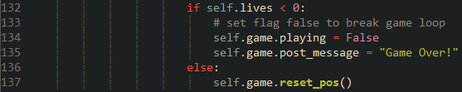

Inside ‘show_post_game_screen’ I add code to fill the screen with black and to draw text showing the post-game message and a prompt asking the user to press the enter key to play again.

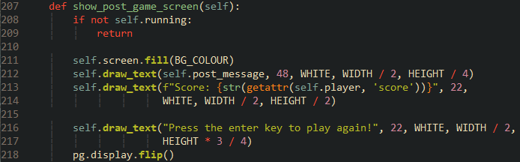

Upon lousing all lives the screen displays successfully.

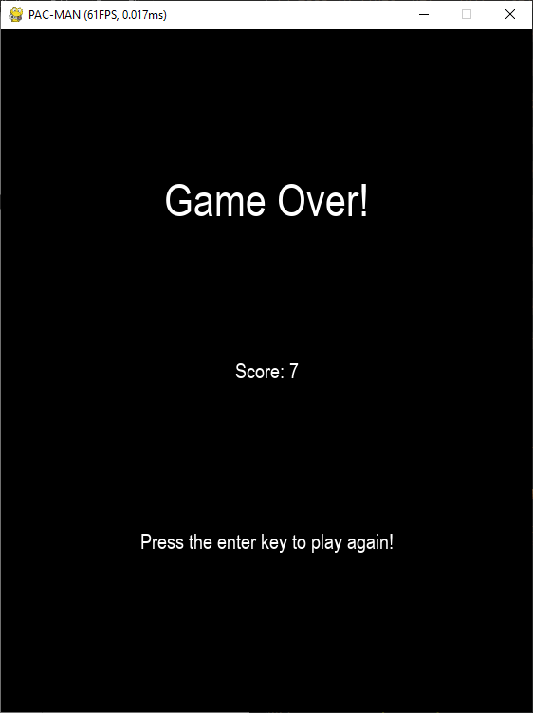

To register the pressing of the return key, a new method called ‘wait_for_key’ is created and called at the end of ‘show_post_game_screen’. ‘wait_for_key’ falls into a forever loop that waits for the player to either close the window or to depress return. ‘running’ is then set accordingly before breaking out the loop.

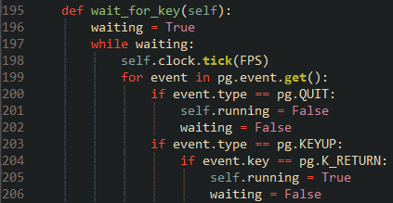

The player is now able to get a game over and reset the game with one key press.

Implementing the congratulations screen will now be simple since I already have screen for in implemented. Inside Pac-Man’s collision check I add a check after he eats a pellet to see if the number of pellets left in the maze is 0 or less. If so, ‘playing’ is set to false and the post-game message is set to an appropriate message.

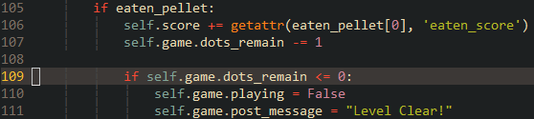

Upon eating all the pellets, the post-game message will be different than if the player got a game over.

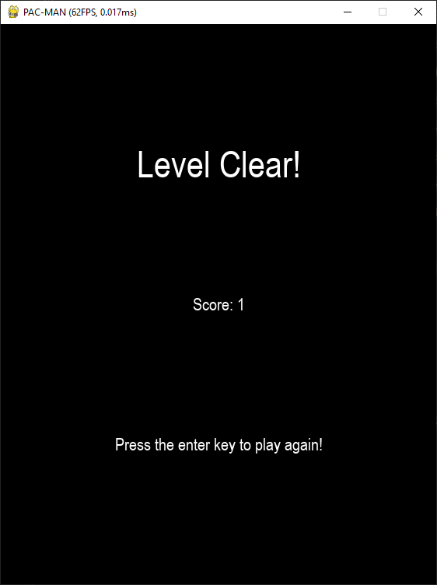

The final thing to add is the high score. Remember how I encrypted the text file holding the high score with a key? I will use the same key to decrypt the high score upon running the game and display it on the screen.

Using the file encryption tutorial, I took the class by at the end that can be used to create and load keys and encrypt and decrypt files [9] and modified it a bit to suit my game. I modified the ‘file_decrypt’ method to cast the decrypted high score to an integer to prevent garbage characters from showing around the score and returning it rather than writing it to a new file. To prevent the game from crashing if either the key or encrypted high score has been tampered with. I used a try except branch catch the error and set the score to be a string instead.

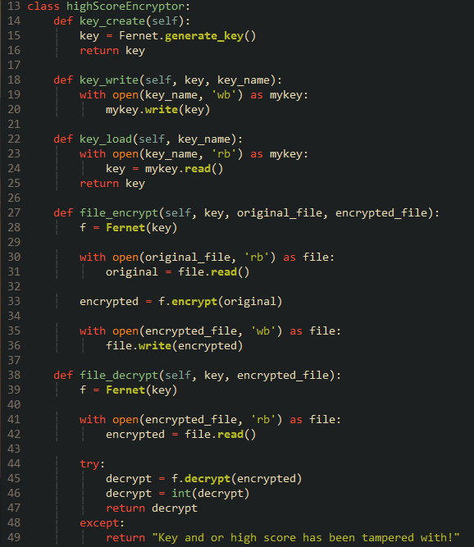

In ‘load_data’ I then instantiate this new class, grab the key and use it to decrypt the high score.

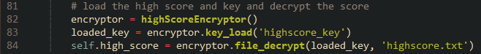

In ‘draw’, I add a new line to show the high score just below the score.



The game can now successfully decrypt the high score using the key and display an appropriate message when either the key or the high score file has been tampered with.

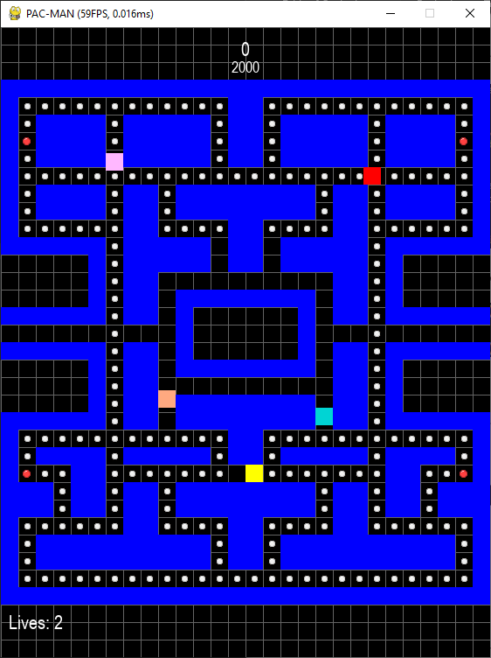





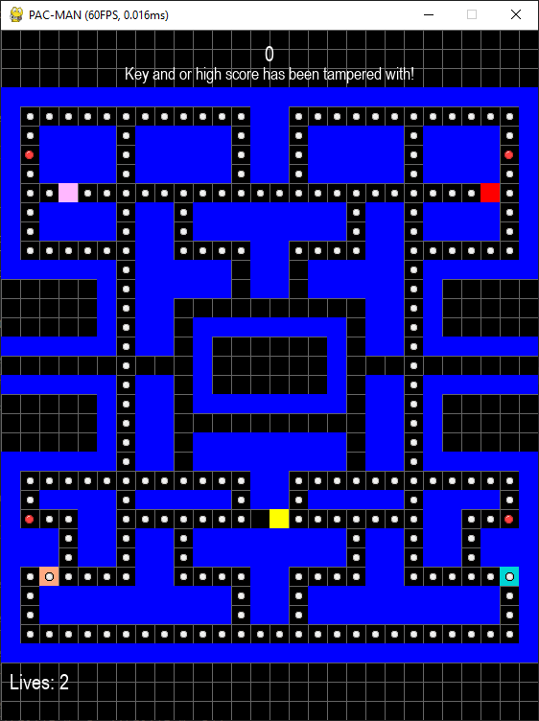

This measure prevents the player of changing the high score, the only way to bypass this protection is to create a new high score file and encrypt it using the same method.

When the player gets a new high score, that score will become the new high score. When the post-game screen appears, if the player’s score is higher than the high score, a celebratory message will appear and update the high score, else it will just display the current high score.

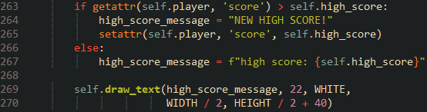

To test this, I set the high score to an easily achieved score. Upon surpassing the high score and showing the post-game screen, the correct message is displayed, and the high score is updated.

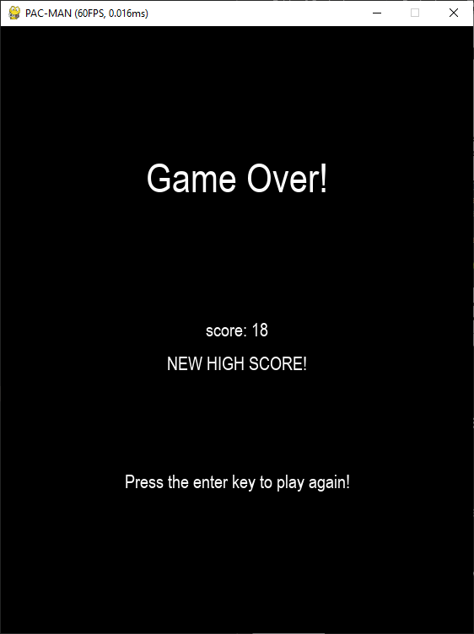 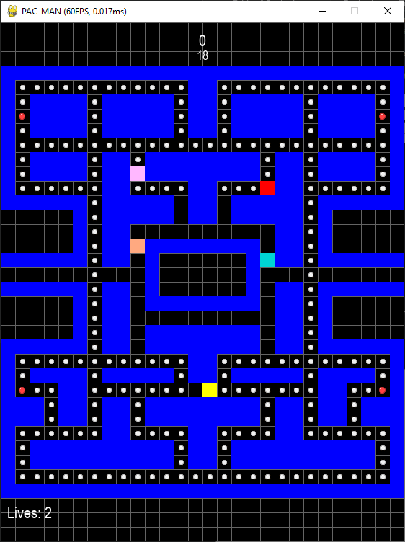

The new high score also needs to be encrypted and wrote into the text file. I modified the ‘file_encrypt’ method so it get passed in a value rather then a file name. This value needs to be encoded ino bytes before being enctypted so it cast into a string and encoded suing ‘str.encode()’. The bytes are then encrypted and written.

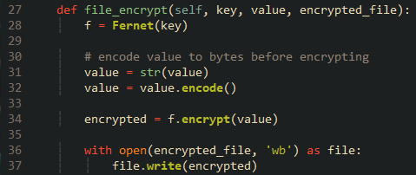

Back at the post-game screen, a new key is generated that is used to encrypt the new high score. This new high score will then be read and decrypted upon starting the game again.

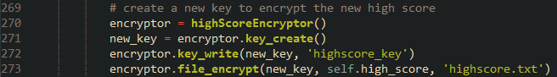

### Reflection

With the conditions and score implemented, the gameplay is effectively finished!

For some extra polish, I am going to implement pausing. Both a handy manual pause and small automatic pauses that occur during notable gameplay moments, like eating ghosts and getting caught. Both should make the game more appealing to play.

|  |  |
| --- | --- |
| **Done** | **To do next** |
| Implemented the win and louse conditions, the core gameplay loop is finished. | Program manual pausing. |
| Implemented the scoring system, providing the player with another goal besides eating all the pellet. | Program the short pause before the game play begins. |
| Implemented the high score system. Giving the game a competitive edge. | Program the pause for when the player eats or the pellets or dies. |
|  | Program a short pause after Pac-Man eats a ghost to add emphasis. |

## Iteration 8 – Pausing

Pausing is an integral part of the game. In the original game pausing was used to create emphasis to specific gameplay moments, one example is now there was a brief pause between eating a ghost and that ghost going into eaten mode to emphasize the satisfaction of temporarily removing a threat from the maze and getting bonus points for it. It was also used to highlight the player’s failures through the short pause between getting caught by a ghost and playing Pac-Man’s death animation so the player can notice how they died.

### Pre-Game Pause

The modular nature of my code should make to trivial to implement pausing. The idea is to have two attributes in the ‘Game’ class. One to count the time elapsed being paused and another to tell the amount of time the game should be paused, like how the ghosts’ flashing works.



I set ‘pause­_time’ to 1.5 seconds because I feel like it hits a sweet spot between allowing the player to get ready for gameplay and not being too long to feel tedious whenever the player dies and respawns.

Inside ‘run’ a check is added that skips the ‘update’ method if the time has not yet met the threshold. This means that all entities will case to move during this paused state.

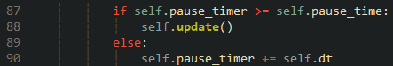

With the pause in place, I want also to add a visual queue for the player to understand that this pause is intentional and not some bug. I wanted to implement a countdown in the middle of the screen. To do so scrapped ‘pause_time’ in favour of using the timer as countdown. This saves me from having to juggle two attributes.

In ‘draw’ I add a line to draw the current time the countdown was on. I used the ‘.trunc()’ method from the ‘math’ module to truncate it into whole numbers.

While it does work it does look quite awkward; the only numbers that appear are 1 and 0 due to the truncation, which does not give the impression of a countdown whatsoever. So, I instead opted to display two strings instead, one being “READY?”, which will change to “GO!” in the last half second of the countdown.

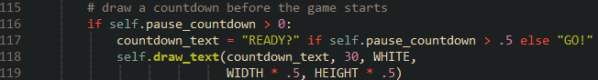

This is a lot better in my opinion.

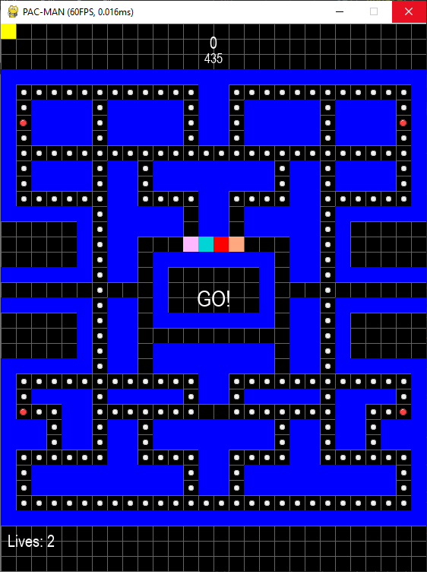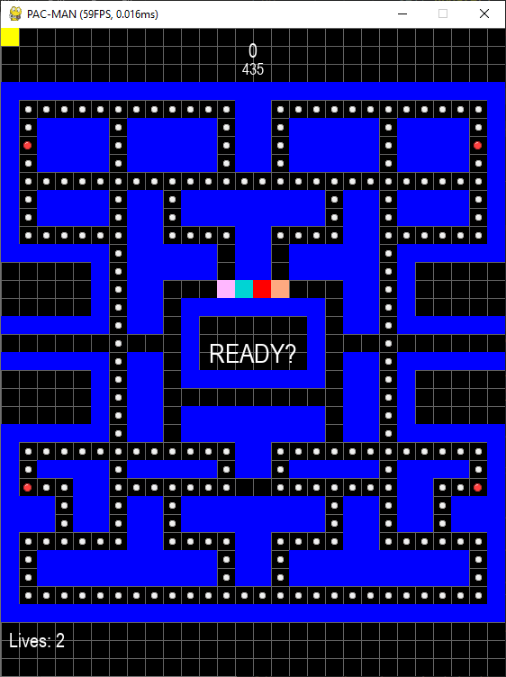

You may have noticed Pac-Man at the top-left corner of the screen. This visual bug is caused because I forget to set Pac-Man’s rect to his ‘pos’ in his constructor, changing that one line fixed this.





After Pac-Man’s and the ghosts’ positions are reset, the countdown is once again set to 1.5 seconds, ready for the next pause.

The countdown is initially initialised inside ‘run’, so that the pause commences even after a game over.

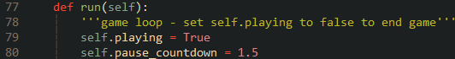

### Eaten Pause

I can use the countdown again for when Pac-Man eats a ghost, but that would mean displaying the countdown again, so a flag must be used.

I declare a new attribute inside ‘run’ called ‘pre_game_pause’ set to True. The text in the draw function checks this flag to see whether to draw the text or not.



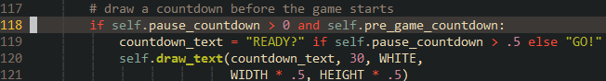

This flag is set false after the countdown has reached 0 and set true again when respawning.

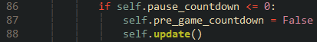

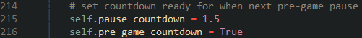

When Pac-Man eats a ghost, the countdown will be set to half a second.

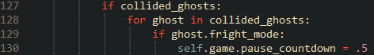

### Manual Pause

Pressing the escape key should be a means of manually pausing and resuming the game, with a message showing that the game is paused.

A Boolean value called ‘manual_pause’ is created inside ‘run’, set to false.



In ‘events’ I repurpose the escape key to toggle this Boolean value when the counter is not in use, this is to ensure that the player can’t pause the game during the other pauses.

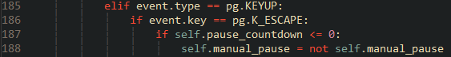

Back inside ‘run’ I add another condition for ‘update’ to be called and that’s if ‘manual_pause’ is false. The game will be paused indefinitely when it’s true.

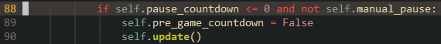

Finally, a check is made in ‘draw’ to see if this Boolean attribute is true. If so then some text saying, ’PAUSED’ will be drawn in the middle.

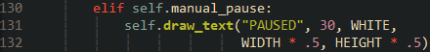

Manual pausing is now implemented.

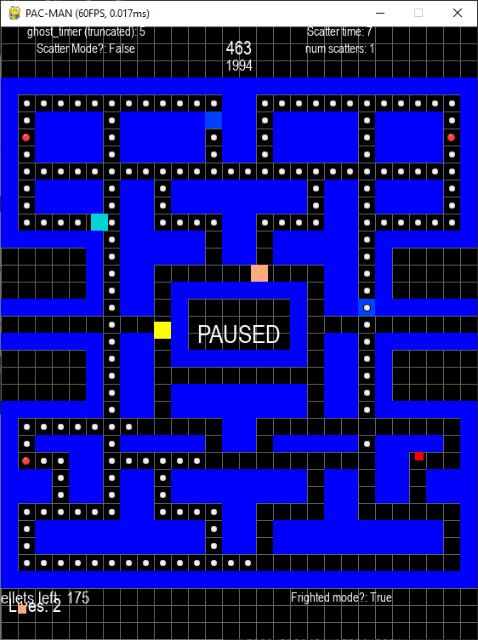

### Capture Pause

Implementing this pause was a little different compared to the other two. When Pac-Man louses a life, a flag called ‘death_anim’ is raised along a two second pause.

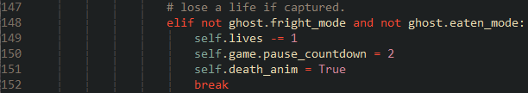

The code that checks whether the player depleted all their lives or not has moved to the game loop. After the pause counter has reached zero the loop will lower the ‘death_anim’ flag if its raised and call ‘reset_pos()’. Then it will check if the players lives are depleted. If so, set the appropriate message and lower ‘playing’ to break out of the loop on the next iteration. 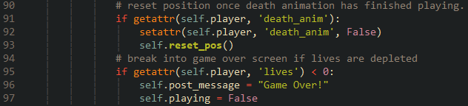

### Level Clear Pause

Like the capture pause, a flag is raised if all the pellets in a maze are eaten. This flag is then checked when the game un-pauses, if raised the appropriate message is set and the loop broken.

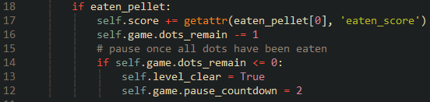

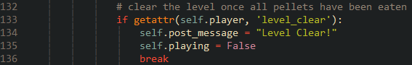

### Reflection

At this point the game is in a very playable state. These pauses should not only help with accessibility but enhance gameplay experience.

Next, I am going to deviate a little from the success criteria and do some improvements to the code and game. This should not take long and will make the gameplay experience better and the code more maintainable.

|  |  |
| --- | --- |
| **Done** | **To do next** |
| Implemented an on-demand manual pause that does not overwrite other pauses. | Revaluate how attributes are accessed by using getters and setters. |
| Implemented a short pause before the game play begins to prepare the player. | Rename method and attribute names to make sure that they are easy to understand. |
| Implemented the pauses for clearing a level to tell the player they have won. | Fix some bugs pertaining to ghost movement, target, and states. |
| Implemented the capture pause to show the player who captured them. | Refactor the methods related to movement to make codebase smaller. |
| Implemented the short pause after eating a ghost to add emphasis. | Implement smaller hitboxes to make the game fairer. |
|  | Tweak Pac-Man’s movement a little. |
| Add more dynamism to the scoring system. |

## Iteration 9 – Refactors, Fixes, Optimizations and Quality of Life Changes

This will be the final iteration before finally adding graphics and animation. This will consist of tweaks to the codes architecture to make it easier to read and extend, small optimalizations, namely to maze loading and some tweaks to hit detection to make the gameplay more forgiving.

### Encapsulation, Getters and Setters

One key principle of OOP is encapsulation; an object’s private attributes cannot be directly accessed and modified, the object’s getters and setters must be called instead, this ensures that access to an object’s information is controlled to so that its always in an intentional state [12]. Unlike other programming languages, Python does not necessarily have private attributes, but a convention exists that makes it more difficult to directly access attributes, adding two underscores before the attribute’s name [12].

I have also been using the functions ‘getattr’ and ‘setattr’ to get and set attributes, but there are still parts in the code that still use direct access.

By doing this I aim to make the object-oriented design more in line to what is expected from in other languages, making those versed in languages outside Python understand the code better.

To speed things up I have a vim plugin that’s a port of Jedi, a popular linter and autocomplete engine for Python. The plugin allows me to mass rename variables within scope, even across scripts!



Unfortunely, I did run into some issues pertaining to Pygame after setting all the attributes to private, it seems like some internal functions of Pygame rely on the direct accessing of attributes. So I undid all my renames and settled on using getters and setters instead.

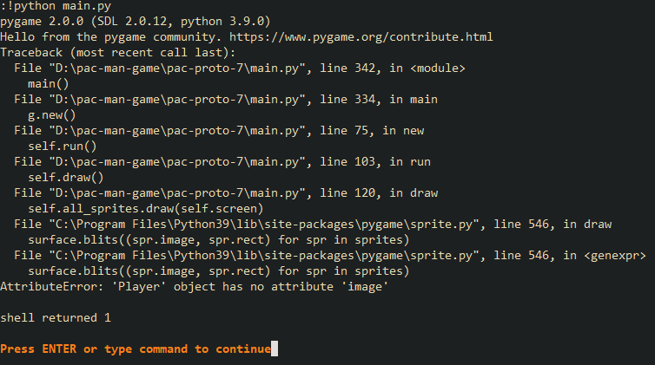

The largest change was inside ‘reset_pos’. I have also removed the line of code that aliased ‘pygame.math.Vector2’ and instead imported ‘Vector2’ directly. Saying ‘Vector2’ as opposed to ‘vec’ is more descript while still being shorter then ‘pygame.math.Vector2’.

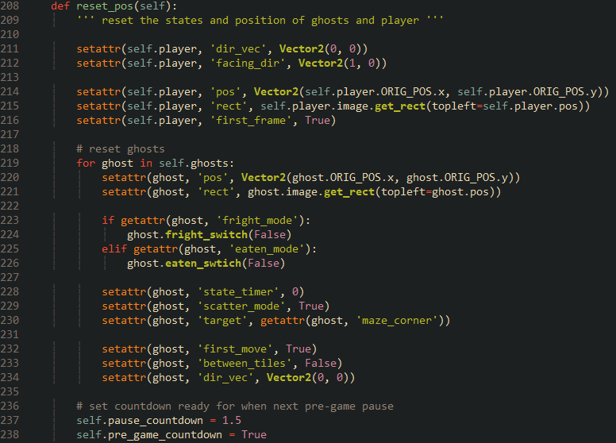



### Improving Variable and Method Names

The names of specific variables and method names, while brief, do not fully convey what they are storing or what they are used for.

One example is the varaible names ‘next_pos’, ‘last_pos’ and both variables are used by the Ghosts to determine whether they have reached the next tile and to check if a direction will cause them to U-turn, respectively. Both names fail to convey the tile-based nature of the game. Another example is ‘dir_vec’, the abbreviated nature of the name means it is not fully obvious what it means at first glance and even when knowing what it means, its hard to keep track of the name amidst all the other code.

The method ‘check_dist’ is overridden by Clyde to check if Pac-Man is within an 8-tile radius of him. Just like the variables, the name does not fully convey what the method does, the name should summarise the purpose, with docstrings providing a more detailed explanation.

I someone was to modify my code they may have to spend a considerable amount of time deciphering names, So I looked at all the names in the code base and renamed them accordingly. This job was easier thanks to the aforementioned vim plugin, but it did understandably fail to recognise varaible names inside getters and setters, so those required manual change.

Key changes include remaining most attributes in the ‘Player’ classes constructor. Note how the ones pertaining to position and vectors now use full words.

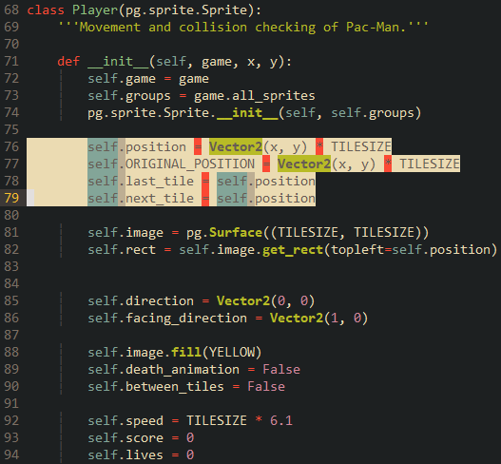

The same was also done in the ‘Ghost’ class.

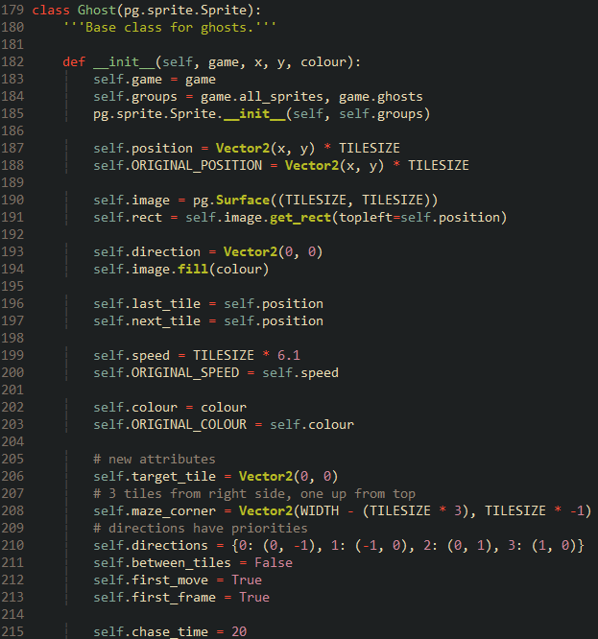

Method names such as ‘check_dist’ have be renamed to something more explanatory.



Most method names in ‘Game’ have been renamed with their docstrings changed to provide a better explanation. Here is what the class looks like with folded methods so that they all fit in a single shot.

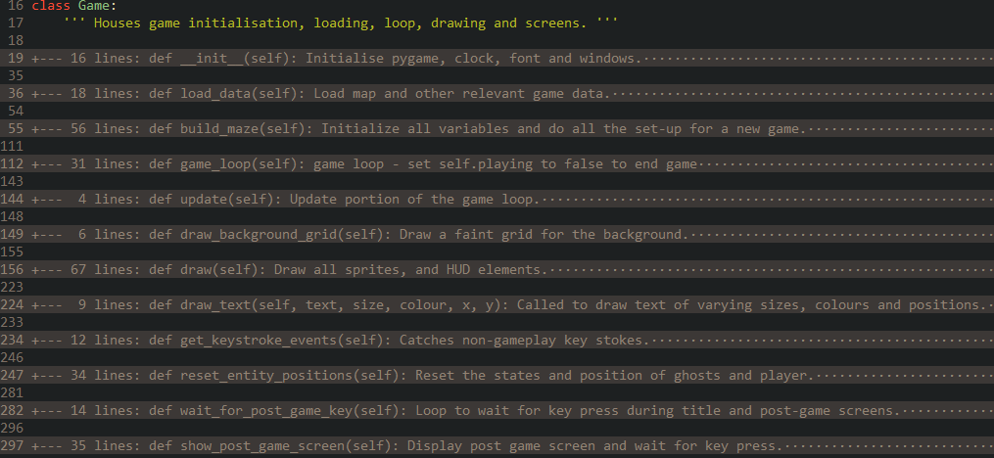

### Fixing Bugs in the Ghosts’ Behaviours

While playing I noted some faults with the ghosts’ behaviours, especially with Inky’s target tile assignment. These bugs are detrimental to gameplay and must be fixed.

#### Fixing Pinky’s Incorrect Tile Assignment

Pinky should target four tiles ahead of Pac-Man, but instead its only two. This was a simple fix, apply a magnitude of four tiles (80 pixels) to Pac-Man’s facing direction instead of two tiles.

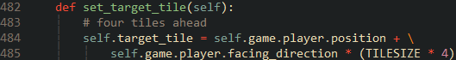



Since her target is now further away from Blinky’s, she now tries to pincer Pac-Man more often, rather than just tailing Blinky.

#### Preventing Eaten to Frightened Mode

When Pac-Man eats a power pellet any eaten ghost will switch into frightened mode, this was fixed by adding an extra check in the ‘Player’ classes ‘check_collision’ method. When Pac-Mans eats a power pellet, he will check if the current ghost in the iteration is in eaten mode, if so then skip calling their ‘toggle_fright_mode’ method.

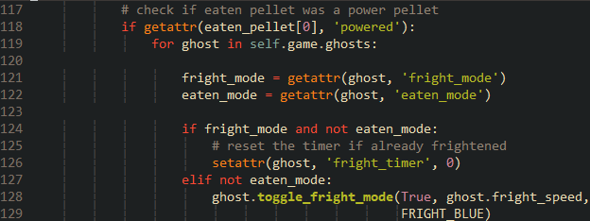

I also changed the first check to get the Boolean value ‘powered’ from eaten pellet rather than iterating through another sprite group again, this is more performant.

#### Fixing Inky’s Target Tile Calculation

Inky’s movement while in chase mode did not seem to be anywhere close to the movement in the original game. This was because the algorithm to find his target tile was completely wrong for two reasons: the distance calculation only yielded the distance between the immediate position and Blinky, not the direction and that inversing the direction was completely unnecessary. These combined put his target tile in a totally arbitrary location way away from the mazes, meaning that he doesn’t play much of a role in the gameplay than be should.

The line to find the immediate position was changed from simply grabbing Pinky’s target tile: one because Pinky could be in scatter mode while Inky is in chase mode and two because Pinky is now targeting four tiles ahead when this tile should only be two.



The distance calculation was removed in place of a subtraction of the immediate position by Blinky’s position. This gives the vector between these two points. I created a simple graphic to demonstrate this.



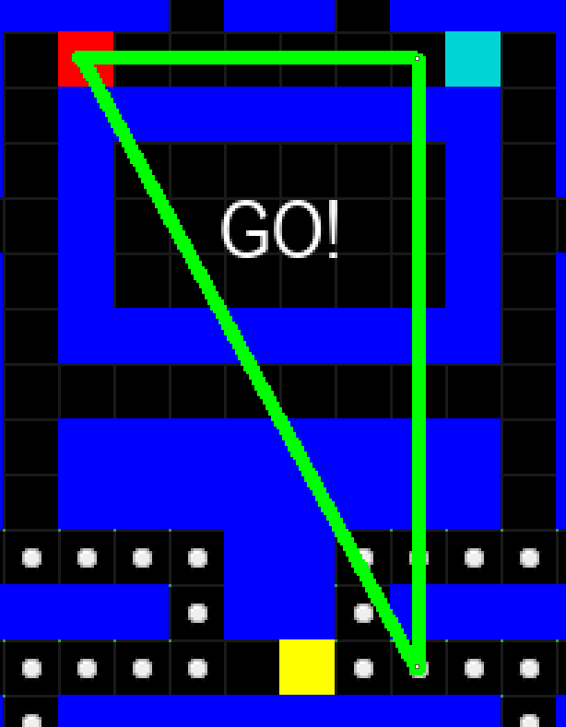

This vector is then added to the immediate position to find the target tile, in this case it is offscreen.



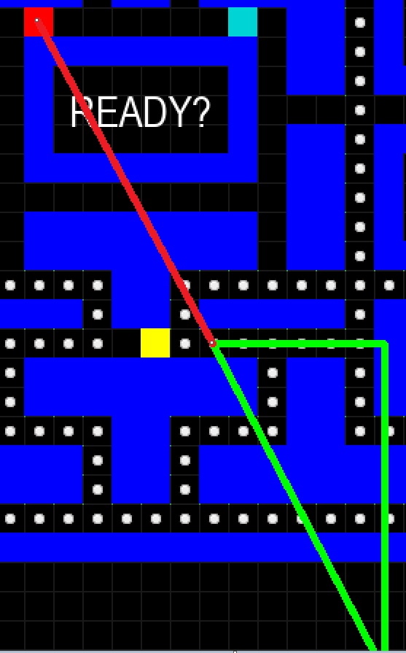

Inky is now a lot more involved in gameplay; encompassing Pac-Man when Blinky is in hot pursuit. Another plus is that the algorithm is more efficient due to the omission of inversing the distance and the entire distance calculation, which required square rooting.

#### Fixing Clyde’s Temporary Scatter Timing

I mentioned previously that each ghost how only sets their target tile when not between tiles instead of every frame. This meant that Clyde would be in his temporary scatter mode for longer than two seconds since the timer for it no longer increments every frame. As a work around I set the scatter time to 0.2 seconds, but this band aid fix fails if the ghosts’ speeds are increased; the method will be called at a faster rate.

To fully fix this I made a new method called ‘increment_temp_scatter_timer’, called every frame in the ‘Ghost’ class’ ‘update’. This is overridden by Clyde to increment the timer when in temporary scatter mode.



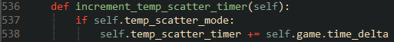

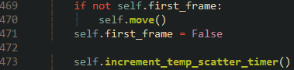

Now the scatter time can be put back to two seconds without having to worry about speed. Clyde could be traversing 100 pixels a frame yet still only scatter for two seconds.

#### Fixing Pac-Man Targeting

During play testing I draw little squares that represent where each ghost is targeting, I noticed that when Blinky and Clyde target Pac-Man their target is updated every frame instead of every time they are not between tiles. To fix this I changed the target assignment for Blinky and Clyde to create a vector of Pac-Man’s position before updating as opposed to just storing it.



I believe doing this prevents a ‘link’ that happens when you assign an attribute to another. When Pac-Man’ position is updated every frame that also reflects in the ghosts’ target tile. This was also the reason why the troublesome bug with resetting Pac-Man and the Ghosts’ original positions occurred.

### Movement Utility Class

The code responsible for moving Pac-Man and wrapping him around the sides of the screens is identical to that of the same code for the Ghosts. I would be nice to compartmentalise the code into its own class that both ‘Player’ and ‘Ghost’ can inherit from. This will reduce the overall lines of code and ensure that any changes to movement reflects across all entities.

I start by adding a new class to the ‘sprites’ script called ‘MovementUtilities’.







It is first method is called ‘screen­_wrap_check’. The code is cut and pasted from the method of the same name inside one of these classes. The same method is now removed from each class since they are now using this instead.

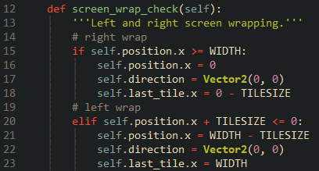

Transferring the movement methods was a little trickier; one key difference in movement between the two is that Pac-Man accepts user input. So, I moved all the code responsible for user input into Its own method called ‘get_movement_keys’.

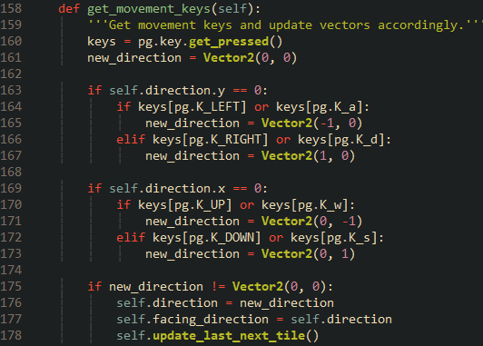

This calls a new method in the utility class called ‘update_last_next_tile’. ‘

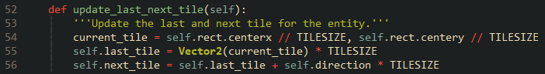

get_movement_keys’ is called the at the start of update.

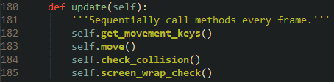

Inside the ‘Ghost’ class the assignment of ‘last_tile’ and ‘next_tile’ is moved over to ‘update’ and replaced with the method instead.



Now the contents of the ‘move’ methods can be transferred over to the utility class without issue. 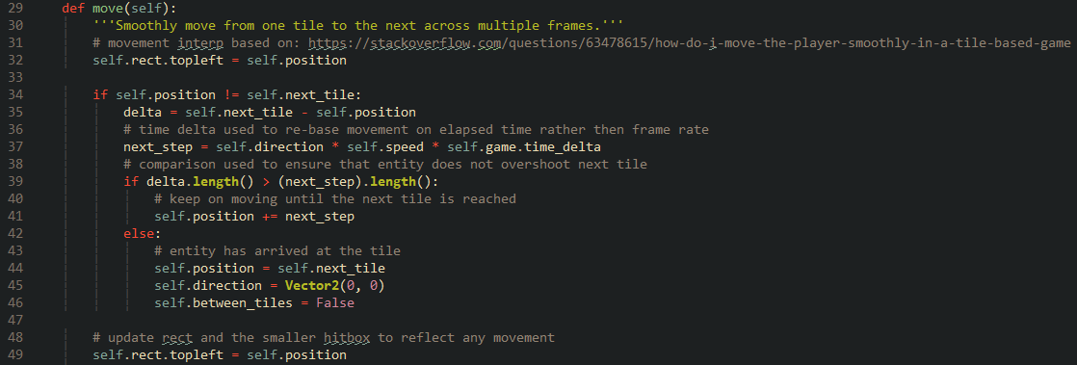

Upon further inspection the class has one big issue. The class relies on both the ‘Player’ and ‘Ghost’ classes having the exact same attribute names. If for example ‘position’ was changed to ‘pos’ for one class and not the other, an error will be raised as soon as it calls one of the methods. The utility class needs to become self-contained.

Instead of directly assessing attributes, they are now instead passed into the methods by value. The local variables are then returned and stored back into the attributes.

For example, the method move now looks like this, note the passed in values and what is returned:

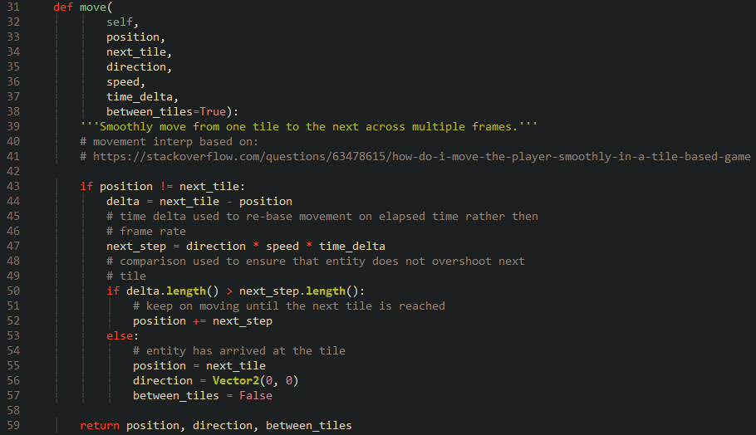

Now when this method is called the attributes are passed in, with the retuned values updating the necessary attributes.



The same has been done for the other methods:

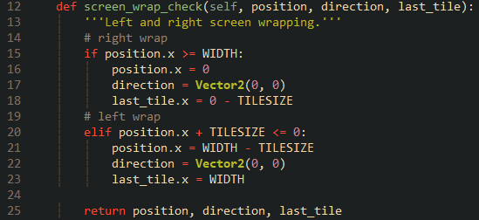



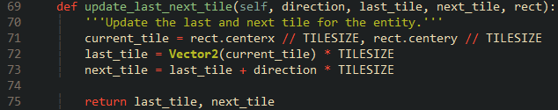



I also added a new method to update the rect of an entity. This was done to prepare for the next improvement, smaller hitboxes.

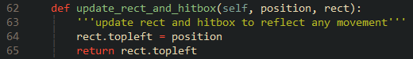



### Smaller Hitboxes

One aspect of the game that annoys me is the fact that you are considered caught if a single pixel of Pac-Man’s sprite touches a Ghost. Not only is this frustrating and for some unfair, but it reduces the tension of barely escaping from the grasp of a pursuing ghost. I wanted to make the hitboxes smaller.

I found a thread on Stack Exchange that explained a method of doing so, it required making a separate rect called ‘hitbox’ and inflating it by a negative size and displacing it by an ‘offset’ from the entity’s position. Then when updating the rect, update the hitbox as well and apply the offset [13].

In the ‘Player’ and ‘Ghost’ class constructors I added both attributes.



I then modified the utility method to update the hitbox along with the rect.

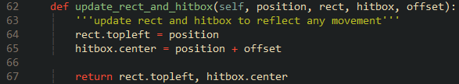

To check if the hitboxes are in the correct place, I added code into ‘draw’ to draw both the rects (in green) and hitboxes (in black).

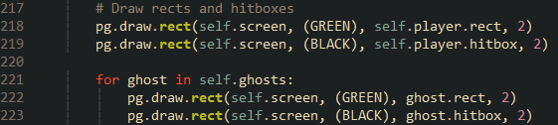

As you can see the hitbox is smaller than the rect. Both successfully update to their respective entity’s positions every frame.

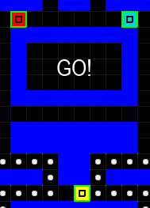

To handle the collision detection between hitboxes, I followed the answer in the thread and added a new method to ‘MovementUtilities’ called ‘hitbox_collide’ which simply returns true if two hit boxes have collided. [13]

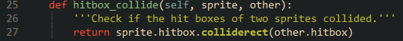

Inside Pac-Man’s ‘check_collision’ I modify the code that creates a list off all the collided with ghosts on that frame to pass in ‘hitbox_collide’ as the ‘collided’ argument which will call the method and either return true or false. [13] So if the rects are overlapping it won’t count as a collision until the hitboxes overlap.



When running the game with the hitboxes drawn, shows that Pac-Man will only be caught when the hitboxes overlap.

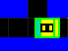

I also created a hitbox for the pellets, (shown in red) and added ‘hitbox_collide’ as an argument. This is to further the impression that Pac-Man is eating the pellets as he is now completely over them before they disappear opposed to them just vanishing in front of him.

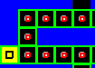



### Refactor of Direction Decision Algorithm

I refactored the algorithm to not require the calling of a nested method to evaluate a direction, the code looks cleaner now.

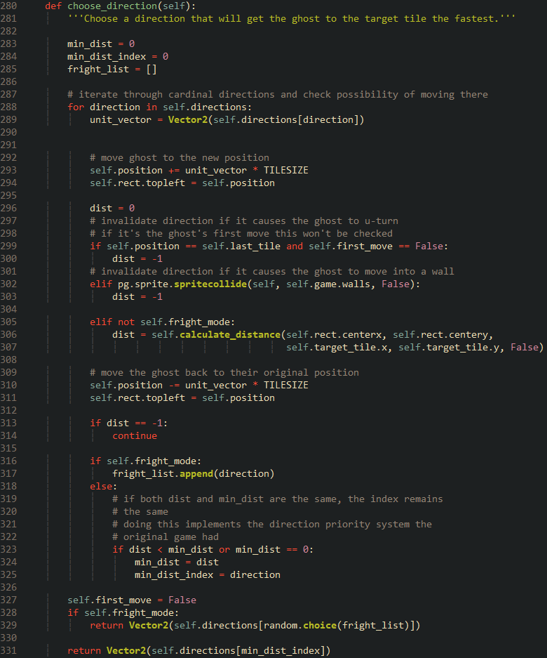

### Minor Improvement to Pac-Man’s Movement

When the player presses a key to move Pac-Man, he moves then instantly rebounds back to his original position if his rect collides with the rect of a wall. While this code works, the order of events does lead to an exploit. Pac-Man’s facing direction updates, so Pinky’s target tile also updates, despite Pac-Man not visibly moving. This can lead to instances where the player can manipulate Pinky’s behaviour, more so than the original game.

To patch this, I commented out the check for walls in the ‘Player’ class’ ‘check_collision’ method, since it won’t be needed anymore.

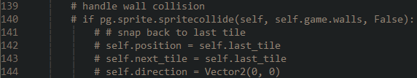

A nested method called ‘check_for_walls’ is added. Like how the direction decision algorithm works, Pac-Man’s position is shifted to check for walls. A Boolean value is returned.

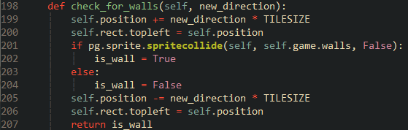

In ‘get_movement_keys’ the method is called whenever the player presses a movement key if the method evaluates to false, then the movement can commence.

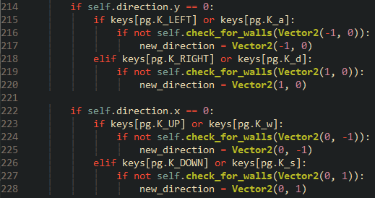

Now Pac-Man is unable to update his direction if that direction leads to a wall; effectively patching the exploit.

### More Dynamic Score

For the final improvement I want to make the scoring element more dynamic to the gameplay. In other words, the player is to be punished for dying with a halving of their score and rewarded for eating a streak of ghosts with a multiplier for the eating points. Both acts as a deterrent for sloppy and good gameplay, respectively.

The score halving is simple, when the player collides with a ghost in normal mode, preform an integer division of two on the score.

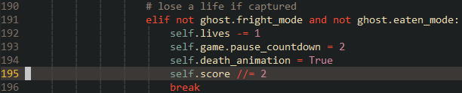

As for the multiplier a new attribute is defined in the ‘Player’ class’ constructor called ‘eaten_multiplier’.



When Pac-Man eats a frightened ghost, multiply the eaten score by the multiplier and increment it.

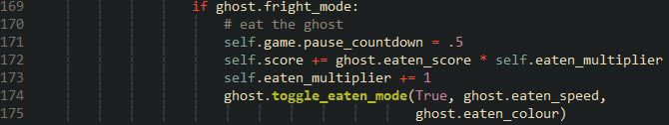

And when an eaten ghost reaches the ghost house, set the multiplier back to one.



That is all the refactors and improvements that I wanted to make. Now it is time to finally add the graphics.

### Reflection

The refactor has generally made the code more compact. And while I think passing in attributes to the utility class methods was a good idea, it does make the calls to those methods look messy as a lot of data is passed in and retuned. I may look back at this If I have the time.

Now it is time for graphics and animation. While this is quite low on my priority list for features to implement, tutorials and research have shown me that there has good algorithms and optimisations to be made.

|  |  |
| --- | --- |
| **Done** | **To do next** |
| Used getters and setters to access object attributes, reflecting practices in other programming languages. | Slice graphics from a sprite sheet |
| Renamed method and attribute names, demystifying their purpose. | Transform (flip, rotate) the existing graphics to make new ones. |
| Fixed all bugs related to ghosts, improving gameplay experience. | Pass in these graphics to the correct objects. |
| Packed all movement methods into an inherited utility class making the code base smaller and easier to maintain. | Program Pac-Man eating animation, changing the animation’s orientation based on which direction Pac-Man is moving in. |
| Added smaller hitboxes to add leeway when evading the ghosts. | Program Pac-Man’s death animation. |
| Tweaked Pac-Man’s movement to prevent exploiting Pinky’s movement. | Change ghost sprite based on direction to give the impression that they are looking. |
| Made scoring more dynamic to encourage an aggressive style of play but comes with high risk. | Add graphics for frightened mode and eaten mode. |
|  | Use Tiled to redesign the maze. |
| Implement maze flashing. |

## Iteration 10 – Graphics and Animation

This will be the final major iteration on the game. I will use the sprite sheet that was mentioned in the design section and slice the sprites from it and assign it to the corresponding entities. One method I have been thinking of is to append the sprites into a 2d list. The entities will then have pointers to display the correct graphic. For example, Pac-Man’s eating frames will be stored in multiple sub-lists each representing each orientation. One pointer will update when Pac-Man changes direction to point to the correct sub-list while another pointer iterates through each frame with a delay.

### Loading the Graphics

All sprites will be sliced from the sprite sheet using a method demonstrated by KidsCanCode’s platformer tutorial, a class called ‘Spritesheet’ is created that uses the passed in positions and dimensions to slice and return a portion of the sheet [14]. I copied class and added it to my sprites script and instantiated it inside ‘load_data’.

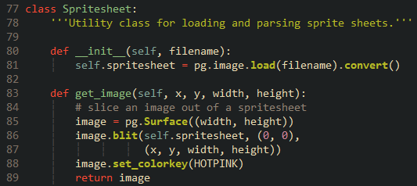



Now I declare a set of lists that will hold each set of graphics.

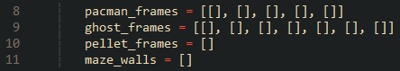

Under this is a bunch of for loops that will iterate through the sheet and append the frames. To minimise the size of the sprite sheet, some sprites are generated using Pygame’s transformation functions. One example of this is Pac-Man’s eating frames. The initial frames on the sheet are appended and using these, a rotated or flipped copy is made and appended to get all the orientations. This took quite a bit of debugging to get right but was worth it as its not only easier to manipulate, but also more performant because expensive image transformations can be avoided at run-time.

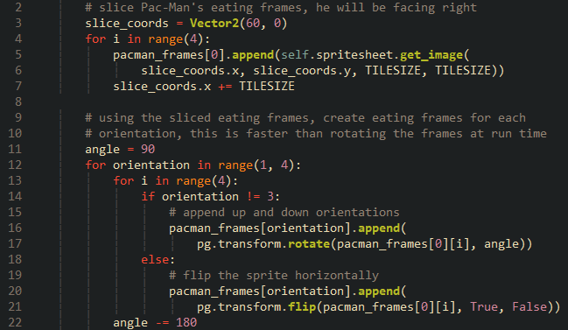

Pac-Man’s death frames are then appended.

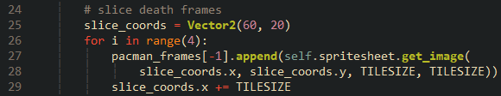

The ghost frames were a little different. I wanted to use the index of the direction with the shortest distance that the direction decision algorithm provides. I reordered the ghost frames to represent the order of iterated directions. I also removed the left and fright frames since the ghosts were looking straight on in the original game.

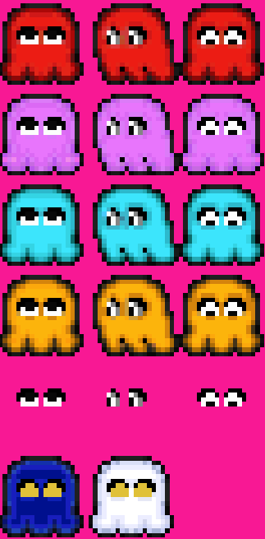

Like Pac-Man, the right frame was appended after each sub-list iteration.

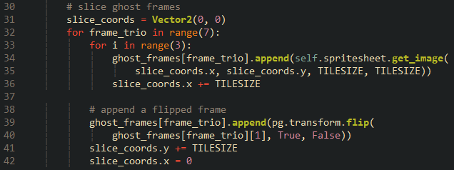

The pellet frames were easy to slice and append thanks to them only having to be a one-dimensional list. As for the maze walls, I will mention them later.

For the lists to be passed into the appropriate entities, I moved the maze building into ‘load_data’. I did not want to turn the lists into attributes since they will never be used, and I did not want to perform the slicing upon entity creation as that would mean performing slicing for every pellet that’s created for example, needlessly adding to loading times.

### Pac-Man’s Frames

Pac-Man’s frames are passed in and transformed into an attribute. A series of new attributes are added relating to animation, and his image is set to be the first frame facing right.

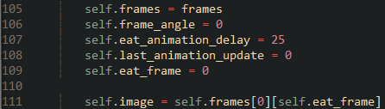

To get his eating animation working. I again followed the KidsCanCode tutorial for making a platformer, in it a method called ‘animate’ is called every frame. It checks to see if the time elapsed since the last frame update is over the delay. If so, then increment the eat frame and modulus it by the length of the sub-list so it does not overflow. Then update the image [14]. I modified the code slightly to account for the fact that I am using a 2d list.

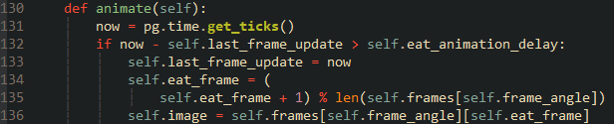

Handling orientations was as simple as setting ‘frame_angle’ to that of the corresponding direction once the player hit a direction key. At the end ‘animate’ is called to increment the frame.

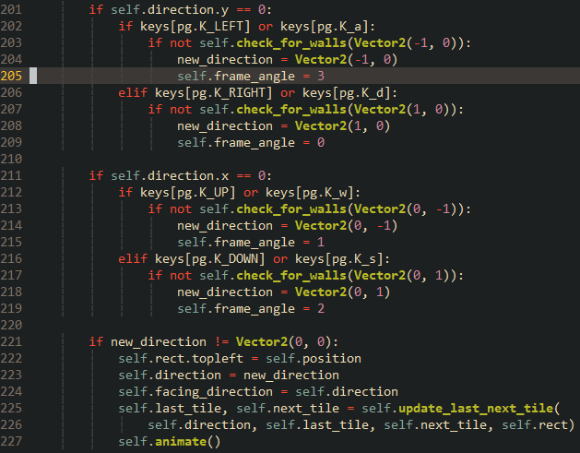

When running the game, the animation plays out fine, but will stop when the player lets go of the key. If they let go when Pac-Man is between tiles, it will look like he slides over to the next tile. This looks quite bad, but thankfully the fix was easy. Move the call to ‘animate’ over to ‘update’ and only call it when between tiles. Also pass in the attribute to move and stored the retuned Boolean value.

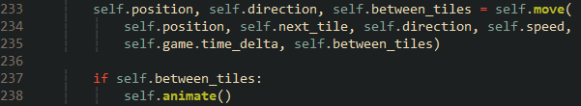

Pac-Man’s eating animation is now complete.

### Ghost Frames

Importing the ghost frames was a little different. Each ghost is given the list and has a pointer called ‘colour_frame’ set to the sub-list of their corresponding colour. ‘frame_direction’ points to the sub-list frame representing their corresponding movement.

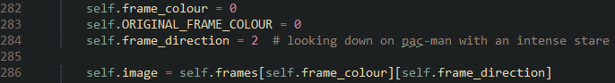

The other ghosts that inherit from the ‘Ghost’ class overwrite ‘frame_colour’ to point at their colour. For example, Pinky points at the first sub-list, since that has her colour.

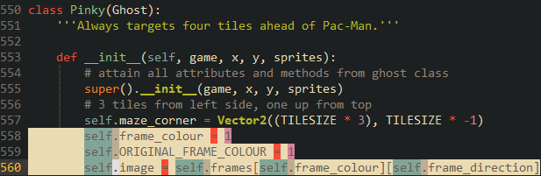

The direction decision algorithm saw some light modification. After picking the index it will be stored into ‘frame_direction’ and the image will be set to the correct direction, provided the ghost is not in frightened mode.

Speaking of frightened mode, inside, ‘toggle_fright_mode’ has been modified so that the correct frames are shown opposed to just filling the rect with a solid colour. Reverting the image when exiting the mode is unneeded because it will reset when the direction decision algorithm is called.

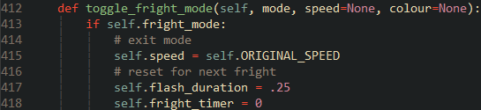

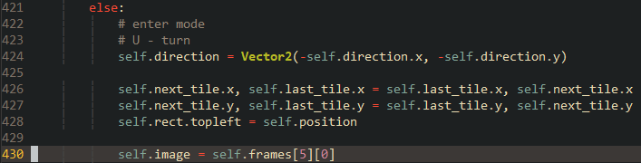

‘check_fright_flash’ is given similar treatment, with the switching between white and blue being substituted with the appropriate frames.

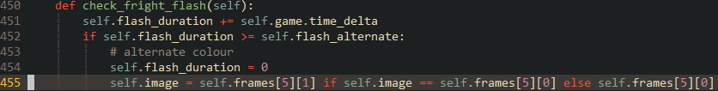

‘toggle_eaten_mode’ is also modified.

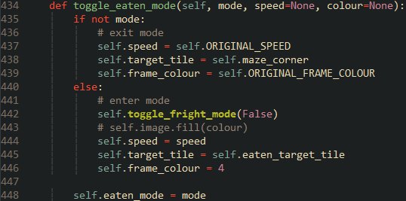

This completes the ghost frames. The game is beginning to feel more alive.

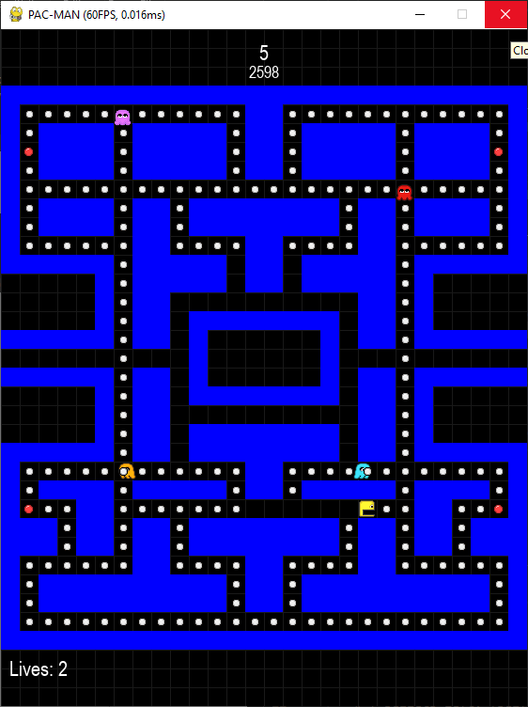

### Win and Death Animations

When Pac-Man gets caught, the ghosts should disappear, and he should play his death animation. When winning he should set his image to the first frame of his death animation.

To achieve this, I first added a new attribute called ‘death_animation_delay’ in ‘Player’ set to a rate of 250ms. I then extended the duration of the death of 5 seconds to account for the whole animation.

I then modified the ‘animation’ method to account for the death animation. I did encounter a issue with the ‘eat_frame’ pointer going out of range but that was solved by incrementing the pointer after setting the image. After the last frame of animation Pac-Man should disappear by filling the image with hot pink. Because the sprite sheet colour keyed hot pink, the entire frame will be transparent.

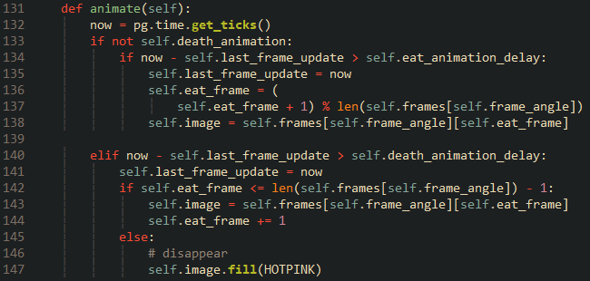

Then in the game loop under the decrement of the pause counter a check is added to see if the player is currently playing the death animation. If so, then check if the pause has reached under 4 seconds, and if so, call animate and make the ghosts disappear. I did have a bit of trouble making the ghosts disappear, the fill trick seemed to overwrite the frame the ghost was on with hot pink, causing them to phase in and out of visibility. The solution was to set the image to the third frame of the sub-list that houses the frightened frames, which is a frame containing just hot pink.

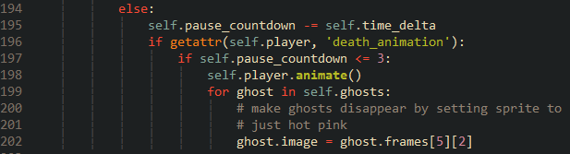

Now Pac-Man can play out his death animation.

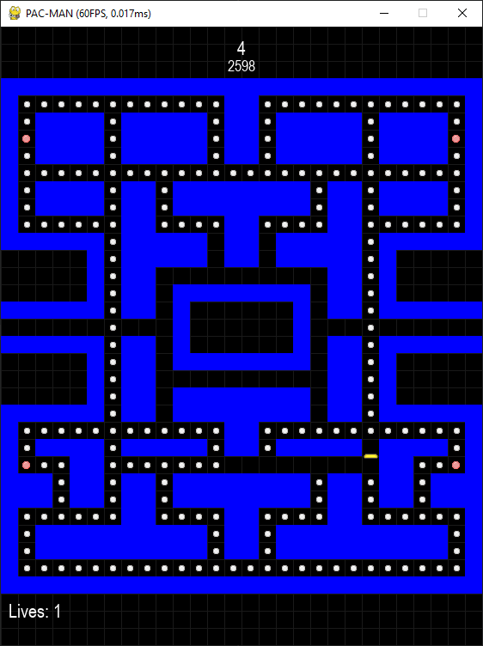

Showing the win animation is a similar story. Back at the pause decrement, another check is done to see if the player was cleared the level, if so, check if the countdown is under four seconds, if so then set Pac-Man’s frame and make the ghosts disappear.

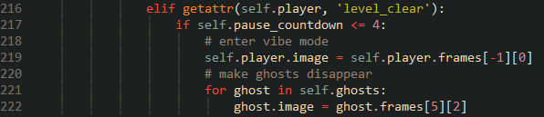

As a final touch I also wanted to make the maze flash Taking cues to how I handled the ghost flashing. I set two new attributes to handle the maze flash.

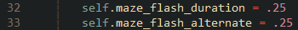

Then I increment the flash duration and check if it exceeds the alteration. If so, then set it back to zero and alternate the colours. The alternation required some modification of the ‘Wall’ class’ constructor, I had to set a new attribute called ‘colour’ and fill the rect using it, then this attribute is changed and used to fill the rect during the flashing.



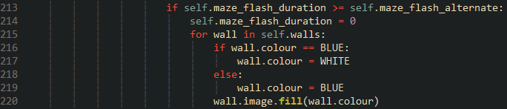

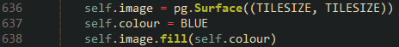

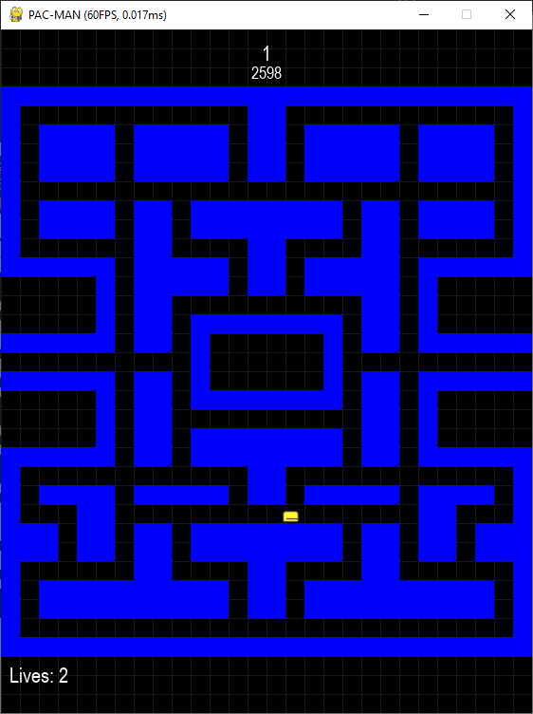The maze will now flash upon Pac-Man eating all the pellets.

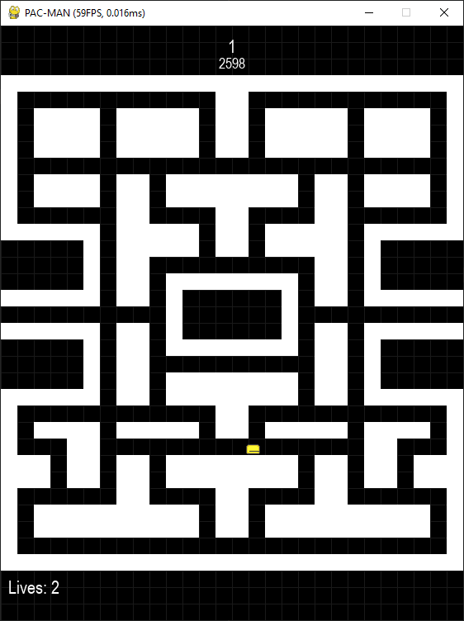

### Pellet Frames

The pellets were the easiest to implement, just pass the frames and set the image. To get the flashing working I added two new attributes to the ‘PowerPellet class to handle animation.

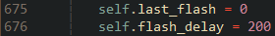

And a new method to handle the flashing.

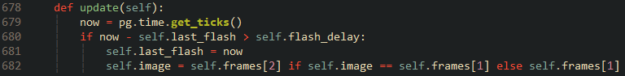

This will be called every frame to swich the power pellet frame on a delay of 200ms.

And it works.

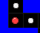 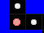

Finnaly the frames of each entitiy is reset upon restarting after lousing a life. While adding these I thought it would be better for entity resetting to within the entites as opposed to having a series of getters and setters. The method, now renamed ‘reset_entities’, now calls new methods from both classes. List comprehention is used to call each ghosts’ method because it looks neater.

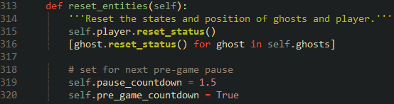

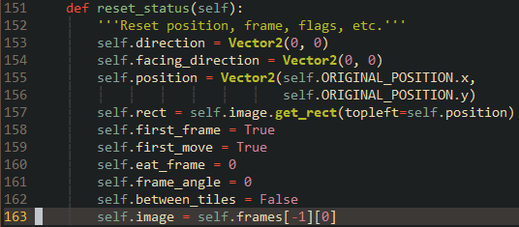

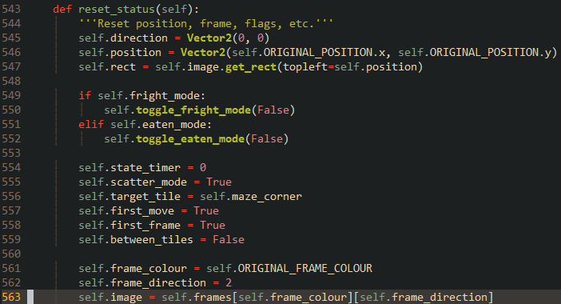

### Fixing an Eating Animation Bug

One bug I noticed with Pac-Man after his position is reset is that his eating animation will play on the spot instead of being set to the first frame of his death animation. This was solved by using the ‘first_frame’ attribute to check whether to call ‘animate’ or not. The method is called when the flag is lowered.



### Maze Graphics

Now, time to talk about the maze graphics, or more specifically the various tile images that comprise the maze. The method of using a text file to generate a tile map, while good for maps with sparse detail, becomes completely unsustainable when a map has dozens of different images. Each image must be represented by a unique character in the text file, not to mention the various rotations that image can be. If I were to continue using the text file it would become a garbled mess and make the maze generation more complex.

Fortunely, there is a way to create tile maps that can be easily imported into Pygame, and that is using a program called Tiled. Tiled is a free, open-source editor for making tile maps with a wide range of compatible engines and frameworks [15], including Pygame via the Pytmx package [16].

To aid me I followed along with three parts of KidsCanCode’s tile-based game tutorial series. The three parts talked about using Tiled, importing tiled maps, and creating obstacles [17] [18] [19]. The last does lead to a significant optimisation that I will talk about when I get there.

First was to create the tile map. I opened Tiled and created a new map with the same dimensions as the game screen.

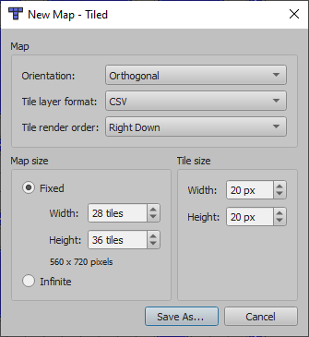

Then I imported the sprite sheet and went to work recreating the maze. I discovered that more tiles were needed to fully create the maze, so I did have to add more tiles to the sprite sheet which did lead to me resetting several times, but I got there in the end.

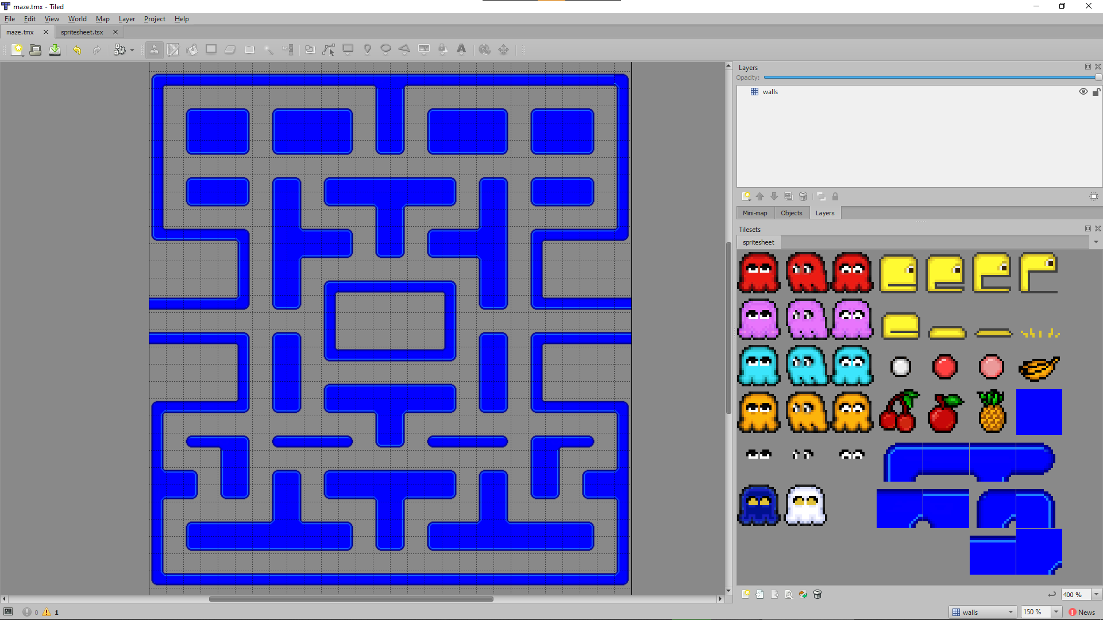

#### Importing the Map

With the tile map done it was time to import it. First, I installed the Pytmx package using pip.

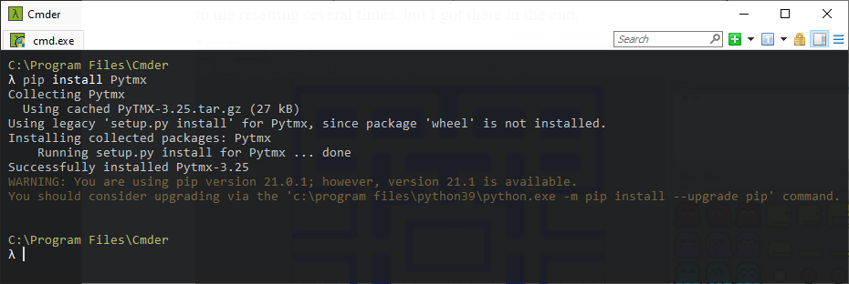

Following the first part of the tutorial I create a new class in ‘main.py’ called ‘TiledMap’. Upon instantiation it loads the given tile map with its width and height as attributes. When ‘make_map’ is called a ‘temp_serface’ the size of the map is created. ‘render’ is then called which will take the global identifiers of each tile and iterate through each layer. If it is a tile layer, then iterate through the properties of each tile in said layer. If the tile has an image, then blit it to this temp surface. By the end ‘make_map’ will return a large image that is the maze.

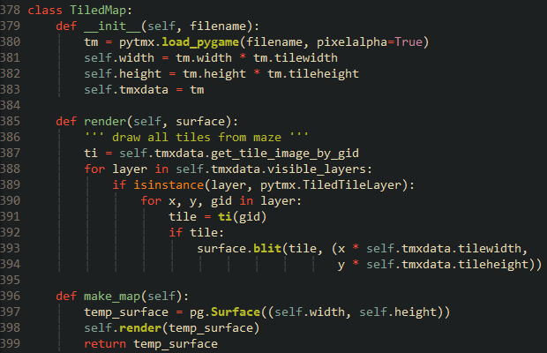

Inside ‘load_data’ I commented out the code involved with creating the legacy maze. To avoid errors pertaining to getting Pac-Man’s attributes, I will spawn him outside the ghost house.



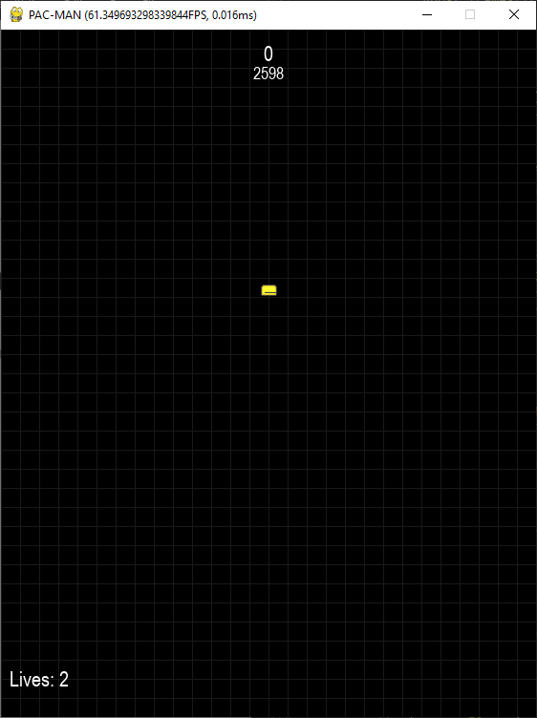

To render the maze the ‘TiledMap’ class is instantiated with the map file imported. ‘make_map’ is then called with the image stored in ‘maze_img’ the rect is then gotten so it is known were to blit the image.



Inside ‘draw’ the maze image is blitted onto the screen after the grid and before the sprites.

While the maze loads and is rendered correctly the grid is not showing. This was because the pixels between the walls are black, so a simple colour key of black done the trick.

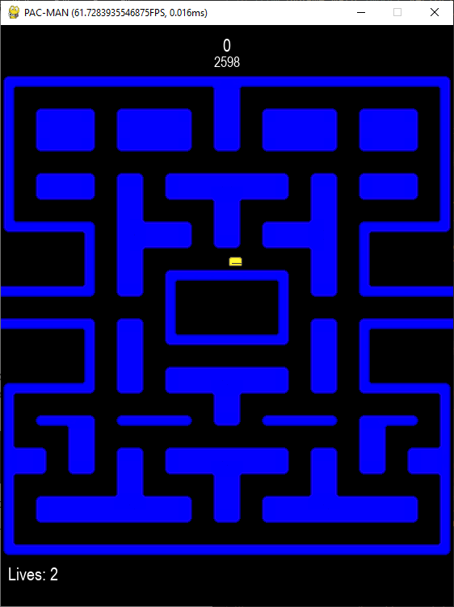



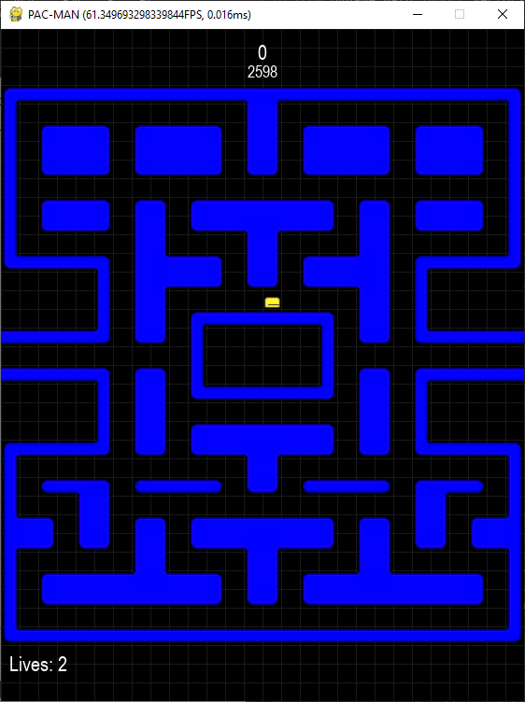

#### Maze Flashing/Tinting

The most interesting aspect of this new maze was trying to get the maze to flash like it did in the old one. I thought the easiest way to do this was to ‘tint’ the image white. Rabbid76 came to the rescue one again with another answer to a StackOverflow thread. A special flag called ‘BLEND_MULT’ is used while blitting a white image with a transparent background to tint it a specified colour [20].

Using the example code, I copied the function a placed it in my ‘Game’ class. It fills a surface of the same as size of the passed in image with the passed in colour. A copy of the filled surface is then created, and the coloured image is blitted on to it, with the blend mode ensuring it gets tinted.

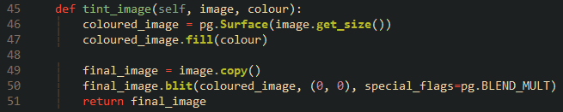

Before continuing with the code, I needed to modify the sprite sheet. For the tinting to work the best the maze needs to be white [20]. A simple colour exchange in GIMP was all that was needed to make the tiles white.

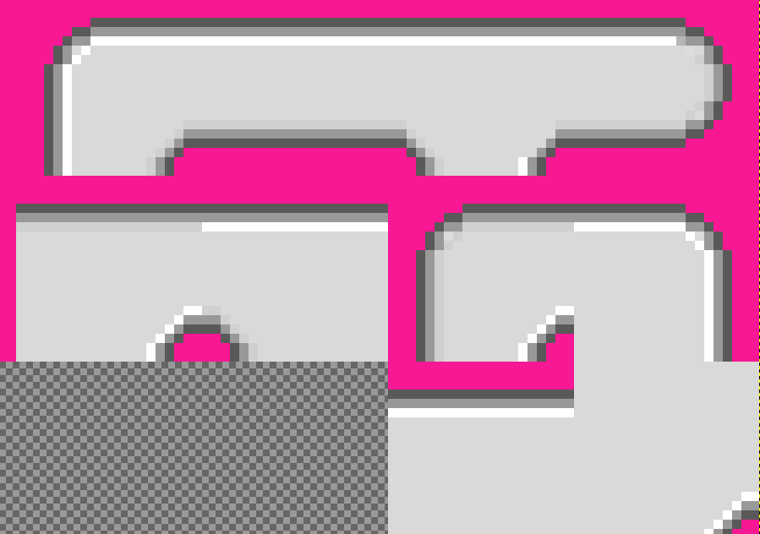

The nice thing about Tiled is that it rereads the sprite sheet given to it upon opening a *.tmx file. The maze is now white.

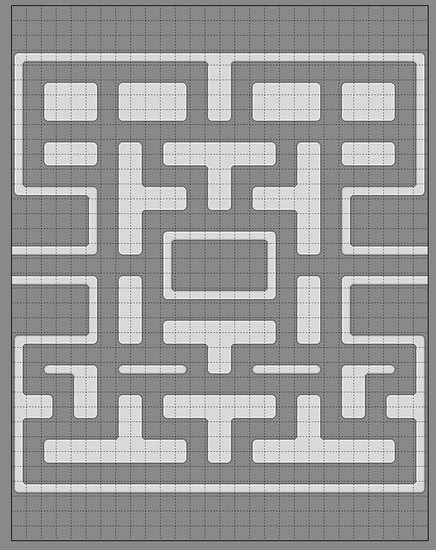

The blend modes can be quite expensive to execute at run-time, so to minimise their use I opted to store both the white and tinted images in memory.

After getting the maze image its stored in an attribute called ‘maze_white’ and the tinted maze in ‘maze_blue’. ‘maze_blue’ is then stored in ‘maze_image’, it is the maze that will be initially drawn. The flag ‘maze_flash’ is used to alternate the maze between these two images.

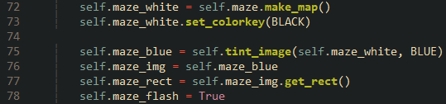

Over were the old maze used to flash a ternary conditional operator is used to swap the maze image depending on the state of the ‘maze_flash’ flag. The flag is then toggled for the next swap.

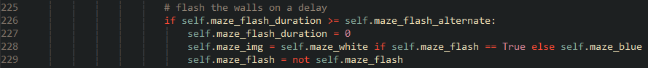

And with that the new maze can now flash upon level completion.

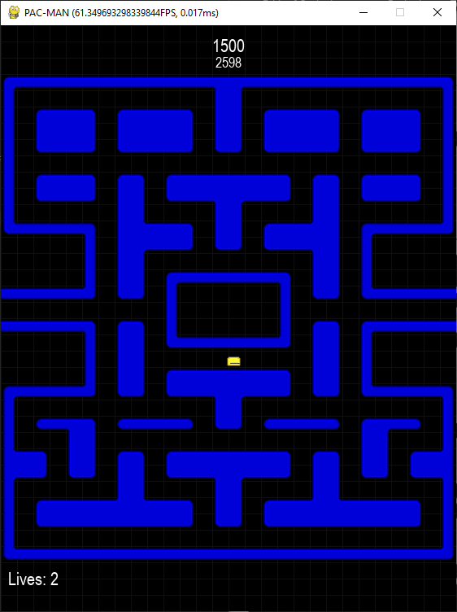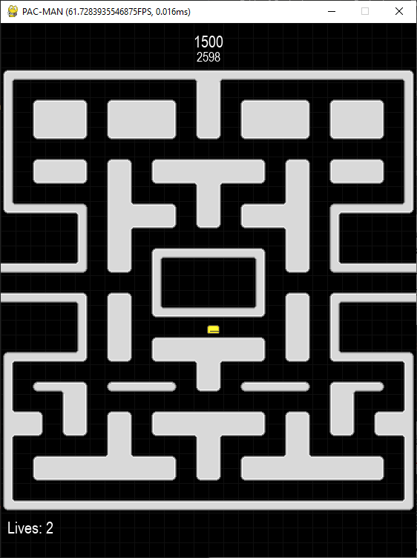

#### Maze Collision and Objects

One reason why I am caring about the maze graphics as much as I am because it leads to a substantial optimisation. In the original maze the walls consisted of many objects with each occupying a single tile, this meant that during collision check all those objects had to be iterated through. When considering the amount of times collision is checked each frame via the ghosts and Pac-Man, its apparent how inefficient this is. With Tiled I’m able to easily define the dimensions of these ‘walls’; greatly reducing the number of objects and in turn the number that need to be iterated through.

So, in tiled I created a new object layer and added the invisible walls. Note how the topmost wall has just one rectangle for collision, in the original maze that was a rectangle for each tile.

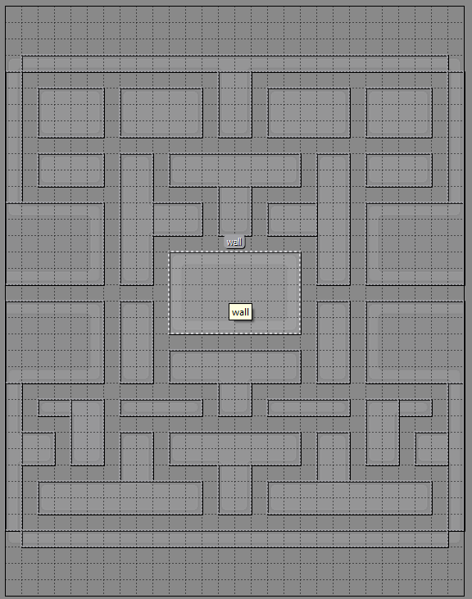

The iteration through the text file is now replaced with some new code. Like the previous code, it iterates through the object layers and checking the name of each object. If the name I gave to these objects in Tiled is inside the else if chain, the corresponding object is created at its position. Since the coordinates are now absolute pixels. Multiplying the passed in coordinates in the objects’ constructors is no longer needed. The ‘Wall’ class has now been replaced with a new class called ‘WallCollision’ which is simply a rect defined with the passed in dimensions. Since its sprite group is ‘walls’, collision detection against them will work like usual.

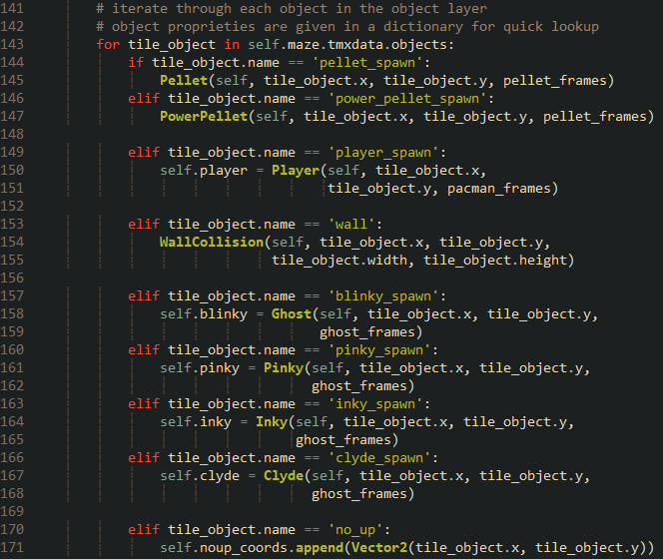:

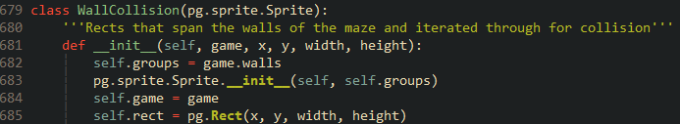

You may wonder what the ‘no_up‘ object is. It appends its position to a list that is iterated through during the direction decision algorithm. If the current unit vector being evaluated is ‘up’ and the ghost’s position is the same as any of the positions in the ‘noup_coords’ list, then ‘up’ will be discarded. This implements a quirk in the original Pac-Man where there were special locations in the maze where the ghosts are denied moving up even if they’re eligible to do so.

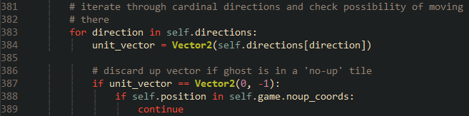

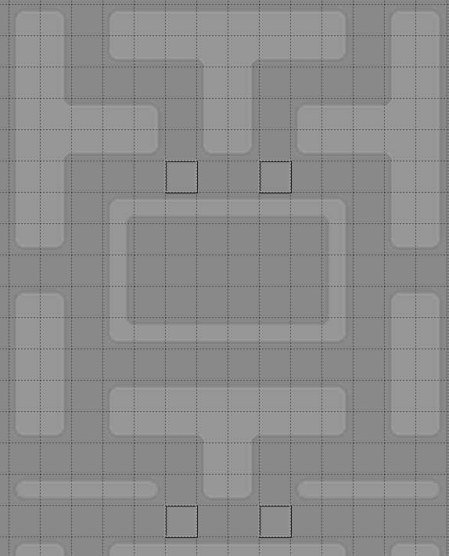

With all that done the new maze is fully implemented, the ghosts, pellets, and invisible walls all spawn and function as they should. Now its time for the final stage of development.

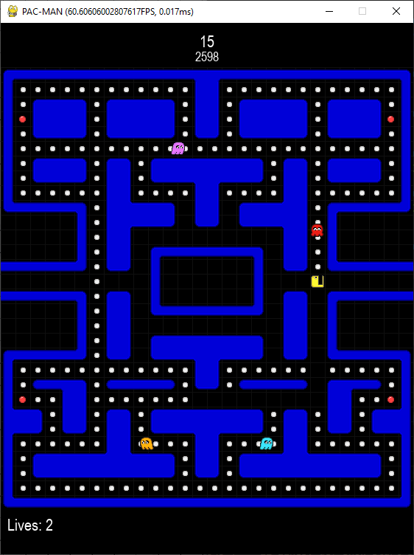

### Reflection

With the visuals complete the game is nearing the end of its development. I am surprised with how relatively simple this was to implement. I thought the maze flashing would be impossible to implement in the new maze and would have to compromise the flashing with the optimised walls, but thanks to Rabbid76’s solution it turned out well in the end [20].

The final iteration will involve implementing a title screen, the bonus fruit (finally), and a handful of bug fixes. I am also going to address some criticism my colleagues gave regarding Pac-Man’s controls.

|  |  |
| --- | --- |
| **Done** | **To do next** |
| Slice graphics from a single sprite sheet. | Create a title screen. |
| Programmatically create new graphics from the existing graphics to keep the sprite sheet small. | Implement the bonus fruit. |
| Append the graphics into lists and pass into entities. | Refine the controls of Pac-Man to reflect the controls of Pac-Doodle [6]. |
| Added Pac-Man’s eating animation, using a 2d list to change orientation. | Redesign title and post-game screens to be more visually appealing. |
| Added Pac-Man’s death animation. | Make frightened ghosts transparent to show vulnerable state. |
| Change the ghost sprite depending on direction and keeping the same sprite when under frightened mode. | Fix bugs pertaining to objects resetting after death and Pinky’s target tile. |
| Added graphics for frightened and eaten mode that are pointed to when in those states. | Handle an error that occurs when comparing a tampered high score. |
| Used Tiled to recreate the maze and more intuitively populate it with objects via the program. |  |
| Implement maze flashing by creating a maze image tinted blue at run-time and alternating between them. |

## Iteration 11 – Title Screen, Bonus Fruit, Refining Controls and Finishing Touches

After all the hardships of development, I thought it would be fitting to end it by doing a few relatively simple things alongside some things that should have been done some time ago.

### Title Screen

First, I made a new method in the ‘Game’ class called ‘show_title_screen’ This will be the first method called once the ‘Game’ class has been instantiated. Alongside the title and prompt to start, I wanted some instructions. The ‘pygame.font.render’ method doesn’t recognise newline characters, so I had to get a little creative.

Each line is stored as an entry in a list called ‘instructions’ and a local varaible called ‘spacing’ is defined. The title and highscore are then displayed.

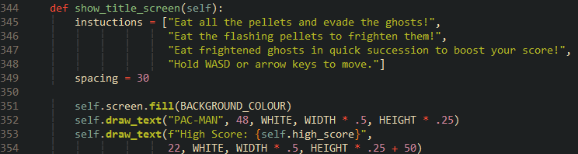

To draw the instructions the list is iterated through with an enumerate to get both the index and data of each entry the index is multiplied by ‘spacing’ to displace the line. So, the line will be displaced by $0 * 30 = 0 pixels$ the second by $1 * 30 = 30 pixels$ the third by $2 * 30 = 60 pixels$ and so on.

This results in the instructions being neatly clumped together with adequate spacing.

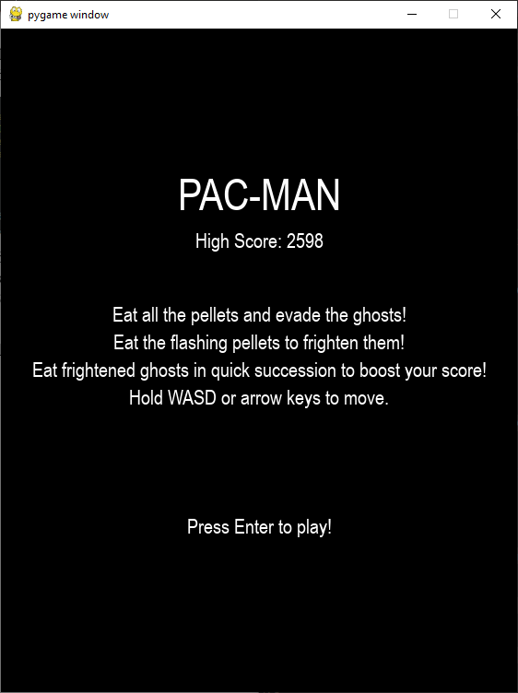

And just like the post-game screen ‘wait_for_key’ is called to wait for the player to press enter. Once they do it then the game will commence.

### Bonus Fruit

After some elapsed time in the level a fruit will appear that when eaten will give the player a big boost to their score, the fruit will remain after losing a life and is only spawned once. This can introduce an interesting dynamic to gameplay. Since the player’s score is halved when caught, would they take the risk to eat it only to die shortly after?

First the fruit graphics must be loaded, a have done a minor refactor of this part of code by adding a nested method called ‘load_image_sequence’ This is called to slice the graphics of both the pellets and fruits. I done this since the two for loops that handled this were similar enough.

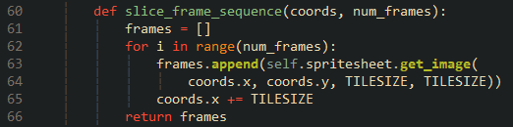



Also, since I’m aiming to create the fruit inside another method ‘fruit_frames’ needs to be an attribute.

I created a new sprite class called ‘BonusFruit’ for simplicity with collision checking it inherits from the ‘Pellet’ class. The ‘eaten_score’ is overridden. The image will be a random frame. A flag called ‘bonus’, which is false in the parent class, denotes whether to deduct one from ‘dots_remain’ when an object in the ‘pellet’ group is eaten. The player should be able to complete the level without eating the fruit, so the deduction is skipped.

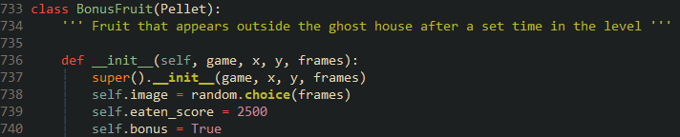

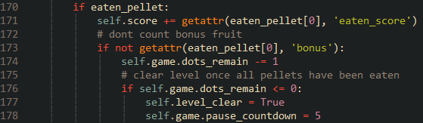

To spawn the fruit in the correct location I add a new object to the tile map called bonus_spawn just below the ghost house.

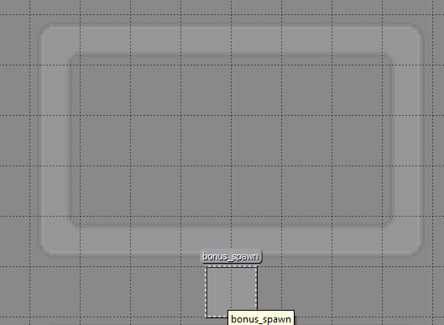

The coordinates will be stored in a vector, ready for use when the fruit is spawned in the game loop.

To control timings some new attributes are defined. The ‘bonus_time’ is the time in seconds that should elapse before the fruit shows up. For testing purposes, the fruit will show up three seconds upon gameplay starting. 'bonus_timer’ will increment each frame.



In the game loop bonus timer is incremented by the time delta during the frames where the game is not paused.



Then alongside checks of Pac-Man’s death animation and lives a check to see if it is time to spawn the fruit is done. If so, then the x and y components of ‘bonus_coords’ are used to create the object.

While the fruit does appear after 3 seconds, the condition to create it will always be true for each subsequent frame, causing a new fruit to spawn every frame. You can see the overlap of the cherry over the pineapple.

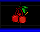

A Boolean flag was used to fix this. ‘bonus_spawned’ is initially set to false upon a new game. The check to spawn some fruit is now modified to also check if the flag is lowered alongside checking if the timer is over the allotted time. If both evaluate to true, spawn the fruit. The flag is then raised to prevent the fruit from ever spawning again.



The timer will no longer increment when the flag is raised since its no longer needed anymore.



And of course, I set ‘bonus_time’ to its intended 60 seconds.

Now a singular fruit will spawn a minute into gameplay that when eaten will reward the player with 2500 points.

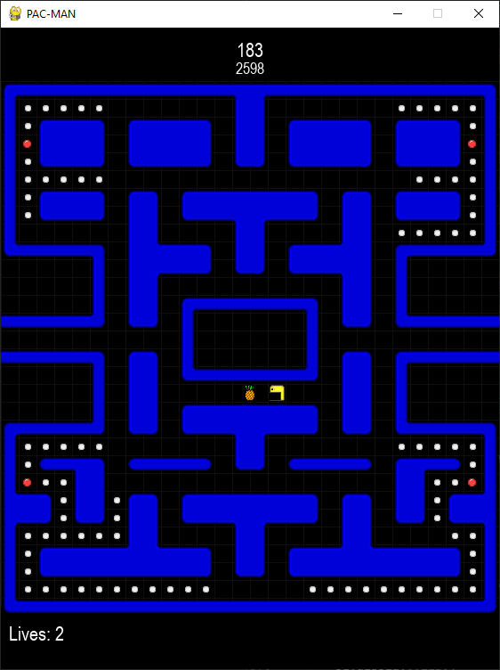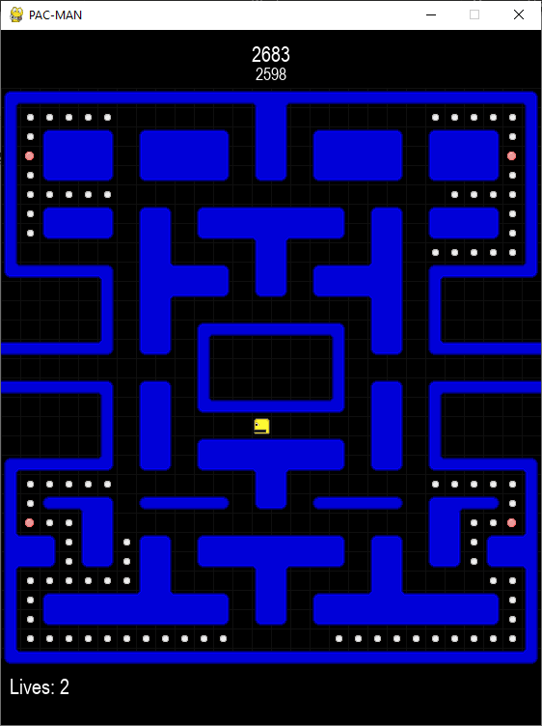

### Major Refinement to Pac-Man’s Controls

The biggest criticism that I got from by colleagues about the game is that Pac-Man is hard to control. To move him you need to hold down a direction key and to stop you let go. While this may sound simple on paper, Pac-Man will never stop between two tiles so to turn a corner, you need to let go of the key you are holding and quickly switch to holding the other key before Pac-Man reaches the intersection. Failure to do so will either cause Pac-Man to stop or completely skip the intersection. This manoeuvre becomes more difficult when the grid is not being drawn as a visual guide.

To fix this my teacher recommended me to replicate Pacman Doodle’s controls. Pac Doodle is a small recreation of Pac-Man by Google to celebrate its 30th anniversary. All the player need to do is tap a direction key, no holding required. Another key can then be tapped and the game will memorise that direction and move in it when possible to do so [6]. This makes turning corners very easy.

Implementation of this mechanic was quite the challenge and required ample knowledge of how the current movement worked. I already had the ‘check_for_walls’ method implemented. So, I can use that to check if a memorised direction is eligible to move in.

First, I defined some new attributes to memorise both direction and frame angle called ‘new_direction’ and ‘new_frame_angle’ respectively.

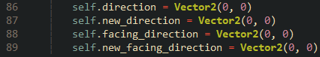

The method ‘check_movement_keys’ has been modified considerably.

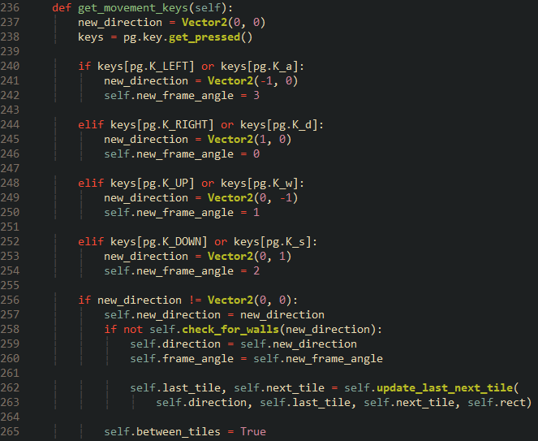

Because both horizontal and vertical movement now needs to be always registered, the checks to see if either the x or y components of ‘direction’ are 0 are removed. Like before when a key is pressed a vector gets stored into the local variable ‘new_direction’. ‘new_frame_angle’ then stores the correct sub-list index. When a direction is pressed, the vector is stored in the attribute ‘new_direction’ and is checked to see if it would lead to a wall. If not, then that new direction will become the direction that Pac-Man will follow.

Then I became stuck, I needed to make Pac-Man move indefinitely after pressing a key. To help with this, I drew two bounding boxes around Pac-Man, one showing his collision rectangle (red), and another showing his ‘next_tile’ (green).



I found out that when holding down a direction Pac-Man will begin to ‘chase’ the next tile. The position of the tile is updated every frame yet always aligned to the grid; when he is halfway into it, the tile will move to the next tile and so on as long as the key is pressed. When letting go of the key, the tile is no longer updated so Pac-Man can arrive at it and stop moving. This also means that the ‘between_tiles’ flag is never set back to false while moving.

Armed with this knowledge I knew I had to update the position of the next tile every frame when moving, so in the method ‘update’ the method ‘update_last_next_tile’ is called after ‘move’.

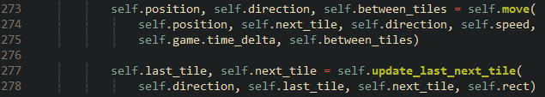

Pac-Man will now move in a direction upon a press of a key. Inside ‘check_collision’ a new check is added to see whether the ‘new_direction’ is eligible to move in.

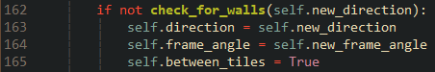

However, I did run into trouble getting Pac-Man to consistently move in the new direction. For example, if he is moving up and the player presses left to make Pac-Man move left at the next intersection, there is a likely chance that he will ignore the first intersection and move left at the next one. This inconsistency is detrimental to gameplay.

I suspected that this was due to the pixel perfect nature of the check. Pac-Man’s collision rectangle must be perfectly aligned with the intersection for it to consistently work. If Pac-Man is going at a high speed, say 200 pixels a second, it is likely that he will completely skip the intersection between two frames compared to if he was moving at around five pixels a second. If he was moving one pixel a second, then he will always be aligned on the intersection, so the check will work every time.

I proved this theory when controlling Pac-Man at different speeds. The error grew the faster Pac-Man was moving. The framerate also showed to influence this error. A higher framerate means that Pac-Man is updating at a faster rate, meaning that his position is updated more and thus increasing the chances he is aligned on an intersection.

So, to make the check perfectly consistent, Pac-Man’s position and rectangle needs to snap to the grid upon arriving at the next tile. Fortunately, this is what the movement interpolation already does. It snaps the position to ‘next_tile’.

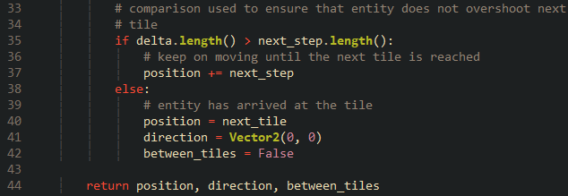

A check can be added to determine if Pac-Man’s position is equal to that of the next tile and run the wall check if it is the case. This means that the ‘next_tile’ can no longer be updated every frame and instead only when Pac-Man has arrived at it. The ‘next_tile’ update in ‘update’ is removed.

A new check is added to ‘check_collision’, if Pac-Man’s position is the same as ‘next_­tile’, then preform the wall check. If there are no walls, move in that new direction. Update ‘next_tile’ no matter what.

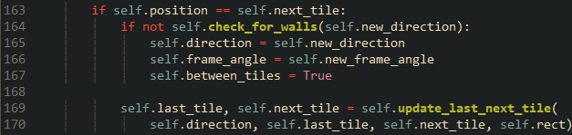

Originally an else branch was added to stop Pac-Man when there was a wall, but this resulted in him stopping at soon as another key was pressed. So, the original check for walls returns and is executed before to ensure that Pac-Man does not clip out of the maze.

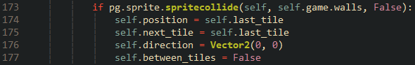

The final piece of the puzzle was to make sure that the direction was not reset when arriving at the next tile. While this may seem like it would mess up the ghost’s movement, it does not since they are also always moving.

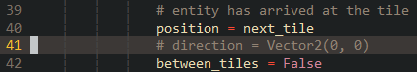

The movement process now works like this:

1. When the player presses a direction key store it in ‘new_direction’.
2. If that new direction does not lead to a wall, make it the direction Pac-Man will move towards.
3. Update the position of ‘next_tile’, 20 pixels ahead of Pac-Man.
4. Move Pac-Man one step.
5. Check if Pac-Man is going to collide with a wall, if so then stop moving.
6. Repeat steps 4 and 5 until Pac-man has arrived at ‘next_tile’. Once arriving, check if the vector stored in ‘new_direction’ does note lead to a wall. If not, then make that the new direction to move in.
7. Jump back to step 3.

The new movement feels miles better compared to the old one, it is also more assessable to boot. Turning corners is now an effortless process.

One catch is that the screen wrapping no longer works. When Pac-Man reaches the position to screen wrap, he instead first checks if there is a wall before, causing him to become stuck. This was fixed by adding a wrap check before right before the wall check like so.

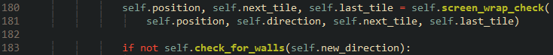

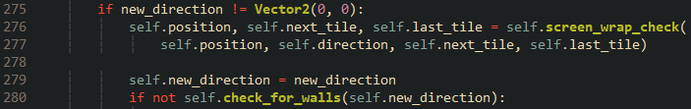

I can now definitively say that Pac-Man’s movement is fully complete. The movement works like a charm no matter the speed or framerate.

As one final touch I added a ‘handbrake’. When the player taps space he will stop in place, good for when you want to tactically lure in ghosts.

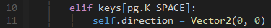

### Redesigning the Title Screen and Post-Game Screen

For first impressions, I thought that it would be beneficial to design the screens to be more appealing than a black background with white text.

I wanted to have an image as a background. I decided on it being the white maze with a gaussian blur applied to it. Having a background like this aligns with the maze during gameplay serving as a (almost) seamless transition in and out of it.

I screen capped the maze in Tiled and used GIMP to crop and applied a black background and blur.



The image is then loaded during game creation and blitted to both screens before everything else.





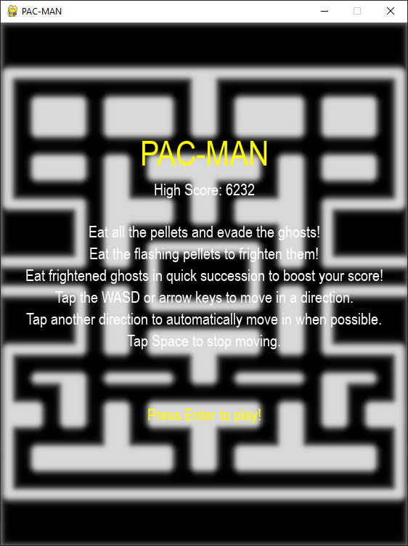

The text on screen is very hard to read, to remedy this a translucent rectangle can be drawn behind the text. Pygame rects do not support alpha, but you can mimic one by creating a surface, setting its alpha channel and blitting it [21].

To avoid repeated code, I created a new method called ‘draw_alpha_rect’. It passes in the position and dimensions of the rectangle and uses them to do what was stated above.

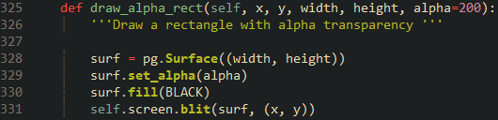

In both screen methods this code is called before drawing the text, manual adjustment was required to get things just right.

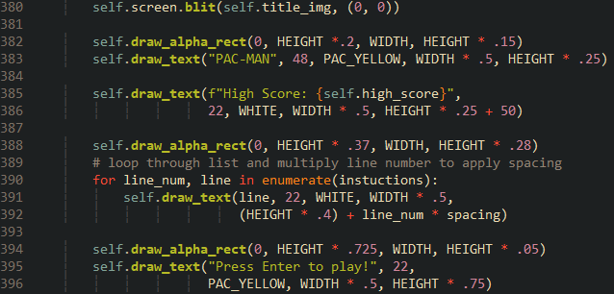

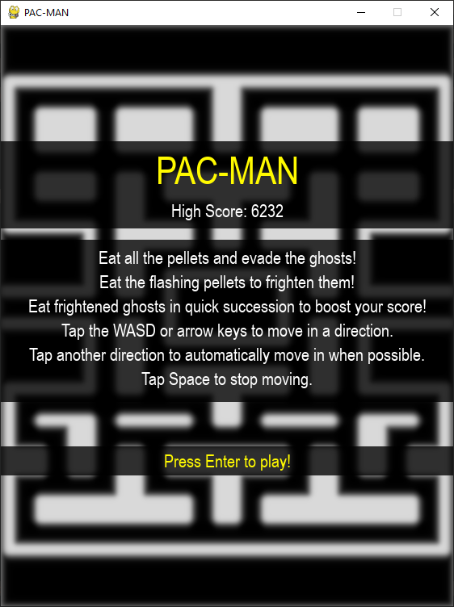

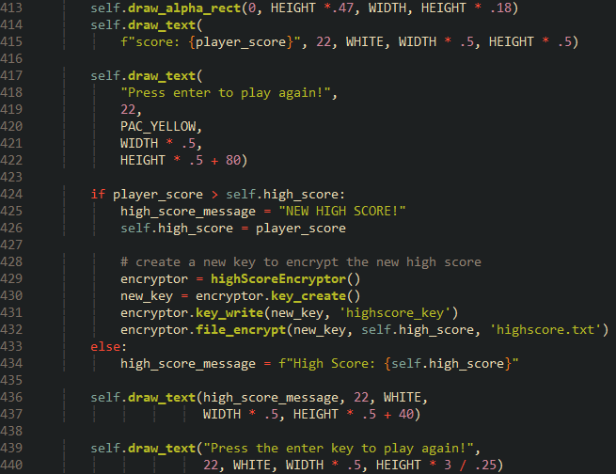

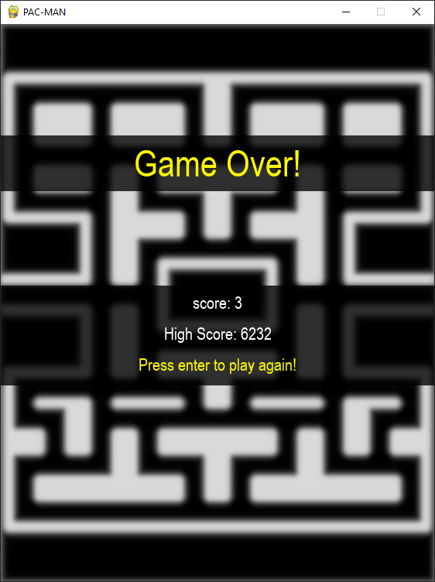

### Final Touches

#### Correct Sprite Layering

Something that a colleague of mine noticed is that some ghosts appear either behind or above the pellets and Pac-Man, leading to visual inconsistencies that affect the overall presentation of the game. To fix this I made use of Pygame’s ‘LayeredUpdates’ method. The ‘all_sprites’ group now uses this method.



In the settings file I added three new constants that store the layers each object will be in. Ghosts will be rendered at the top, then Pac-Man then the pellets.

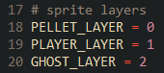

Within the top of each class’ constructor I define a special private attribute used by ‘LayeredUpdates’ called ‘_layer’. Set to the respective layer.

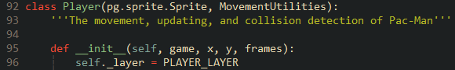

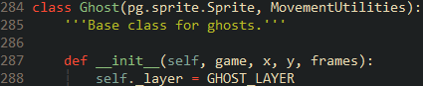

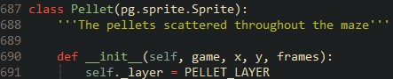

The sprites are now always drawn in the correct order.



#### Fixing a Hitbox Bug

A bug that emerged is that when Pac-Man dies and resets his position, he will instantly die again. This bug does not occur in any subsequent deaths. After some digging, I found that this was due to the ghost and Pac-Man hitboxes not updating to their new position after a reset, until their update method is called. So, when the pre-game countdown reaches zero, the ‘update’ method for Pac-Man is called, it checks to see if he is colliding with a ghost’s hitbox, which he erroneously is, and the death sequence plays out again. Though I am not sure why this does not occur more than once.

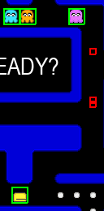

Here the hitboxes are shown in red. Note the overlapping red boxes. That is the collision that caused Pac-Man’s death. Because those boxes have not been reset that collision will still be valid as soon as gameplay starts.

This was an easy fix. Inside the ‘reset_status’ methods in the ‘Player’ and ‘Ghost’ classes, I call the ‘update_rect_and_hitbox’ methods. This ensures that the hitbox will be in the correct place.

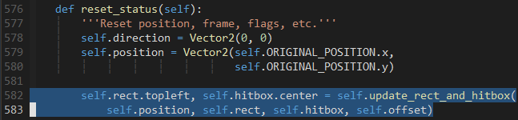

I bought back the code to draw the target tiles of the ghosts to check that it was all working correctly and noticed that Pinky was not targeting four tiles ahead of Pac-Man. This was because I forgot to set ‘facing_direction’ to ‘new_direction’ meaning ‘facing_direction’ was always (0, 0), so adding magnitude to it did nothing.

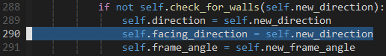

#### Final Reactor of Direction Decision Algorithm

I also done another refactor of the direction decision algorithm. This time it was to change ‘directions’ from a dictionary to a list. I found using a dictionary in this scenario to be pointless because the key values are pretty much the same integers you would get from list indexes.

I changed ‘directions’ to be a list of vectors and used Python’s ‘enumerate’ function to get both the index and data of each vector.



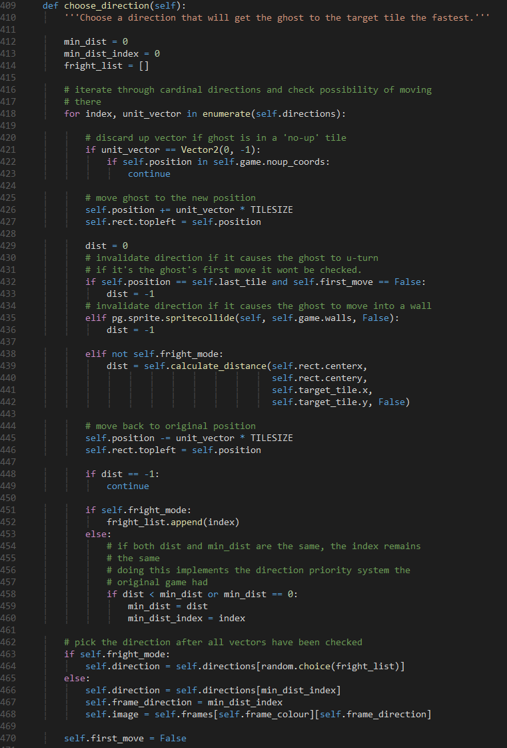

#### Frightened Ghost Translucency

A simple addition. Making the ghosts translucent when frightened indicates to the player that they are both in a vulnerable state and that they can be safely passed through.

This is done by one line. ‘set_alpha’ is called when a ghost enters frightened mode. I found that an alpha of 200 stuck a balance between conveying the above and not being too hard to see.





#### Fixing Case of High Score Tampering

I returned to the high score encryption to test how the game handles a tempered high score and key. I found that the game crashes when it tries to compare the player score with the high score since it is a string.

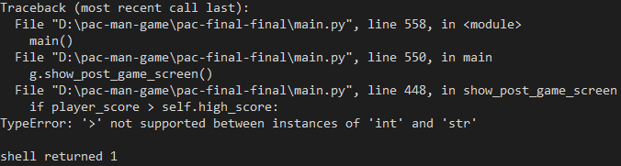

A try and except condition was all that was needed to fix this. If the high score is a string. Then the comparison is skipped and instead set to be the ‘high_score_message’ so it is displayed.

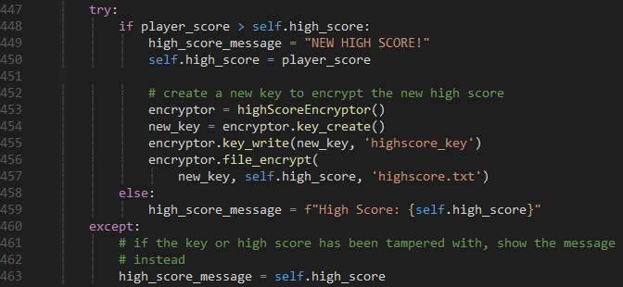

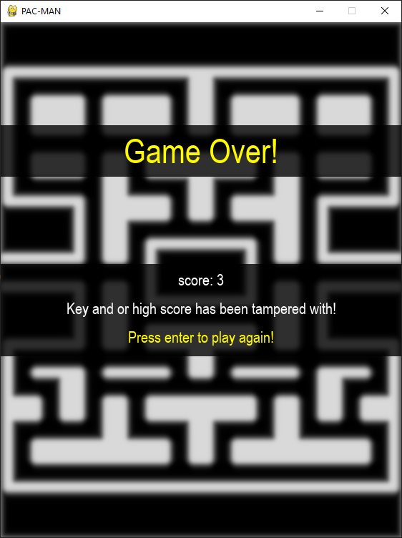

### Minor Reformatting and Comment Editing

As a final touch minor reformatting and comment editing was done to make the code look the most presentable it can be.

### Reflection

And with that the game is now in a state in which I consider completed!

While it is possible to continue and add more, such as multiple levels maze layouts and sound. I will stop here in the interest of time and the fact that the solution in this current state satisfies my success criteria well enough.

Next is to perform a final test to see exactly how well the solution satisfies the criteria.

# Testing Compilation

Each entry of the success criteria will be assessed against the solution. A timestamp is provided to point to a specific part of the complementary video showing the game in action.

To show you what keys I am pressing, I added some debug text that shows on the bottom right corner whenever I press a key.

## Functionality Testing

|  |  |  |  |
| --- | --- | --- | --- |
| **Test No.** | **Criteria** | **How it was measured** | **Results with timestamps** |
| 1 | Make the game boot up and display a window | Running the python interpreter on ‘main.py’ | Passed – shown at 00:00 |
| 2 | Have the game be able to display Pac-Man and be capable of switching between his animation frames. | Seeing if Pac-Man is being rendered and moving him around. | Passed – shown at 00:06 |
| 3 | Have Pac-Man be able to move in all four directions while keeping always aligned to the grid. | Moving Pac-Man around using the movement keys. | Passed – Shown at 00:07 |
| 4 | Have Pac-Man freeze in place when the maze is complete. | Eating all the pellets. | Passed – shown at 03:12 |
| 5 | Make Pac-Man collide with the maze walls along with the ghosts also inside it. | Moving Pac-Man and looking the ghosts to see if either phase into the walls. | Passed – shown at 00:10 onwards. |
| 6 | Make the player’s score increase accordingly upon Pac-Man eating an edible object. | Moving Pac-Man into pellets (+1 point), power pellets (+10 points) and bonus fruits (+2,500 points). | Passed – shown at 00:06, 00:28 and 01:18 respectively. |
| 7 | Kill Pac-Man upon colliding with an un- frightened ghost and deduct a life. | Making Pac-Man collide with an un-frightened ghost. | Passed – shown at 01:44 |
| 8 | Make the game render the maze. | See if the maze is rendered with all tiles in the correct places and tinted correctly. | Passed – Shown at 00:05 |
| 9 | Efficiently load in pellets of the maze, with power pellets and fruit being in the right place. | See if all pellets are rendered correctly and fruit spawns in the correct position. | Passed – Shown at 00:05 and 01:07 |
| 10 | Have the warp zones on either side of the maze correctly screen wrap Pac-Man and the ghosts. | Moving into the warp zone and luring ghosts into it. | Passed – Shown at 00:48 |
| 12 | Ensure that eaten pellets do not reappear after respawning. | Get caught to respawn. | Passed – Shown at 01:49 |
| 13 | Have all the ghosts stay in the maze for a set amount of time at the beginning before leaving. | Start a game. | Failed – Not implemented. |
| 14 | Implement each ghost’s behaviour to intercept Pac-Man. | Playing the game and observing how to ghosts chase Pac-Man. | Passed – Shown during gameplay. Note how Clyde tends to stay at the bottom left corner, Blinky making beeline, Pinky trying to flank and Inky joining in when Blinky is close to Pac-Man.  This is shown well at 01:43, Pinky and Inky pincer Pac-Man. |
| 15 | Reset the ghosts’ positions to the ghost house after Pac-Man dies and respawns. | Getting caught and seeing where the ghosts end up. | Partly Passed – Seen at 01:48, while the ghosts do reset positions, they are not inside the house. |
| 16 | Implement the four states the ghosts will transition to at designated times and events. | Observing where the ghosts initially move to, eating a power pellet and colliding with a frightened ghost. | Partly Passed – Seen at 00:06 to 00:12, note how Blinky begins by circling his maze corner for some time before heading towards Pac-Man.  00:27 shows the ghosts becoming frightened.  00:30 shows a ghost moving into eaten mode.  00:31 shows that eaten ghosts becoming uneaten.  However, At 02:59 an eaten ghost fails to convert back into a normal ghost, circling the house indefinitely. Seems to be an edge case bug I missed. |
| 17 | Ensure that ghosts go into frightened a frightened state upon Pac-Man eating a power pellet. | Eating a Power Pellet. | Passed – Shown at 00:29. |
| 18 | When Pac-Man eats a frightened ghost, add bonus points to the score and show their eyes moving back to the ghost house. | Eating a ghost, checking score, and seeing if their eyes move back. | Partly Passed – Shown at 00:29 – 00:33. While points are added to the score, the ghost does not retreat to the house |
| 19 | Alter the behaviour of ghosts depending on the number of pellets left (e.g. Blinky defaulting to chase when there’s 30 pellets left). | Eating pellets to reducing the number of pellets to under 30 and seeing if he will just chase. | Partly Passed – I noted that edge case bug with eaten ghost circling the house indefinitely only occurred in with Blinky and near the end of a game. I found that the bug was caused by this defaulting the chase mode.  While Blinky is fine with defaulting when not eaten or scattering. If the number of remaining pellets falls below 30 while Blinky is frightened or eaten, he will ignore any checks to escape these states. |
| 20 | Decrease the amount of time the ghosts the ghosts are in scatter mode the more levels are completed. | See how long the ghost scatter for. | Failed – Multiple levels not implemented. Though the time a ghost spends scattering is decreased from five to three seconds after three scatter cycles. |
| 21 | Display the score and high score above the maze. | See if the two values are shown. | Passed – shown at 00:04 |
| 22 | Store the high score in a text tile and unload it at run time. | See if in ‘highscore.txt’ updates after gameplay is finished. | Passed – Shown at 02:44 to 02:57.  A new high score is achieved and stored in the file.  02:57 onwards shows the new high score, indicating that it correctly loaded. |
| 23 | Encrypt the high score in the text file. | See if the score in the file is illegible. | Passed – Shown at 02:46 |
| 24 | Display the lives and fruit below the maze. | See if both are displayed. | Partly Passed – Shown at 00:04 onwards. While lives are displayed, the fruits are not, due to multiple levels not being implemented. |
| 25 | Change the amount of fruit displayed depending on the current level. | See if the fruits change. | Failed- fruits are not displayed due to multiple levels not being implemented. |
| 26 | Display the title screen and ask for a key prompt to start the game. | See if the title screen and prompt appear when the game boots up. | Passed – shown at 00:01. |
| 27 | Display a game over upon losing all lives and retuning to the title screen after some time. | See if the post-game screen appears and transitions into the title screen after some time. | Partly Passed – Shown at 02:44. While the screen does appear, it will not transition to the title screen and instead asks for a prompt that will just start a new game. |

## Usability/Cosmetic Testing

|  |  |  |  |
| --- | --- | --- | --- |
| **Test No.** | **Criteria** | **How it was measured** | **Results with timestamps** |
| 1 | Allow Pac-Man to move smoothly between the tiles. | By moving Pac-Man | Passed – shown at 00:06 and throughout. |
| 2 | Allow the turning of corners not be pixel perfect. | By pressing a key once to move Pac-Man along a direction and pressing another key to see if will memorise the direction and move along it when eligible. | Passed – Shown at 00:50 to 00:52.  Note how the player presses left before reaching the intersection, Pac-Man then automatically move left. |
| 3 | Have the maze flash white upon clearing a level. | Clear the level by eating all the pellets and seeing if the maze flashes. | Passed – Shown at 03:12 |
| 4 | Hide the ghosts when Pac-Man collects all the pellets or is dying. | Clear the level and get caught. | Passed – Shown at 03:12 and 01:46 respectively. |
| 5 | Add a manual pause that can be called on command. | Pressing the escape key and seeing what happens. | Passed – Shown at 01:52 |
| 6 | Pause the game for a short time before starting the game. | Starting the game. | Passed – Shown at 00:04 to 00:06 |
| 7 | Do a pause when eating a ghost, clearing a level, and getting caught. | Eating a ghost, clearing a level, and getting caught. | Passed – Shown at 00:29, 03:12 and 01:44 respectively. |

## Robustness Testing

|  |  |  |  |
| --- | --- | --- | --- |
| **Test No.** | **Criteria** | **How it was measured** | **Results with timestamp** |
| 1 | Since there is no limit to how many times you can pause, it is important for pausing to not break anything. | Spam the escape key. | Passed – Shown at 01:55 to 02:00 |
| 2 | Pac-Man’s movement should work the same when the player is tapping or holding down the movement keys. | Tap the movement keys and hold down the movement keys. | Passed – Shown at 00:09. The player is holding down keys and movement is still working. |
| 3 | The player can press two movement keys at the same time and Pac-Man will still move in the direction he was travelling in. | Holding down one movement key and pressing another while holding down the other. | Passed |
| 4 | The player can eat a power pellet and reset the fright timer. | Eating a power pellet while ghosts are frightened. | Passed – Ghosts remain in frightened mode for longer.  Small Caveat- If the ghost is flashing and Pac-Man eats a power pellet while it is white, it will remain white instead of overriding to blue. A Purely cosmetic bug. |
| 5 | Ensure that an eaten ghost does not become frightened. | Eating a power pellet while an eaten ghost is in the maze. | Passed |
| 6 | The player can press another movement key while holding another and Pac-Man will update his movement to the newly pressed key. | Holding down a movement key and holding down another while Pac-Man is moving. | Partly Passed - While Pac-Man responds to the latest pressed key when moving right, he will not when moving right. The same applies for moving up and down. I assumed that this was due to the else if statements when checking the keys; I changed them all to ifs and it now works fine.  Either way, it is arguably more intuitive for new and experienced players to just tap the keys. |

# Evaluation

## Successes, Partial Successes and Failures

Below is a bar chart showing the tests and passed, partly passed, and failed. As you can see the majority of tests passed.

From testing I can say that all the most important features of the solution have been successfully implemented. I previously picked out the core components of the original arcade release. Which is controlling Pac-Man and eating all the pellets while evading the Ghosts, all of that can be done in my solution as shown in the test video and functionally testing.

As for the partly successful tests, they should be easy to fix, such as the direction Pac-Man moves in when more than one key is pressed, re-frightened ghosts remaining white and that eaten ghost not turning back, as shown at 02:59 in the test video, which could be solved by moving the check to see if the ‘ignore_scatter’ flag is raised below the checks to exit frightened and eaten mode.

The tests that failed are solely due to multiple levels not being implemented. But as mentioned before the solution has met the features from the original game that I defined to be paramount Pac-Man’s gameplay and style, multiple levels are not integral for Pac-Man to function.

Despite not meeting everything in the success criteria, I would consider the solution in its current state to be a success.

## Usability Features

### Screens

Despite not following my screen design ideas due to focusing much development time on the functionality and robustness of the solution. I did try my best to apply ‘the three reads’ [5] to the screens I did end up with. For example, the maze and HUD are very similar to the initial design, while the HUD is slightly different, the screen still follows the principles. The maze is a primary read, score and lives are secondary reads and the high score a tertiary read. My solution is missing a setting and a proper pause screen. While I could have spent development time making these screens. I refrained due to both thinking that focusing on gameplay will make for a better solution and that I realised the solution has a nice simplistic feel to it that adding complex menus to would compromise.

The screens that I did end up with are arguably more intuitive than the design ones. The player is only one key stroke away from starting, pausing, and retrying the game.

### Controls

In the end I am proud of the solution’s controls and how they developed over the development. At first, I thought that the ‘pressed’ based movement was good enough. But I was then told by my colleagues that they found controlling Pac-Man tricky. This motivated me to pursue the ‘tap’ based movement of Pac-man Doodle that I alluded to in the design section. This significantly improved the controls and the overall quality of the solution. I am sure that my hypothetical stakeholders would like the controls also.

### Sprites

The sprites did not change much from initial design compared to the rest of the solution. I did modify the sprite sheet some to facilitate the procedural generation of new sprites.

## Limitations and Potential Improvements

As mentioned above, a large limitation is a lack of multiple levels, and in turn, a difficulty curve, but I made sure that my code is extensible enough for these features to be added. I made sure that the code was free from any ‘magic numbers’, literal data types hard coded into branching and iteration without being stored into a variable first. One example are the ghost timers. I could make the duration a ghost scatters for a magic number, but I realised that this would make it difficult to modify this duration if need be, so I stored the duration in an attribute.

Thanks to this precaution, the values in these attributes can change depending on the level. The duration ghosts spend scattering can decrease the more levels the player completes for example.

One way of implementing this could be to use a file format that uses key-value pairs like JSON. This file could consist of the values of relevant attributes. At the start of each level this file is read and looks at the pairs of the current level and sets the relevant attributes. This means that I would have granular control over the properties for each level, thus providing a way to implement a difficulty curve.

## Maintenance

### Corrective Maintenance

I tried my best to keep the code modular and well documented. During the development section I spent an entire iteration refactoring the code to have better variable names, comments and structure. One highlight of its modular is the utility class for movement that both Pac-Man and the Ghosts inherit from. This means, for example any modifications to screen wrapping or movement interpolation will reflect across all the objects that inherit from it. This makes the code extensible and easy to maintain.

### Adaptive Maintenance

I tried my best to ensure that my solution archives the maximum compatibility. Python and Pygame are supported by a multitude of different operating systems and hardware configurations. The only compatibility assurance I had to do was to make file paths agnostic using the ‘os’ module. Any hardware and or software that can run Python and Pygame will run the solution. I can even use tools such as Pyinstaller to compile the game into a binary, so users would not even need to install Python and Pygame, clogging up their storage with dependencies they may never use outside of the game.

### Perfective Maintenance

There is room to make the code more efficient and cleaner.

Over development the game loop method became messier with its various branching to play out the death animation and maze flashing. I avoided splitting these into separate methods because I was late into development and wanted to wrap it up in the interests of time. Refactoring this could cause bugs that may take a lot of time to address.

While the procedural generation of sprites means, for example that someone will only have to modify one set of frames for Pac-Man, the code does look quite messy. In retrospect it may have been better to trade the ease of modifying the sprite sheet with cleaner graphics loading code. I could have used the function I made to slice a sequence of sprites more frequently.

# References

|  |  |
| --- | --- |
| [1] | Pygame, “About - Wiki,” 2021. [Online]. Available: https://www.pygame.org/wiki/about. [Accessed 25 March 2021]. |
| [2] | SDL, “Introduction to SDL 2.0,” 2021. [Online]. Available: https://wiki.libsdl.org/Introduction. [Accessed 25 March 2021]. |
| [3] | C. Bradfield, “Python Lessons and Tutorials,” KidsCanCode, 2019. [Online]. Available: https://kidscancode.org/lessons/. [Accessed 1 May 2021]. |
| [4] | R. 76, “How do I move the player smoothly in a tile based game?,” StackOverflow, 2020. [Online]. Available: https://stackoverflow.com/questions/63478615/how-do-i-move-the-player-smoothly-in-a-tile-based-game. [Accessed 25 March 2021]. |
| [5] | Z. Gage, “Building games that can be understood at a glance,” GDC, 2018. [Online]. Available: https://stfj.net/DesigningForSubwayLegibility/. [Accessed 2 May 2021]. |
| [6] | Google, “Pacman Doodle,” 21 May 2010. [Online]. Available: https://www.google.com/logos/2010/pacman10-i.html. [Accessed 1 May 2021]. |
| [7] | drakzlin, “20x20 Tileset,” OpenGameArt, 7 January 2018. [Online]. Available: https://opengameart.org/content/20x20-tileset. [Accessed 2 May 2021]. |
| [8] | C. Bradfield, “Tile-based game Part 2: Collisions and Tilemap,” KidsCanCode, 31 July 2016. [Online]. Available: https://www.youtube.com/watch?v=ajR4BZBKTr4. [Accessed 10 May 2021]. |
| [9] | PyShark, “Encrypt and Decrypt Files using Python,” [Online]. Available: https://pyshark.com/encrypt-and-decrypt-files-using-python/. [Accessed 1 April 2021]. |
| [10] | C. Bradfield, “kidscancode/pygame_tutorials/platform/part 7,” Kids Can Code, 2017. [Online]. Available: https://github.com/kidscancode/pygame_tutorials/tree/master/platform. [Accessed 1 April 2021]. |
| [11] | C. Bradfield, “Pygame Platformer Part 7: Splash & End Screens,” Kids Can Code, 4 April 2016. [Online]. Available: https://youtu.be/rLrMPg-GCqo. [Accessed 1 April 2021]. |
| [12] | Python Tutorial, “Python Private Attributes,” [Online]. Available: https://www.pythontutorial.net/python-oop/python-private-attributes/. [Accessed 10 April 2021]. |
| [13] | Stack Exchange: Game Development, “Adjusting collision hitbox size with Pygame,” 25 May 2018. [Online]. Available: https://gamedev.stackexchange.com/questions/159082/adjusting-collision-hitbox-size-with-pygame. [Accessed 16 April 2021]. |
| [14] | C. Bradfield, “pygame_tutorials/platform/part 18/sprites.py/,” KidsCanCode, 31 January 2017. [Online]. Available: https://github.com/kidscancode/pygame_tutorials/blob/master/platform/part%2018/sprites.py#L7. [Accessed 25 April 2021]. |
| [15] | Tiled, “Tiled: Full-featured Level Editor,” 2021. [Online]. Available: https://www.mapeditor.org/. [Accessed 25 April 2021]. |
| [16] | bitcraft, “Pytmx,” 20 April 2021. [Online]. Available: https://github.com/bitcraft/PyTMX. [Accessed 16 April 2021]. |
| [17] | C. Bradfield, “Tile-based game Part 11: Tiled Map Editor,” Kids Can Code, 9 September 2016. [Online]. Available: https://www.youtube.com/watch?v=Mr5l4U9S4kI. [Accessed 25 April 2021]. |
| [18] | C. Bradfield, “Tile-based game Part 12: Loading Tiled Maps,” Kids Can Code, 9 September 2016. [Online]. Available: https://www.youtube.com/watch?v=QIXyj3WeyZM. [Accessed 25 April 2021]. |
| [19] | C. Bradfield, “Tile-based game Part 13: Map Obstacles,” Kids Can Code, 13 September 2016. [Online]. Available: https://www.youtube.com/watch?v=vIT7P-RPJNo. [Accessed 25 April 2021]. |
| [20] | Rabbid76, “Is it possible to change sprite colours in Pygame?,” StackOverflow, 19 May 2019. [Online]. Available: https://stackoverflow.com/questions/56209634/is-it-possible-to-change-sprite-colours-in-pygame. [Accessed 27 April 2021]. |
| [21] | G. Giráldez, “Draw a transparent rectangle in pygame,” StackOverflow, 14 June 2011. [Online]. Available: https://stackoverflow.com/questions/6339057/draw-a-transparent-rectangle-in-pygame. [Accessed 1 Mar 2021]. |
| [22] | Retro Game Mechanics Explained, “Pac-Man Ghost AI Explained,” 2019. [Online]. Available: https://www.youtube.com/watch?v=ataGotQ7ir8. [Accessed 7 March 2021]. |